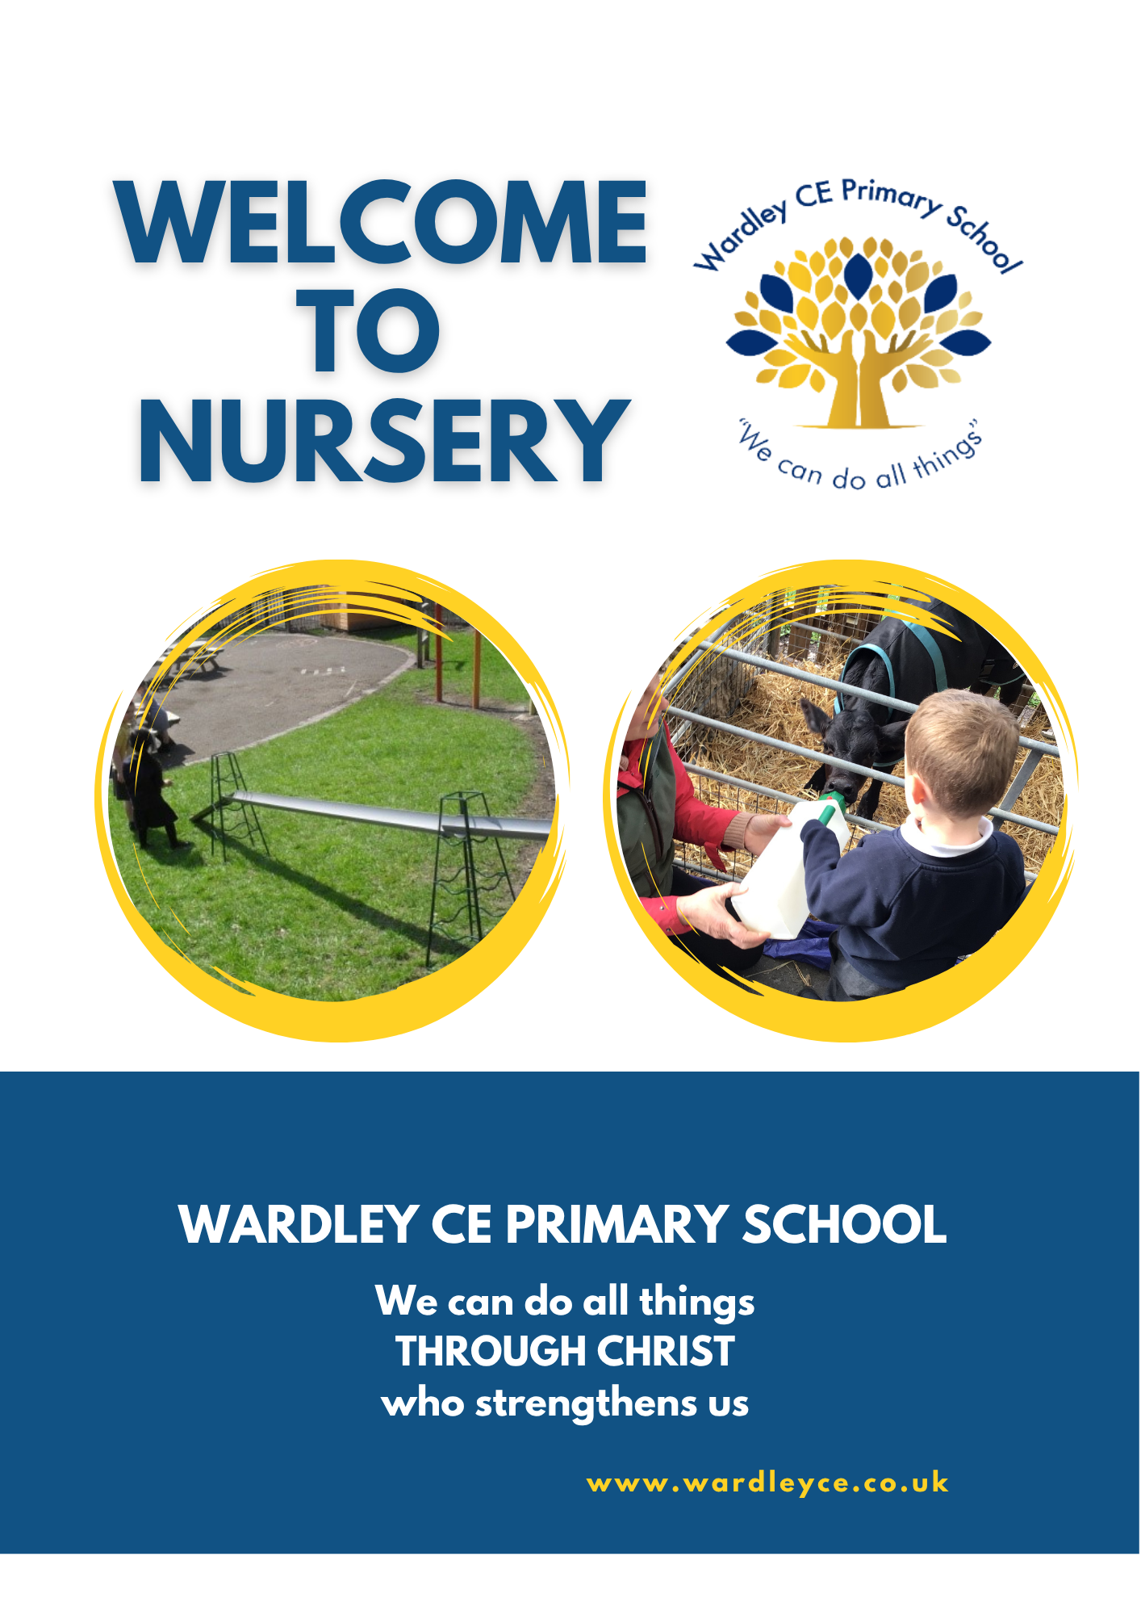

Welcome to Nursery at Wardley C of E Primary School
Starting Nursery is an exciting milestone for both children and their families. Our Nursery provides a warm, nurturing environment where children feel safe, valued and inspired to learn through play.
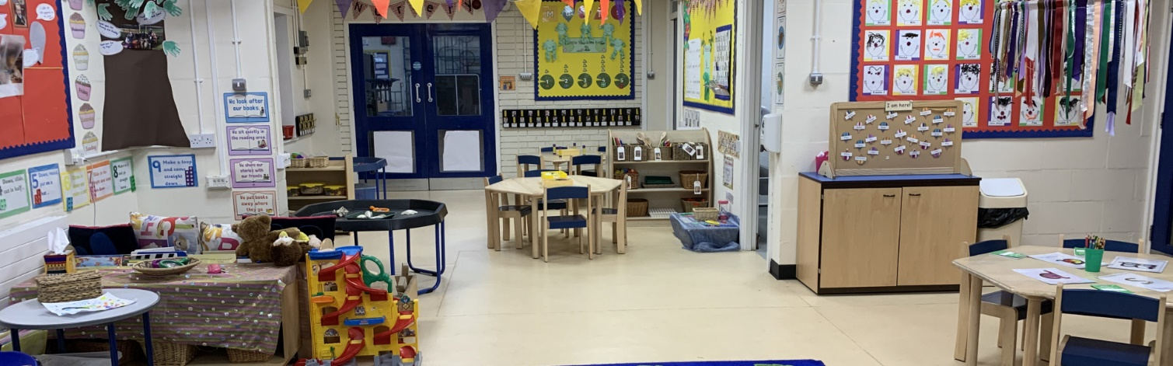

"In the early years, children make a strong start to their learning. Highly skilled practitioners swiftly establish routines that help children to feel secure and develop their independence. They design learning activities that foster children’s sense of curiosity, awe and wonder."
Ofsted, September 2025
Through play, children develop confidence, independence and curiosity, while gaining the skills and knowledge that provide a strong foundation for future learning.
Our aim is for every child to feel happy, secure and successful in Nursery. We provide engaging learning experiences that encourage children to explore, achieve and enjoy their learning.
This booklet contains information to help you and your child feel welcome and prepared for Nursery life. We believe children thrive when home and school work together, and we value the important role families play in supporting children's learning and development.
If you have any questions or concerns, please do not hesitate to speak to a member of staff. We are always happy to help.
We look forward to welcoming your family and sharing this exciting year with you.
Settling In
Starting Nursery is an exciting milestone, and there are lots of simple ways you can help your child feel ready for this new adventure. Talking positively about Nursery, sharing books about starting school and discussing any worries they may have can help build confidence. Sometimes children worry about being in a new environment, meeting new adults or even using unfamiliar toilets – these feelings are completely normal.
You can also help your child develop some useful independence skills, such as:
• Putting on their coat and shoes
• Pulling up trousers and managing clothing
• Using the toilet and washing their hands independently
• Using a knife and fork
These self-help skills help children feel confident and successful as they settle into Nursery, and we continue to support and develop them throughout the year.

Every child settles at their own pace. A positive, confident goodbye and reassurance that you will return at the end of the session can make a big difference. Our experienced staff are always on hand to provide comfort, encouragement and support as your child begins their Nursery journey.

You can find lots of information, tips and advice about helping your child with their transition into primary school on the CBeebies website:
https://www.bbc.co.uk/cbeebies/curations/starting-school-curation

Activities in the Nursery

In Nursery we follow ‘The Early Years Foundation Stage’ which continues into and ends in the Reception Class before commencing Year 1.

The EYFS principles are grouped into four themes:
A Unique Child
Positive Relationships
Enabling Environments
Learning and Development
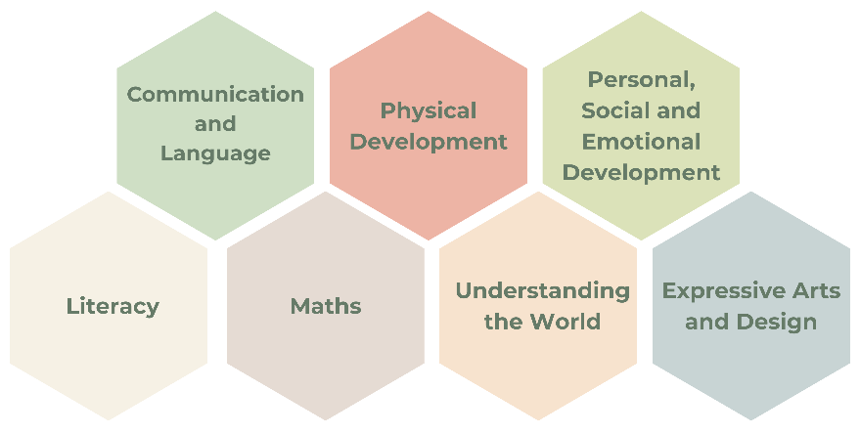
Through carefully planned play-based experiences, children develop skills across seven areas of learning:

- Prime areas which are foundational and essential for all future development:
  - Personal, Social and Emotional Development
  - Communication and Language
  - Physical Development
- Specific areas which help children to develop essential knowledge and practical skills for a broad curriculum
  - Literacy
  - Mathematics
  - Understanding the World
  - Expressive Arts and Design
These areas are woven into everything we do, helping children grow into confident, curious and independent learners.
Play

Play underpins everything we do in Nursery; it is the way young children learn - through enjoyment and challenge.
Why Play Matters
Play is at the heart of everything we do in Nursery. Through play, children:
- Develop confidence and independence
- Build friendships and learn to cooperate
- Explore ideas and solve problems
- Practise language and communication skills
- Develop creativity and imagination
- Learn about the world around them
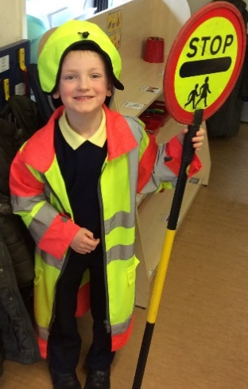
Our staff carefully support and extend children's play to help them learn and grow every day.

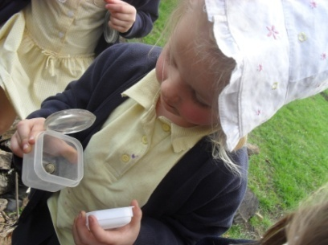

Our staff carefully support and extend children's play, providing engaging experiences that build on their interests, knowledge and experiences. We aim to create a stimulating environment where every child feels valued, develops confidence and enjoys learning.

Nursery Snacks

All Nursery children are provided with a mid-afternoon snack of fruit (such as apples, pears, bananas, oranges, tomatoes) and a carton of milk (without added fluoride).
Milk is free for Nursery children.

In addition, each child needs a plastic water bottle that you should bring in daily, containing fresh water only. Juice/ flavoured water is not permitted.

Lunch

We encourage all children to have a school lunch. Lunch-time is a very social occasion – we help the children to develop their use of cutlery, and encourage them to try a broad variety of food.

Dinner money is payable on a weekly basis on a Monday morning. We are a cashless school so all payments should be made via the School Gateway at www.schoolgateway.com.

Children are also welcome to have a healthy packed lunch. Here is some guidance to help pack your child a healthy and nutritious lunch.

https://www.nhs.uk/healthier-families/recipes/healthier-lunchboxes/

Please do not include fizzy drinks, glass bottles, sweets or large chocolate bars in their packed lunch. For health and safety reasons, we are a no-nuts school so we request that no nuts are included.

If you think that you may be eligible for free meals, please contact the school office.

Dressing for Nursery

Wardley C of E Primary School uniform is navy blue with a white polo shirt. The school sweatshirt features the school logo. Our full school uniform can be purchased from: https://www.mclellanclothing.com/
or
You can visit Whittakers School Wear in Swinton

Clothes that are easy for your child to manage are the most practical. During the learning process both indoors and out, clothes can get messy and dirty. Velcro-fastening shoes are recommended as they help children become more independent.

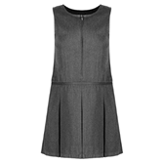






Pump bags

Please send a named drawstring pump bag, as opposed to a backpack, as storage space is limited and larger backpacks cannot be accommodated. Please put a spare set of clothing in this bag in case of accidents (including multiple sets of underwear and socks).

The children do not need a P.E. kit in Nursery.
Behaviour in the Nursery
We help children learn how to be kind, respectful and responsible members of our Nursery community. Positive behaviour is encouraged through praise, encouragement and clear expectations.
Our Golden Rules are:
• We work hard
• We are gentle
• We are kind and helpful
• We are honest
• We listen
• We look after property
We encourage children to use good manners, share their feelings and seek help from an adult when needed. Any concerns are dealt with calmly and sensitively, and we work closely with parents to support every child to make positive choices.

Jewellery
In line with the rest of the school, jewellery is not permitted in the Nursery for reasons of safety. If your child has pierced ears, please ensure your child only wears studs and no hooped earrings.

Contact Information
It is vital that the Nursery staff have day-time contact telephone numbers for yourself and a relative or friend in case your child is ill or has an accident during the day. If you change any of these telephone numbers, address or work place during the year, please let us know as soon as possible in writing.

Collection of children
Using the ‘Collection Permission’ form, please let us know the adults who have your permission to collect your child from school. Please note that all named adults must be aged 18 or over. If, for any reason, someone else has to come, please let us know in advance, either in the morning or by phoning the school. We can then reassure your child about who will be picking them up. If we have not been told of a change, we may have to contact you before allowing your child to leave Nursery – in the interest of safety.

Nursery times
Nursery doors open at 8.40am to provide an opportunity for you to speak to your child’s teacher.
- The Nursery day begins at 8.50am.
- The morning session ends at 11.30.
- Lunch time begins at 11.30am.
- Our afternoon session begins at 1.00pm.
- The Nursery day finishes at 3.05pm.

We hope that this booklet has answered some important questions which you may have had about the Nursery. If you require any further information, please contact the school on 0161 537 0383.

And finally…
We are confident that your child will settle happily into Nursery and enjoy all the exciting opportunities that lie ahead.
We understand that starting Nursery can be a big step for both children and parents. If your child is upset when you leave, our experienced staff will comfort and support them, and we will endeavour contact you for your reassurance. Please remember that children often settle quickly once they become engaged in play and activities.
Our team is always happy to answer questions, discuss concerns or celebrate successes with you. Together, we look forward to making your child's first year at Wardley C of E Primary School a happy, successful and memorable one.

