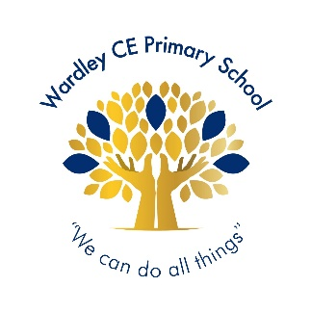
Wardley CE Primary School
‘With God’s love we enjoy and excel’
Celebration -Shout Out

Nursery | Pearlly
Reception | Margot
Year 1 | Oliver
Year 2 | Johanna
Year 3 | Aurora
Year 4 | Letty
Year 5 | Freddie T
Year 6 | Mollie




Year 1 | Essie
Year 2 | Ada G
Year 3 | Roman
Year 4 | Daisy
Year 5 | Blake
Year 6 | Ellie-Mae


Handwriter of the Week

For knowing how to be a good friend and enjoy healthy relationships
Year 1 – David, Noel, Hudson B, Hudson N, Breyah, Ella, Poppy, Orrin, Saul, Penny-May, Stanley, Archie, Mirha, Ayda
Year 2 – The whole class
Year 3 – The whole class
Year 4 – Olivia, Jeevan, Koby, Kiudrian, Mia, Lyanna, Lottie, Leah, Ollie
Year 5 – Freddie T, Delilah, Blake, Theo, Finn, Mila, Poppy, Malak, Niamh, Seth, Grace
Year 6 – Sienna, Amelia D, Beckett, Anna, Dominic, Finlay, Kayal, Eleanor, Ellie-Mae, Elliott, Ellis, Angus, Ava E

Jigsaw Stars

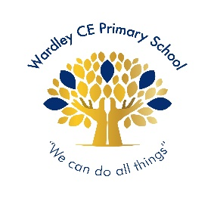
Wardley Way Awards

Well done to the following children for achieving their gold award:
Year 3: Sienna, Alecia

Gold Award

Well done to the following children for achieving their silver award:
Year 5: Blake

Silver Award

Well done to the following children for achieving their bronze award:
Year 5: Emelye

Bronze Award

Headteacher’s Special Awards

Year 1: Bobby for always sharing his wonderful thoughts and ideas.
Year 2: Jayden & Ada for dedication and effort towards their Home Worship Books.
Year 3: Kaytee for a fantastic week in school.
Year 4: Rosebud & Alex for their fantastic start to the Ancient Egypt topic.
Year 5: Malak for her amazing improvement in reading
Year 6: Freddie for his positivity and courage
Elliott for his fabulous comprehension skills.

