
Climate Action Plan


Wardley CE Primary School

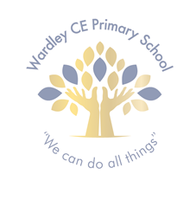
‘Be a friend to nature’

At Wardley CE Primary School, we believe that small actions can lead to big changes, and we're excited to take steps toward a greener, more sustainable future. Our Climate Action Plan is all about creating a positive impact on the environment while inspiring our students, staff, and families to work together for a cleaner, healthier world.


From reducing waste to saving energy, we are committed to making eco-friendly choices that will benefit not only our school but the community around us. By embracing these efforts, we hope to encourage everyone at Wardley CE Primary School to become climate champions and help build a brighter, more sustainable tomorrow.
The Ethos Committee 2025/2026:
Gabriel, Grace, Lottie, Mia, Ese, Mrs Walker & Mr Gettins

Decarbonisation
Outdoor Lessons

Deliver some lessons outside
Outdoor lessons provide pupils with fresh air and a change of scenery while reducing reliance on indoor lighting and heating. Whether it’s reading in a shaded area, conducting science experiments outside, or using school gardens for hands-on learning, outdoor education fosters engagement and sustainability awareness.

Run a switch off campaign
Switch Off Campaign
switch-off campaign raises awareness about energy consumption and encourages simple behavioural changes to reduce waste. Our school will run competitions, put up reminder posters, and conduct audits to track energy savings. Engaging pupils through classroom discussions and real time energy monitoring can make energy efficiency a long-term habit. Class competitions to check that lights and monitors are switched off will gain classes gain points. We are, ‘Light Savers!’



Adaptation & Resilience
Water Conservation Strategy

Develop a Water Conservation Strategy
Wardley CE Primary School will adopt water-saving measures such as dual-flush toilets, drought-resistant landscaping, and leak monitoring systems. We will also run a ‘turn the tap off’ campaign. Educating students on responsible water use can further enhance conservation efforts.

Switch to Recycled Paper

Switch to Recycled Paper for Printing
School can significantly reduce our environmental impact by switching to recycled or FSC-certified paper for printing. Recycled paper manufacturing requires less water and energy compared to virgin paper, reducing carbon emissions. Schools should also consider digital alternatives to minimise paper use.
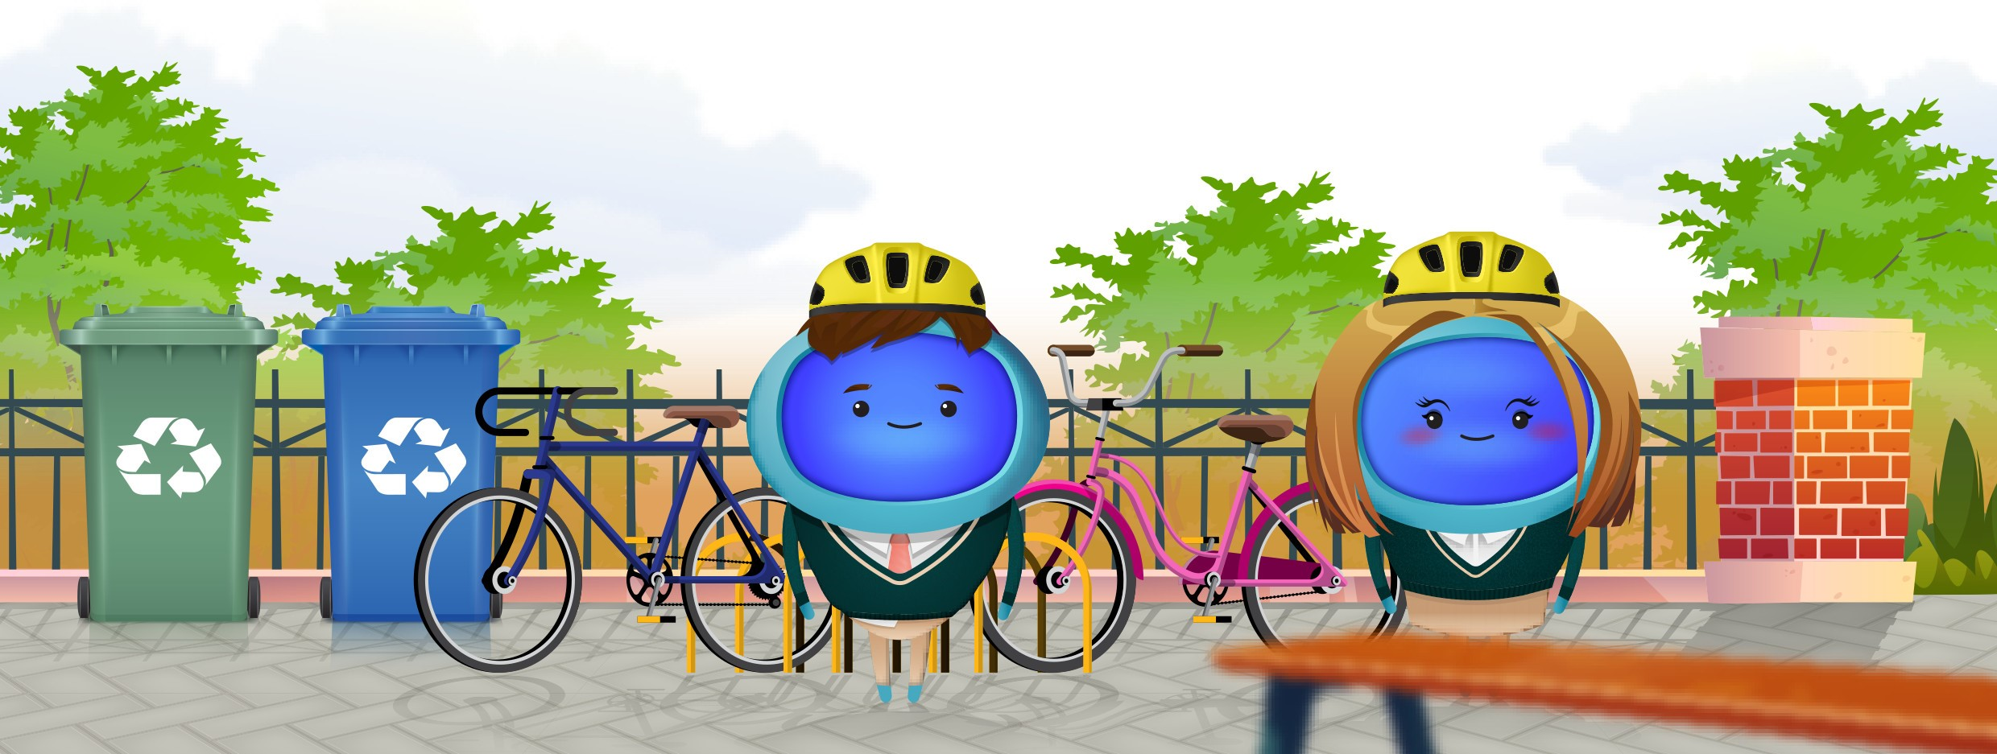
Nature & Biodiversity
Participate in the RSPB Birdwatch

Participate in the RSPB Birdwatch
We will engage pupils in the Royal Society for the Protection of Birds (RSPB) Birdwatch, an annual citizen science event where participants record and report bird sightings. This initiative helps develop observation skills, raises awareness of biodiversity, and contributes valuable data for conservation efforts. We can also integrate this activity into science and geography lessons to reinforce learning.

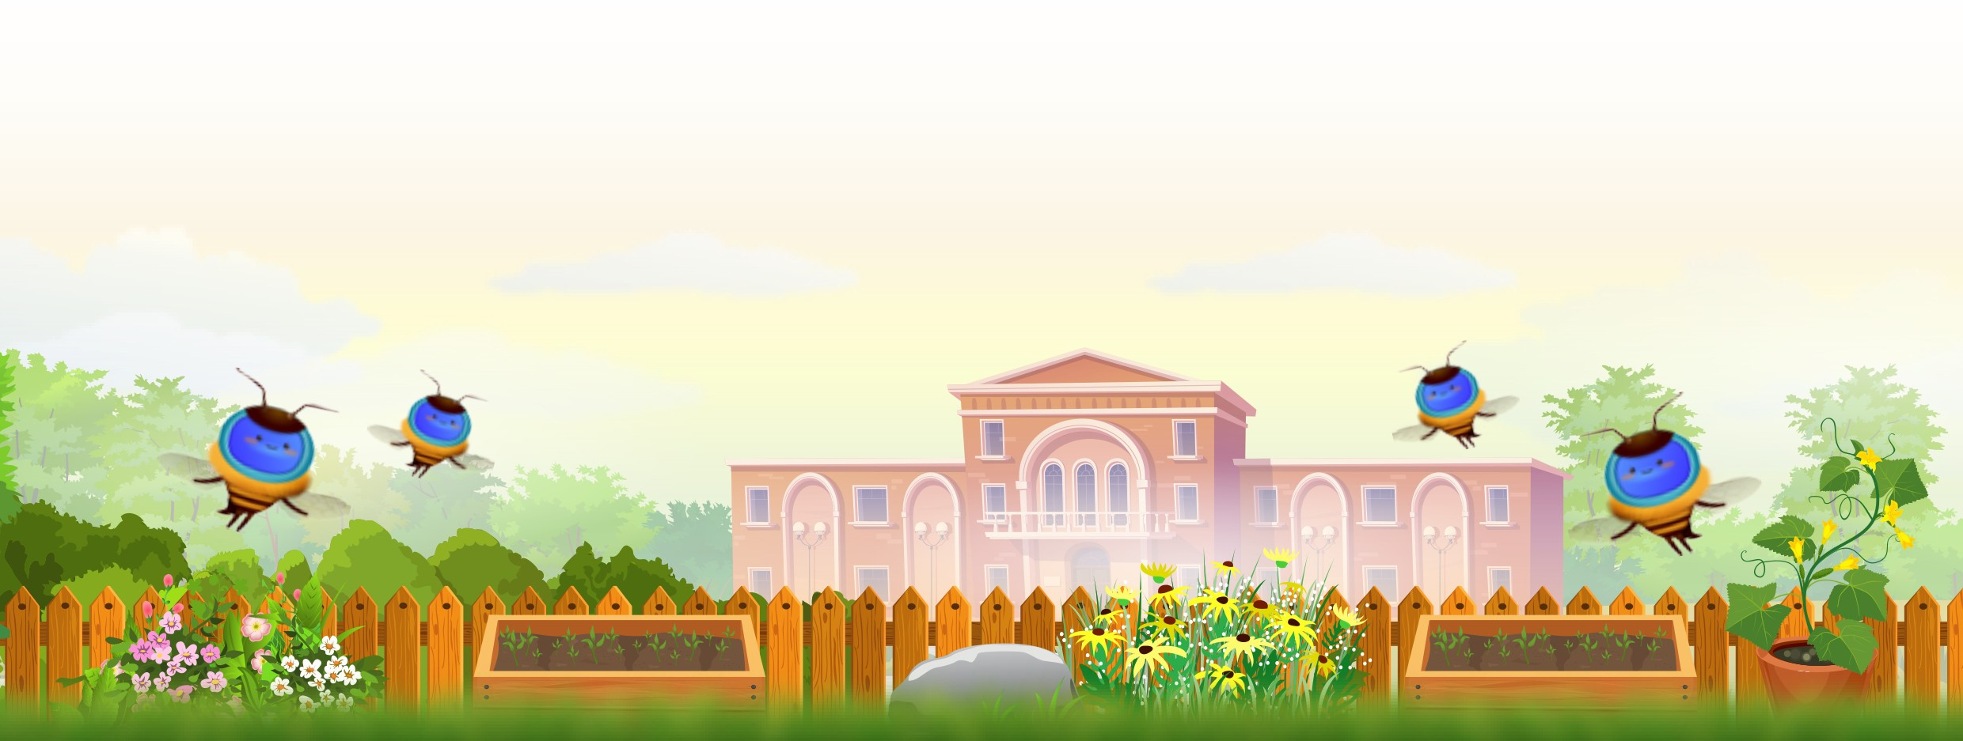
Not star
A gardening club will provide our pupils with hands-on experience in growing flowers, vegetables and trees while also teaching them about sustainability, soil health and biodiversity. Gardening improves mental well-being, fosters team work and enhances outdoor learning opportunities. Our school can use God’s Garden to beautify the environment and engage pupils in long-term eco-friendly initiatives.

kvkgvhkfjrjg

Gardening Club

Climate Education
We will encourage pupils and staff to walk, bike, car pool or use public transport instead of driving to school over the course of a week. Using these methods to get to school instead of driving can reduce emissions and improve local air quality. A walk to school week helps raise awareness about the environment and the health benefits of active travel.
Our Ethos Committee will host a sustainability-themed assembly each term to ensure the pupils in our school remain engaged with environmental topics. These events will involve pupil-led presentations and school-wide challenges to encourage everyone’s participation. Assemblies will help to build a culture of sustainability and reinforce its importance throughout the school community.
Walk to School Week
Sustainability Themed Assembly each term

