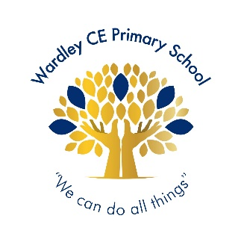
Wardley CE Primary School
‘With God’s love we enjoy and excel’
Celebration -Shout Out

Nursery | Aleia
Reception | Mollie
Year 1 | Lenny
Year 2 | Unique-Praise
Year 3 | Harlie
Year 4 | Eva
Year 5 | Finn
Year 6 | Ava E




Year 1 | David
Year 2 | Lucas
Year 3 | Emily
Year 4 | Jeevan
Year 5 | Mila
Year 6 | Freddie


Handwriter of the Week

For thinking about everyone’s right to learn.
Year 1 – Ayda, Rory, Stanley, Lottie, Penny, Lenny, Hudson N, Oliver, Tommy, Saul, Hudson B, Noel, Poppy
Year 2 – Noah, George, Anaya, Lucas, Evelyn, Anna, Johanna, Lily, Kavin, Alfie, Daisy
Year 3 – Olivia, Oakley, Mia, Emily, Reece, Anais, Holly, Alex, Sienna, Oscar, Jude, Matilda, Harlie, Megan
Year 4 – Kuidrian, Leah, Georgie, Lottie, Lyanna, Prescious-Jewel, Mia, Alex
Year 5 – Seth, Niamh, Oscar Sn, Lola, Theo
Year 6 – Freddie, Vincy, Alexis, Ava E, Ava-Leigh, Beckett, Eleanor, Oscar

Jigsaw Stars

Headteacher’s Special Awards

Year 1: Mirha and Breyah for being super scientists.
Year 3: Willow & Roman for their great listening and learning.
Olivia for her fabulous RE work about God.
Alecia for being a PE superstar.
Year 4: Koby for being kind and sensible at swimming.
Year 5: Mila for her super writing when writing a formal letter.
Year 6: Gabriel for his superb contributions to all class discussions.
Anna for her outstanding maths work.

