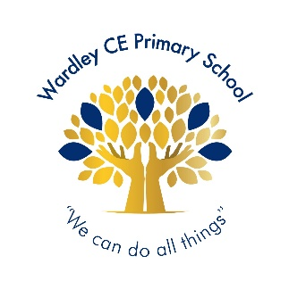
Wardley CE Primary School
‘With God’s love we enjoy and excel’
Celebration -Shout Out

Nursery | Arabella
Reception | Rory
Year 1 | Omar
Year 2 | Roman
Year 3 | Alex
Year 4 | Mila
Year 5 | Amelia
Year 6 | Danielle




Year 1 | Noah
Year 2 | Elliott
Year 3 | Ollie
Year 4 | Anson
Year 5 | Sienna
Year 6 | Emily


Handwriter of the Week

For knowing how to keep calm and deal with difficult situations.
Year 1 – Emilia J, Lucas, Reema, Lexi, Rueben, Evelyn, Kavin, Rudi, Anna
Year 2 – Anais, Alex, Sienna, Jude, Harlie, Oakley, Mia
Year 3 – Jeevan, Eva, Leah, Koby, Olivia, Prescious-Jewel, Olivia, Savannah, Ollie, Alex, Georgie, Mia
Year 4 – Lucy, Blake, Poppy, Grace, Darren, Lola, Seth
Year 5 – Ellis, Kayal, Alexis, Backett, Yas, Eleanor, Dominic, Megan, Ava E, Kyron, Courtney, Anna
Year 6 – Danielle, Charlie, Ben, Phoebe, Joe, Suraya, Charlotte, Emily, Sienna, Ralph, Thea

Jigsaw Stars

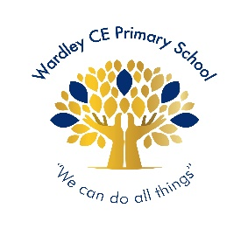
Wardley Way Awards

Well done to the following children for achieving their gold award:

Gold Award

Well done to the following children for achieving their silver award:
Y5: Mollie Y4: Grace & Arthur
Y3: Letty Y2: Anais & Willow

Silver Award

Well done to the following children for achieving their bronze award:
Y5: Dominic, Ellie-Mae, Angus & Finlay

Bronze Award

Headteacher’s Special Awards

Year 5: Beckett for his superb writing.
Ava for her super science work.
Year 4: Rafeef & Freddie T for their wonderful haiku poem.
Year 1: Lexi for being such a fantastic pupil in class.

