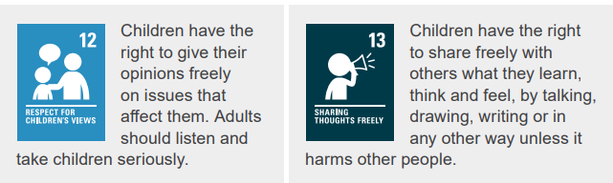
One Voice
19.10.26
Welcome and gathering
Welcome all the children to One Voice.

Ask children if they would like to share one thing that they enjoyed learning about last week

Introduce theme:
“Today we are thinking about Love”

Thought/story/scripture
Share this Bible verse with the children
“1 Corinthians 13:4-7 – “Love is patient, love is kind. It does not envy or boast. It always protects, always trusts, always hopes, always perseveres.”
Story:
The Good Samaritan (Luke 10:25-37) – Loving others means helping anyone in need, even people who are different from us.
Who do you think was a good neighbour in the story? Why?

Reflection
Ask children to sit quietly for a few seconds and think about the reflection question
Reflection questions
- Who can you show love to today?
- How can you show love through your words or actions?

Short prayer
“Dear God,
Thank You for loving me. Help me to love others the way You love me—kindly, patiently, and with a big heart. Teach me to see the good in everyone and to share love through my words and actions.
Amen.”

News
Rights Respecting

Thank you to the new rights rangers, please let your One Voice group know why you wanted to be a ranger! What are children's rights?

Children’s rights are things that every child needs to be safe, healthy, happy and able to learn and grow. Every child has rights, no matter who they are or where they come from.There are the ABCDE of rights to help us remember this, do you know what these are?
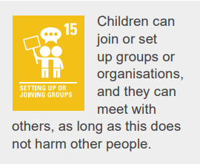
A- ALL children have rights (universal)
B- Children have rights at BIRTH (inherent)
C- Rights CANNOT be taken away (inalienable)
D- Rights DO NOT have to be earnt (unconditional)
E- Rights are all equal (indivisible)

These will be given to every teacher today to display in each classroom.You will also see some more large posters appearing around the school- Let's get talking about rights again! Rights Rangers will meet today at 1pm in Ms Gallienne's room.

Christmas Choir

Mrs Rainey will be running a Christmas themed choir for Key Stage 2 children after half-term, meeting on Monday or Tuesday after school.
There will be opportunities to perform in the community, for example, at the Christie Hospital and local care homes.

Science equipment
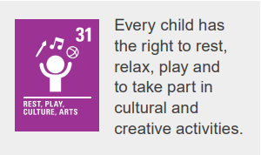
Unfortunately, some children have not been looking after our science equipment and therefor Miss Edwards won’t be adding anything new to the cupboard this week. Hoe can we make sure that the equipment is taken care of?

Dates
21.10.26 – National apple day, what is you favourite fruit?
21.10.26 – Halloween is during the half term break and some of us will be celebrating –
Halloween is a fun time, but it is important to stay safe! Always go trick-or-treating with a trusted adult and stay with your group. Wear bright or reflective clothing so drivers can see you in the dark and remember to look both ways before crossing the road. Never enter a stranger’s house or car and always ask an adult to check your sweets before eating them. Be careful around candles and lit pumpkins, and most importantly, be kind and respectful to others. Have a happy and safe Halloween!

Affirmation of the day
"I choose to show love to everyone today."

