Educational visits/ celebrations/outdoor learning

- Pyramid build in forest
- Museum of Liverpool- TBC expedition on display- Liverpool Philharmonic

Physical Education
Gymnastics, Cricket
- play competitive games, modified where appropriate and apply basic principles suitable for attacking and defending
- develop flexibility, strength, technique, control and balance
- compare their performances with previous ones and demonstrate improvement to achieve their personal best.

French
At the market
Fruit and Veg, numbers to 100, at the market, recipe.

Clothes
Clothes at school, own clothes, clothes and carnival.
PSHE and Citizenship
- Y6 My Happy Mind - Appreciate Relate
- No Outsiders - The Island & A Day in the Life of Marlon Bundo
- Awareness Events - Jan RSPB’s Big Schools’ Birdwatch
Feb LGBT+ History Month
Mar Neurodiversity Celebration Week
World Book Day
April World Health Day
Mathematics
- Fractions, Decimals and Percentages
- Y6 Ratio Y5 Fractions
- Y6 Algebra Y5 Percentages
- Geometry - Properties of Shape & Position and Direction

English
Selfish Giant by Oscar Wilde and Ritva Voutila
Outcome - Classic fiction & Explanation

Island and Jemmy Button
Outcome- Narrative and persuasive writing

Poetry
The Sea
A variety of poems are explored linking to the theme of the sea outcome of a narrative poem linked to a journey across the sea
Reading for Pleasure Texts
Secrets of a Sun King - Emma Carroll
The Explorer by Katherine Rundell,
Computing

Y6 Variables in games
- Design, write and debug programs that accomplish specific goals, including controlling or simulating physical systems; solve problems by decomposing them into smaller parts
- Use sequence, selection, and repetition in programs ;work with variables and various forms of input and output
- Use logical reasoning to explain how some simple algorithms work and to detect and correct errors in algorithms and programs
- Select, use and combine a variety of software (including internet services) on a range of digital devices to design and create a range of programs, systems and content that accomplish given goals, including collecting, analysing, evaluating and presenting data and information
- Use technology safely, respectfully and responsibly; recognise acceptable/ unacceptable behaviour; identify a range of ways to report concerns about content and contact

Y6 Introduction to spreadsheets
- Select, use and combine a variety of software (including internet services) on a range of digital devices to design and create a range of programs, systems and content that accomplish given goals, including collecting, analysing, evaluating and presenting data and information

Geography
- Locate the world’s countries, using maps and focussing on their environmental regions and key physical characteristics.
- Use maps, atlases, globes and digital/computer mapping to locate countries and describe features.
- Describe and understand key aspects of physical and human geography.
Science

Y6 Animals including humans
- identify and name the main parts of the human circulatory system, and describe the functions of the heart, blood vessels and blood
- recognise the impact of diet, exercise, drugs and lifestyle on the way their bodies function
- describe the ways in which nutrients and water are transported within animals, including humans.

Art and Design
Sculpture inspired by Ancient Egyptian Wall Art and Canopic Jars
Artist in Focus: Jean-Michel Basquiat
- Improve their mastery of art and design techniques including sculpture and painting with a range of materials.

Music
Make you Feel My Love Y5
Style: Pop Ballads
Topic and cross-curricular links: Historical context for ballads.

You've Got a Friend Y6
Style: The Music of Carole King
Topic and cross-curricular links: Her importance as a female composer in the world of popular music.

Reading Units
The Happy Prince and Other Tales by Oscar Wilde
Genre – Fiction: classic
The Explorer by Katherine Rundell,
Genre – Information, Fiction: contemporary

Design and Technology
Electrical systems more complex switches and circuits
Product: Design, make and evaluate an alarm for a valuable Egyptian artefact for a museum curator for security.
Designing
• Use research to develop a design specification for a functional product that responds automatically to changes in the environment. Take account of constraints including time, resources and cost.
• Generate and develop innovative ideas and share and clarify these through discussion.
• Communicate ideas through annotated sketches, pictorial representations of electrical circuits or circuit diagrams.
Making
• Formulate a step-by-step plan to guide making, listing tools, equipment, materials and components.
• Competently select and accurately assemble materials, and securely connect electrical components to produce a reliable, functional product.
• Create and modify a computer control program to enable an electrical product to work automatically in response to changes in the environment.
Evaluating
• Continually evaluate and modify the working features of the product to match the initial design specification.
• Test the system to demonstrate its effectiveness for the intended user and purpose.
• Investigate famous inventors who developed ground-breaking electrical systems and components.

History
- the achievements of the earliest civilizations – an overview of where and when the first civilizations appeared and a depth study of one of Ancient Egypt
- Know and understand significant aspects of the history of the wider world: the nature of ancient civilisations; characteristic features of past non-European societies.
- Gain historical perspective by placing their growing knowledge into different contexts, understanding the connections between short- and long-term timescales.
- Understand the abstract term ‘civilisation’.
Religious Education
- How do Sikhs worship?
- What does it mean to belong in a religiously diverse world? Project work with partnership schools.
Cycle A Spring
Class 4
Ancient Egypt
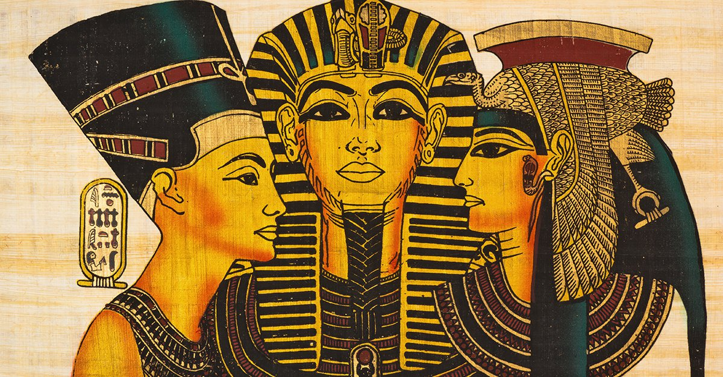
Who were the Ancient Egyptians?

