Music
Dancing In The Street Y5
Style: Motown
Topic and cross-curricular links: The history of Motown and its importance in the development of Popular music. Civil rights.
Reflect, Rewind and Replay Y6
Style: Western Classical Music and your choice from Year 6
Topic and cross-curricular links: Think about the history of music in context, listen to some Western Classical music and place the music from the units you have worked through, in their correct time and space. Consolidate the foundations of the language of music.

French
Out of this world
Space travellers planets, space travel

Going to the seaside
Come to the beach, pack the beach bag, sand castle pictures.

Science
Y6 Evolution and Inheritance
- recognise that living things have changed over time and that fossils provide information about living things that inhabited the Earth millions of years ago
- recognise that living things produce offspring of the same kind, but normally offspring vary and are not identical to their parents
- identify how animals and plants are adapted to suit their environment in different ways and that adaptation may lead to evolution.

Y6 Living things and their Habitats
- describe how living things are classified into broad groups according to common observable characteristics and based on similarities and differences, including micro-organisms, plants and animals
- give reasons for classifying plants and animals based on specific characteristics.

Art and Design
Painting: Henri Rousseau
Drawing – Frida Kahlo Self Portraits and Manjit Thapp My Head is a Jungle
- to create sketch books to record their observations and use them to review and revisit ideas
- to improve their mastery of art and design techniques, including drawing, painting and sculpture with a range of materials
- about great artists

Computing

Y6 3D modelling
- Select, use and combine a variety of software (including internet services) on a range of digital devices to design and create a range of programs, systems and content that accomplish given goals, including collecting, analysing, evaluating and presenting data and information
- Use technology safely, respectfully and responsibly; recognise acceptable/unacceptable behaviour; identify a range of ways to report concerns about content and contact

Y6 Sensing
- Design, write and debug programs that accomplish specific goals, including controlling or simulating physical systems; solve problems by decomposing them into smaller parts
- Use sequence, selection, and repetition in programs ;work with variables and various forms of input and output
- Use logical reasoning to explain how some simple algorithms work and to detect and correct errors in algorithms and programs
- Select, use and combine a variety of software (including internet services) on a range of digital devices to design and create a range of programs, systems and content that accomplish given goals, including collecting, analysing, evaluating and presenting data and information

Reading for Pleasure Texts
The Explorer- Katherine Rundell
Millions by Frank Cottrell-Boyce
Educational visits/ celebrations/outdoor learning
- Residential to Waddow Hall
- Compare our woods to the rainforest

English
King Kong by Anthony Browne
Outcome - Revision

Plastic Planet By Georgia Amson-Bradshaw
Outcome: Persuasive speech

Poetry
Sonnets: The View from a Hot Air Balloon
Sonnets are explored with a final outcome of a poem in the style of a sonnet
Physical Education
Athletics, Rounders, Swimming
- develop flexibility, strength, technique, control and balance
- use running, jumping, throwing and catching in isolation and in combination
- compare their performances with previous ones and demonstrate improvement to achieve their personal best.
- swim competently, confidently and proficiently over a distance of at least 25 metres
- use a range of strokes effectively [for example, front crawl, backstroke and breaststroke]
- perform safe self-rescue in different water-based situations.
PSHE and Citizenship
- Y6 My Happy Mind - Engage
- Alien Nation - Trans and Non binary identity
- Awareness Events May World Orienteering Day
- June World Refugee Day
- July Mandela Day
- First Aid
- Sex and Relationship Education

Mathematics
- Measure - Perimeter, Area, Volume and Imperial
- Y5 Time, Fractions, Decimal Percentages & Four Operations
- Y6 Consolidation

Geography
- locate the world’s countries, using maps to focus on North and South America, concentrating on their environmental regions, key physical and human characteristics, countries, and major cities
- identify the position and significance of latitude, longitude, Equator, Northern Hemisphere, Southern Hemisphere, the Tropics of Cancer and Capricorn, Arctic and Antarctic Circle
- understand geographical similarities and differences through the study of human and physical geography a region within South America
- human geography, including: types of settlement and land use, economic activity including trade links, and the distribution of natural resources including energy, food, minerals and water

Design and Technology
Aspect: Celebrating culture and seasonality
Product: Design, make and evaluate a pizza for people with special dietary needs for school dinner on a Friday.
Designing
• Generate innovative ideas through research and discussion with peers and adults to develop a design brief and criteria for a design specification.
• Explore a range of initial ideas, and make design decisions to develop a final product linked to user and purpose.
• Use words, annotated sketches and information and communication technology as appropriate to develop and communicate ideas.
Making
• Write a step-by-step recipe, including a list of ingredients, equipment and utensils
• Select and use appropriate utensils and equipment accurately to measure and combine appropriate ingredients.
• Make, decorate and present the food product appropriately for the intended user and purpose.
Evaluating
• Carry out sensory evaluations of a range of relevant products and ingredients. Record the evaluations using e.g. tables/graphs/charts such as star diagrams.
• Evaluate the final product with reference back to the design brief and design specification, taking into account the views of others when identifying improvements.
• Understand how key chefs have influenced eating habits to promote varied and healthy diets.

Reading Units
Great Adventurers by Alistair Humphreys
Genre – Information

Sky Chasers by Emma Carroll
Genre – Fiction: adventure

Brightstorm - Revision Unit
Religious Education
- What are some of the differences and similarities within Christianity locally and globally?
- What is the Kingdom of God and what do Christians believe about the afterlife?

Cycle A Summer
Class 4
Our World
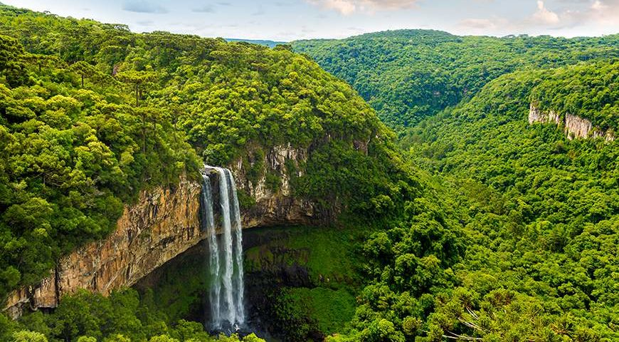
Why should we protect the rainforests?

