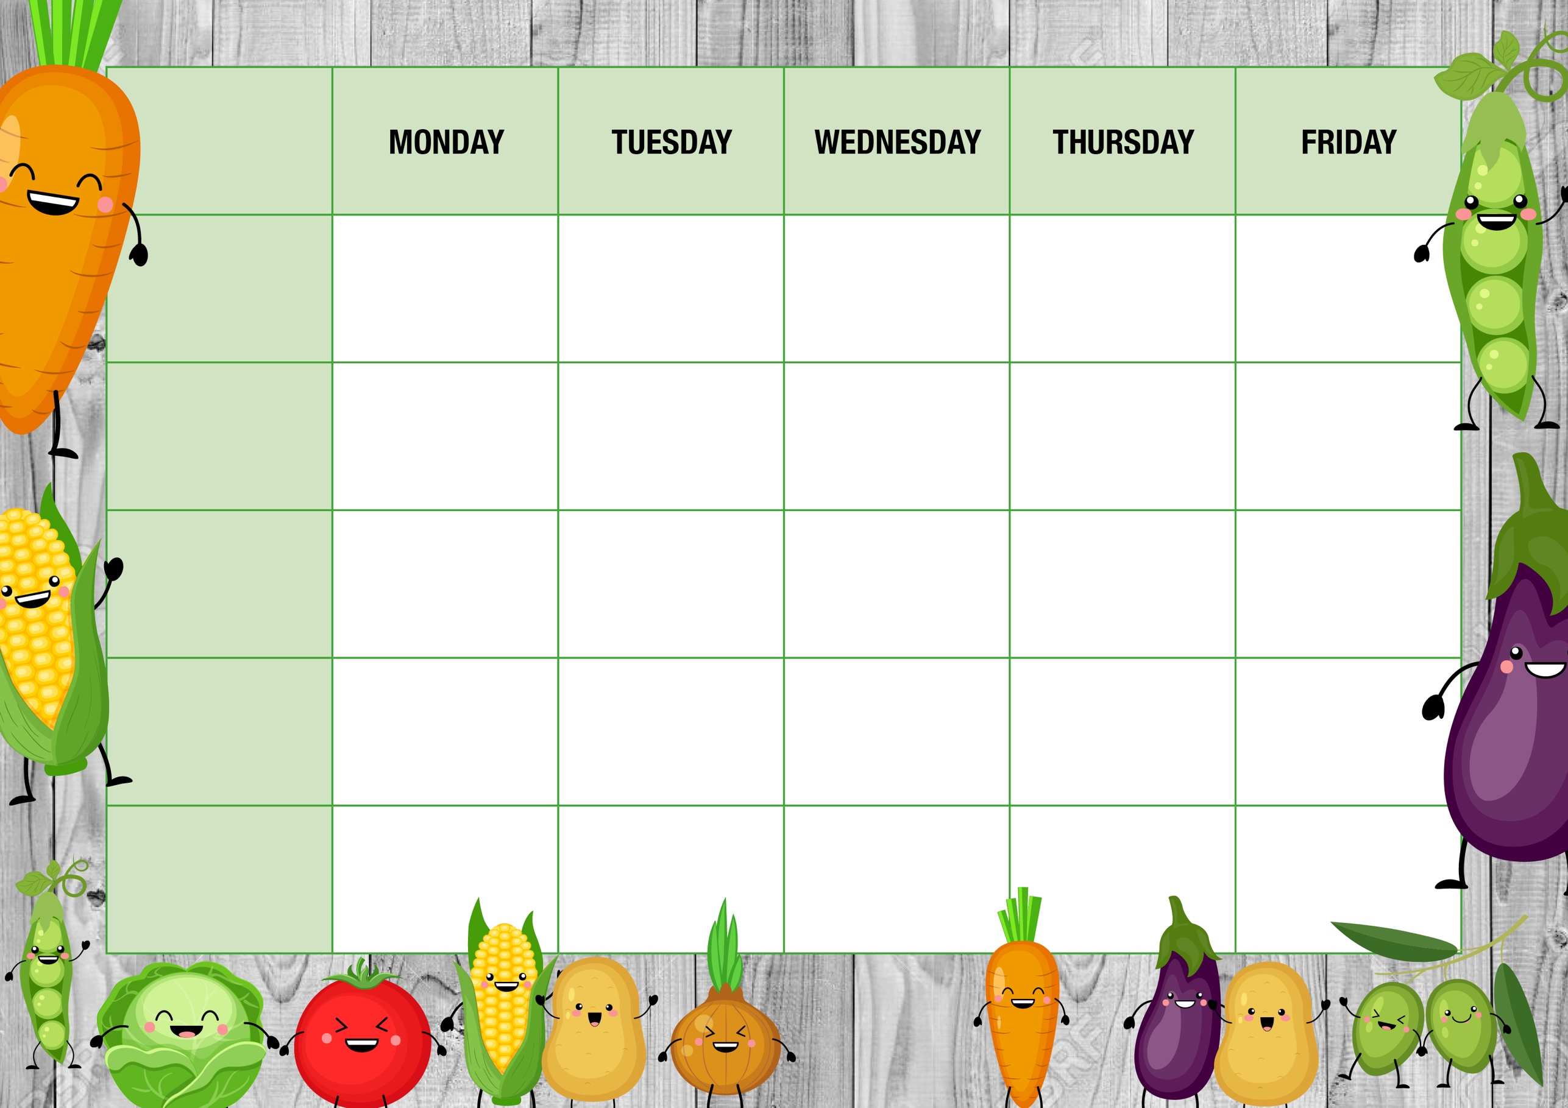
Cheese Pasty
With Chips & beans

Chicken Fajita ‘Lasagne’
With Potato Wedges, and Corn

Iced Mousse Pot

Sweet waffle with custard
Cheesy Pasta
With Garlic Bread

Breaded Chicken Burger
With Chips, peas or beans

Oven baked Sausages
Mashed Potato or Chips, Carrots, gravy
Filled Jackets
*
Assorted Sandwiches
*
Tomato Pasta

Filled Jackets
*
Assorted Sandwiches
*
Tomato Pasta

Filled Jackets
*
Assorted Sandwiches
*
Tomato Pasta

Filled Jackets
*
Assorted Sandwiches
*
Tomato Pasta

Filled Jackets
*
Assorted Sandwiches
*
Tomato Pasta
Alternatives
Quorn Dippers
Baked Potato wedges, and corn
Cheese Whirl
With Baked Potato cubes, broccoli,

Sweet Treat
of the day
Ice Cream Roll
Meat free Balls
Mashed potato or Chips, Carrots, Gravy
Shortbread Biscuit

Cheese Whirl
With Baked Potato cubes, broccoli,

Fish & Chip Fry-yay!
Fish fingers
With Chips & beans

Freshly made salad Bar
*
Fresh Fruit & Yoghurt
*
Cheese & Crackers

Freshly made salad Bar
*
Fresh Fruit & Yoghurt
*
Cheese & Crackers

Freshly made salad Bar
*
Fresh Fruit & Yoghurt
*
Cheese & Crackers

Freshly made salad Bar
*
Fresh Fruit & Yoghurt
*
Cheese & Crackers

Freshly made salad Bar
*
Fresh Fruit & Yoghurt
*
Cheese & Crackers

Main offer
WEEK TWO
Meat Free

Dessert

Every day

