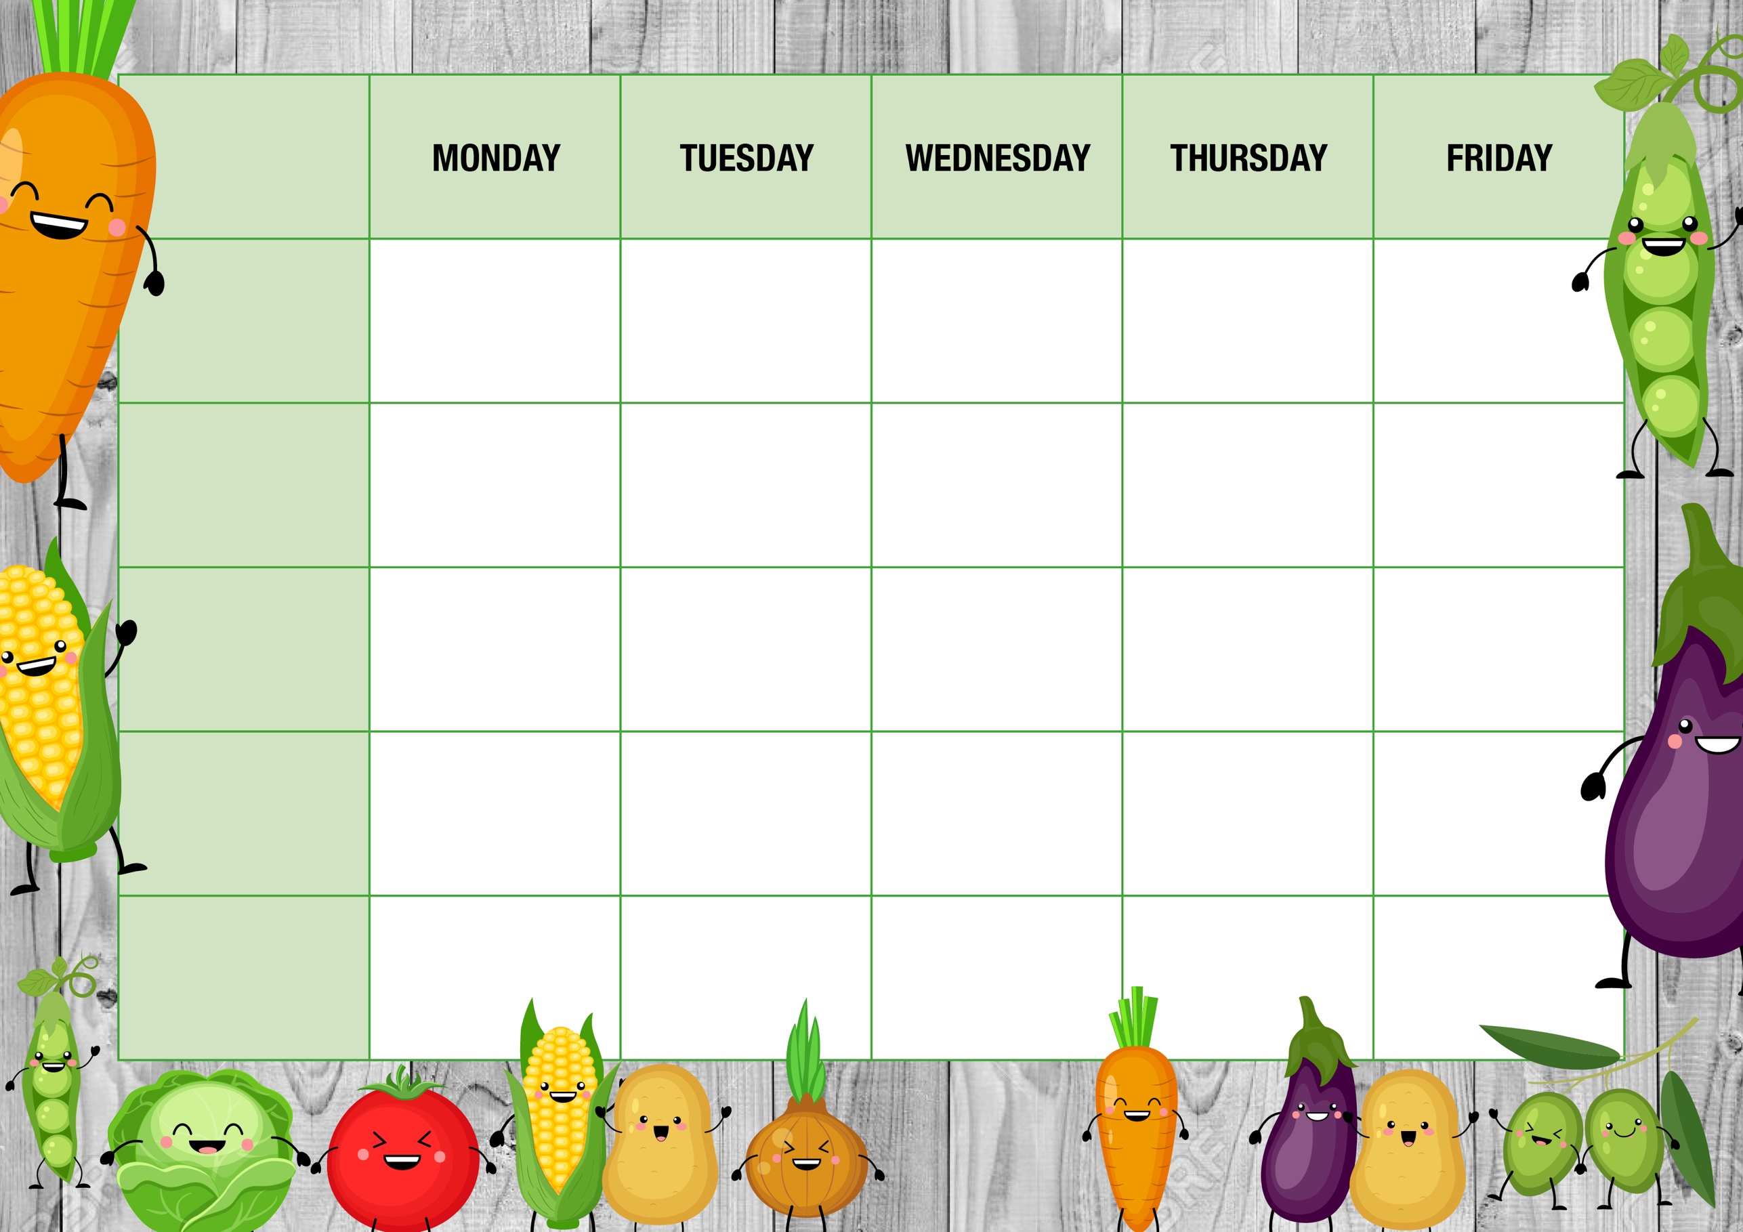
Cheese Whirl
With Chips & beans

Quorn Lasagne
With Garlic bread

Home baked cookie

Fruity Jelly
Cheese Pasty
Baked Potato cubes, Peas or beans

Chicken Curry
Steamed Rice, Pitta bread

BBQ Chicken Burger
Chips, beans or Coleslaw
Filled Jackets
*
Assorted Sandwiches
*
Tomato Pasta

Filled Jackets
*
Assorted Sandwiches
*
Tomato Pasta

Filled Jackets
*
Assorted Sandwiches
*
Cheesy Pasta

Filled Jackets
*
Assorted Sandwiches
*
Tomato Pasta

Filled Jackets
*
Assorted Sandwiches
*
Tomato Pasta
Alternatives
Quorn Dippers
Baked Potato wedges, beans, or coleslaw
French bread style Pizza Baguette
With Baked Potato cubes, corn, salad

Sweet Treat
of the day
Baked Doughnut with Custard
Southern Fried Quorn Burger
Chips, beans or Coleslaw

Shortbread biscuit

French bread style Pizza Baguette
With Baked Potato cubes, corn, salad

Fish & Chip Fry-yay!
Fish fingers
With Chips & beans

Freshly made salad Bar
*
Fresh Fruit & Yoghurts
*
Cheese & Crackers

Freshly made salad Bar
*
Fresh Fruit & Yoghurts
*
Cheese & Crackers

Freshly made salad Bar
*
Fresh Fruit & Yoghurts
*
Cheese & Crackers

Freshly made salad Bar
*
Fresh Fruit & Yoghurts
*
Cheese & Crackers

Freshly made salad Bar
*
Fresh Fruit & Yoghurts
*
Cheese & Crackers

Main offer
WEEK ONE
Meat Free

Dessert

Every day

