
Sandy Lane Nursery and Forest School
Learning Ambitions
“Nurturing curiosity and inspiring imagination”
Alongside our children making progress and developing through our carefully planned activities and their own directed play in continuous provision, following their interests and meeting their learning needs, we have some specific Learning Ambitions that we want our children to develop before they leave us for Reception. The learning goals outlined below are not an exhaustive list of everything a child will learn during their time with us, but these goals celebrate the things we think our children need to know before they continue their learning journey in Primary School.
Communication and Language
This is central to everything we do at Sandy Lane Nursery and Forest School. From different starting points children interact with our highly skilled staff who help them build strong communication and language skills which underpin all of our learning aspirations. The ability to speak, listen and communicate is essential to achieving these goals. Where we identify that children may need additional support, we use a range of suitable communication strategies and interventions to help children build their skills.
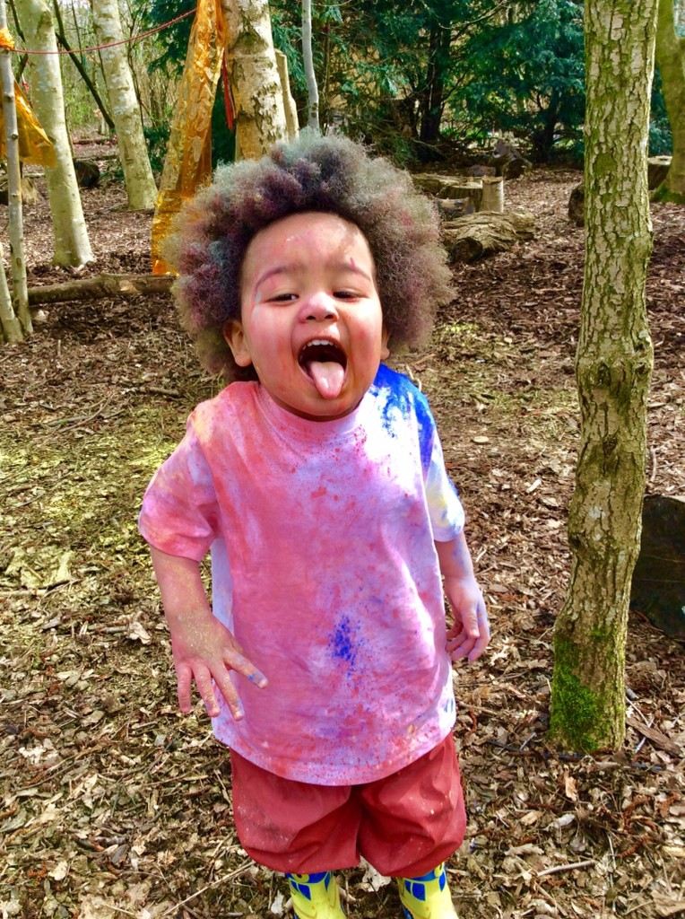
- Embracing Cultures and Traditions
Children have a strong sense of their own family and the people who are important to them and are able to talk about their family traditions. Children can also share their knowledge of cultures and traditions that are different to their own. They also understand that not all families are the same as their own.
- Solving Problems
Children engage in a range of experiences which encourage them to find solutions. These experiences include cooking and preparing snack, mixing paint, observing and exploring nature – seasons changing, observing and talking about lifecycles of living things and working collaboratively
- Love of Reading and Books
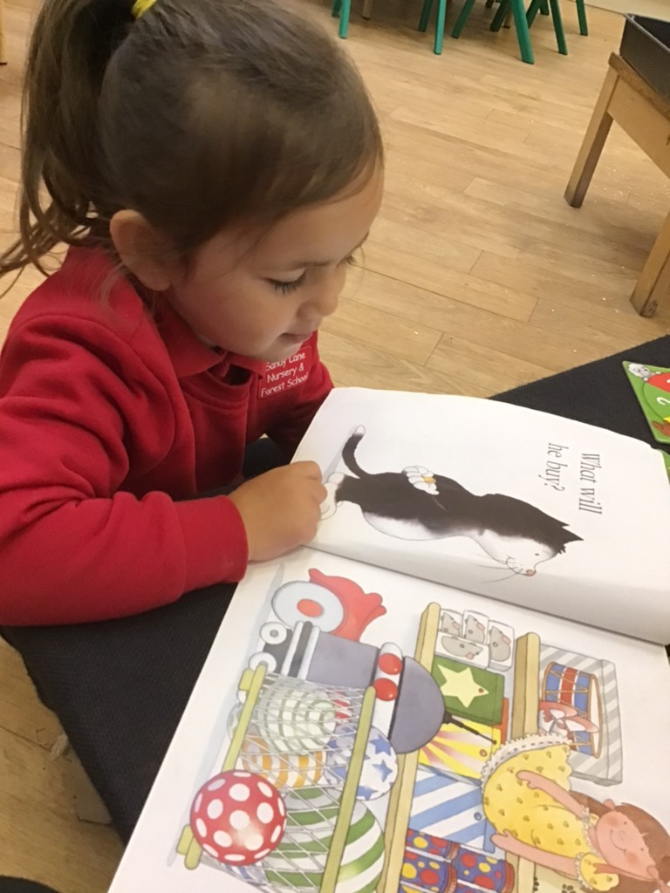
Children will be able to talk about the books they enjoy. They will have spent time sharing a wide variety of books and poems throughout the year. Children will be able to recall and describe what happens in some of the stories they are more familiar with either in conversations, through role play or using small world characters
- Sense of Self and Identity as a Confident Learner
Children are able to reflect on their learning, through reviewing photographs and their work. With adult support they will be able to talk about the processes they have engaged in. Children will be able to identify the things they are proud of and found hard and celebrate their achievements. This may be when working individually or as part of a small group.

- Be a Confident Mark Maker
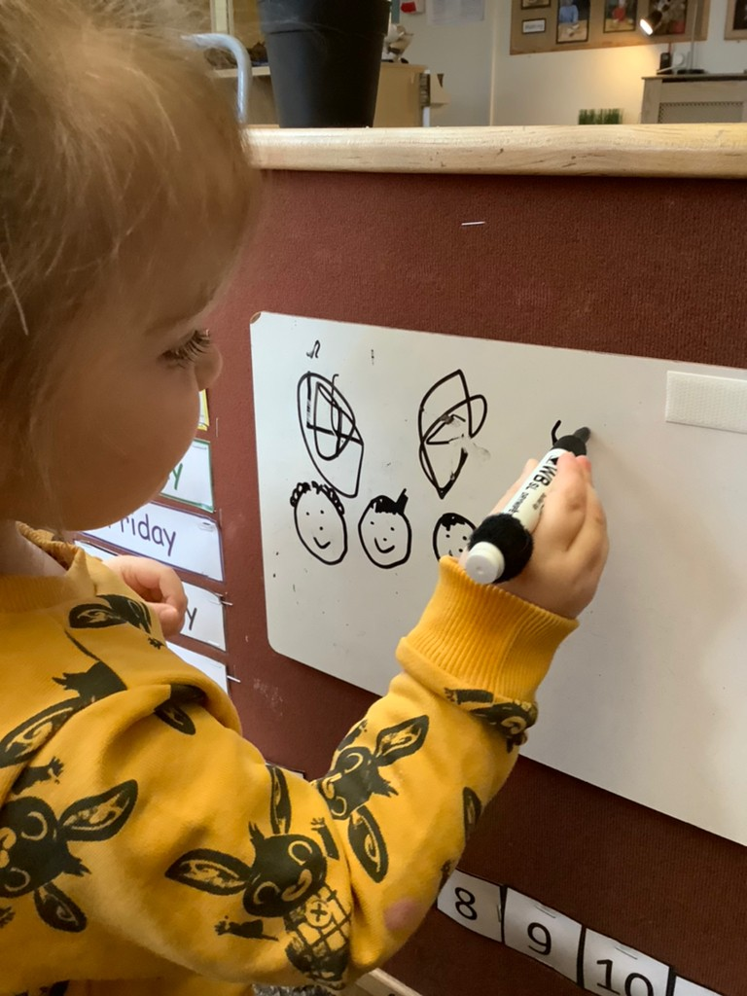
Children will be able to use a range of tools that support their interests, such as hammers in woodwork or mallets in forest school, holding scissors correctly and use them effectively to cut paper, pinching and rolling clay or play dough to make creations. Children will make marks for a range of purposes in play and talk about what these marks represent. In addition they will be able to write two recognisable letters.
- Self-Regulation and Keeping Safe
Children will be able to say how they are feeling and have an ‘emotional vocabulary’ that they can use to explain when they are ‘happy, sad, angry, excited or worried’. They will be able to demonstrate ways to self-regulate their emotions. In addition children will be able to identify how to keep themselves safe , for example in forest school and when they have ‘yucky feelings’ by identifying the three strategies: telling a trusted adult, saying no or walking away.
- Use Maths in Real Life Situations
Children will demonstrate their application of maths knowledge and vocabulary when solving real life problems including those related to size, length and weight. They will have a strong understanding of numbers up to five, to count, represent, subitise and order amounts.
- Being Physical and Keeping Healthy
Children move confidently in a range of ways and negotiate space. They are able to coordinate their bodies and show control when jumping, climbing, running, dancing, throwing, catching and kicking a ball. In addition, children are able to talk about and demonstrate some of the ways they keep healthy.
- Be a Confident Communicator
Children become confident, capable communicators who use language to express their needs, share their ideas and take part in conversations with others.
