

St. Joseph’s Catholic Primary School
Where every child is known and loved as a child of God

Mission Statement
At St. Joseph’s,
we live in faith,
grow in love and serve one another,
as children of God.

Behaviour and Engagement Policy

Document Control
Name of Policy | Behaviour and Engagement
Date approved and adopted | September 2025
Updated | February 2026
Date to be reviewed | February 2027

Our vision at St Joseph’s Catholic Primary School is to provide a happy, purposeful, secure environment with Christ at the centre of all we do. We aim to provide high standards of education and achievement for all of our pupils, in an environment where Catholic values are shared and lived by all. We aim to ensure that every child has the opportunity to realise their full potential in a positive, motivating and caring environment, where relationships are based on the values of respect, honesty, kindness and love. We aim to develop positive self-esteem in each child to encourage the best efforts, independence, self-reliance and responsibility for their own actions.

The Behaviour and Engagement Policy should allow us to build a framework from which to work that allows us to be consistent in our routines, support staff to build relationships, and provide appropriate and effective responses to children. We want our children to be happy, successful and included at all times. Our distinct nature as a Catholic school has informed this policy. This policy is in place to ensure a consistent approach from staff in dealing with incidents that arise in school so that any incidents that occur are dealt with in a just and timely manner.
Our ethos stems from an understanding that all behaviour is a form of communication and that it is the role of school staff, parents and carers to support the children in our care to communicate in a positive way by having their individual needs met.
Aims and Objectives
Through this policy, we aim to:
- create a warm, caring, calm and orderly atmosphere of belonging that positively promotes learning and a sense of community
- create an environment that is safe (physically and emotionally) for everyone to enjoy learning as part of a mutually supportive social group
- achieve consistency of attitude and response by staff which gives a sense of security
- promote and encourage the continual development of all staff in their understanding and working with children with social, emotional and mental health difficulties and review our practice regularly
- promote in all children, a sense of self-regulation and an ability to take responsibility for their actions
- ensure each child feels safe in their ability to manage their emotions, feelings, behaviour and responses
- develop a partnership with parents/carers which recognises and respects important factors in the home life and experience of the child; through dialogue this supports parents to take a proactive and confident role in the management of their child’s behaviour and needs
- develop self-awareness and organised thinking skills
- to promote the importance of effective communication and the development of positive relationships
- to ensure that every member of the school community is treated fairly and inclusively, and feels valued and respected
- to help children grow and to become positive, responsible, confident and independent members of society
- to ensure that every child feels valued and has a strong sense of belonging in our school family

The Governing Body
Governors have a crucial role in promoting the good behaviour of pupils, as well as in ensuring that the staff code of conduct supports all the staff in the school and enables them to create a positive and supporting learning ethos for every member of the school community. Governors will approve and review the written statement of general principles, ensuring it complies with the law and promotes good behaviour, discipline, and a safe environment for all pupils. While they do not implement the policy day-to-day, governors hold the headteacher accountable for its effective implementation and monitor its impact.

The Headteacher
The Headteacher is responsible for reviewing this behaviour policy in line with other policies. The Headteacher will also approve this policy. The Headteacher will ensure that the school environment encourages positive behaviour and that staff deal effectively with poor behaviour and will monitor how staff implement this policy to ensure rewards and consequences are applied consistently.

School Staff
Staff are responsible for:
- Implementing the behaviour policy consistently
- Modelling positive behaviour
- Providing a personalised approach to the specific behavioural needs of particular pupils
- Recording serious behaviour incidents on CPOMS
The Senior Leadership Team will support staff in responding to behaviour incidents.

Parents
Parents are expected to:
- support their child in adhering to our school rules
- inform the school of any changes in circumstances that may affect their child’s behaviour
- discuss any behavioural concerns with the class teacher promptly

Staff development, induction and support
We prioritise training at least termly for staff on the behaviour policy, and where appropriate, we will implement a curriculum response to address poor behaviour choices. When staff join our school team, they will be provided with a copy of the policy to read and be included in updated training throughout the year.

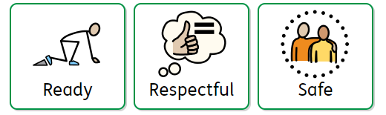
Be ready. Be respectful. Be safe.
All pupils understand that if the three golden rules are followed, everyone can learn to love and love to learn. The three rules are displayed across school and read in assembly.
 | Staff at St Joseph’s strive to be:  Relentlessly positive with high expectations for all. Proactive in establishing strong, clear routines.  Passionate about praising positive behaviour to make pupils feel noticed.
If a child is not being ready, respectful or safe, the following processes are used:
*If there are incidents of violent behaviour, children must go to step 3 and if their behaviour continues to endanger the safety of themselves, children or adults then they must be sent to a member of SLT who will decide on an appropriate sanction (missing of whole playtimes or lunchtimes or using the school Exclusion Policy) depending on the severity of the behaviour.
    1.Remind and redirect | Staff will use – eye contact and hand gestures to redirect children to positive choices.  Positive reinforcement of other children around them.  Staff will give a verbal reminder of the three rules.  Children will be given clear direction, using a scripted response. e.g Not safe/respectful. Feet on the floor.  Pupils have a choice to do the right thing (give take up time)  Staff will praise any positive change
  2.Think  Pupil will be given a verbal warming  The pupil will be made aware of their behaviour and given a clear outline of consequence if they continue via a scripted conversation. | Our Script:  - The rule is … (be ready, be respectful, be safe)  - Clear instruction. (e.g. Feet on the floor, follow me, complete your task)  - If you don’t follow the instruction, you will have to miss … (adult to determine consequence as appropriate)  - Thank you.
    3. Reflect and repair | If behaviour continues, the pupil will be given time out in an appropriate space (calm space in their own class or in another classroom for no more than 10 minutes) to allow them to reflect upon their behaviour. This incident will be recorded on CPOMS.  Pupils may need to regulate first using taught strategies (breathing, calm box, teddy squeeze etc.) and reflect using a reflection sheet.  Time must be made to repair the relationships between those affected. This should be facilitated by the adult using the reflection sheet as a guide and using restorative conversations. The consequence will then follow as per step 2. This will usually be missing a part of playtime or lunchtime. For more serious incidents, parents will be informed and the suspension and exclusion policy may be implemented at the discretion of the SLT.

- De-escalation techniques should be used for non-compliance.
- If a child moves to ‘Reflection and repair’ more than twice in a day or three times in a week, teachers are to inform SLT. There will be a letter sent home to inform parents and arrange a meeting.
- The number of ‘Reflections’ given are recorded on CPOMS and will be closely monitored.

  Behaviours we encourage: |   Unacceptable behaviour includes:
- Respect for other people, their views and their work  - A sense of right and wrong  - Self-respect and discipline  - Respect for the environment  - Working well with others  - Honesty and trust  - Fair  - Being polite  - Setting a good example to others  - Holding doors open  - Walking when inside | - Intentionally hurting other people’s feelings  - Threatening or violent behaviour including bullying and cyber bullying  - Dishonesty  - Deliberate disobedience  - Lack of respect  - Using unacceptable language such as swearing or discriminatory language  - Deliberately damaging property  - Disrupting teaching and learning  - Taking things that do not belong to you  - Unsafe use of technology

Behaviour outside of the classroom
Our behaviour system must also apply to poor behaviour at playtime, in the corridor and during assemblies. All staff must report incidents that they have dealt with to the class teacher so that pupil behaviour is monitored and they are not causing disruptions at other times of the day.
During break and lunch times, children may be given a time out on the playground. They may have to stand with an adult or sit on a bench for a designated amount of time before returning to play after a discussion about expectations following the script in step 2. If the behaviour continues or there is a more serious incident, children will have to miss some of their play the following day and complete a reflection sheet.

Child-on-Child and Peer-on-Peer Abuse
Child-on-child sexual violence and assault is not accepted and will never be tolerated. This includes but is not limited to sexual harassment, sharing of nude/ semi- nude images and harmful sexualised behaviour.
All incidents of child-on-child and peer-on-peer abuse will be referred to the Designated Safeguarding Lead, who will advise on the most appropriate course of action in the given circumstances. All inappropriate language and behaviour between pupils will be challenged by staff.

Rewards | Behaviour Steps
Verbal Praise   | Remind and redirect
  Dojo Points | Think  - Some missed play time
Share success  - Stickers  - Praise postcards    - Certificates  - Messages home | Reflect and repair  - Longer period of missed play time or lunch time  - Working outside of usually classroom space  - Possible suspension
Dojo system
Dojo points are awarded to children for many reasons to promote positive behaviour and attitudes. All classes will reward children for positive behaviour in the following categories:
- Be ready
- Be respectful
- Be safe
- Attendance
- Punctuality
- Uniform
- Bonus

Dojos must not be removed as a sanction.

Strategies

- Provide frequent, descriptive, specific, proximate praise for good behaviour at every opportunity for all children by focusing on opportunities where positive behaviour is shown as opposed to focusing on correcting behaviour.
- Be consistent with routines.
- Use of the school’s RWI actions (see appendix A) to ensure a consistent approach across the school.
- Staff teach ‘from feet’ (i.e. standing or moving) to show the importance of the lesson being taught.
- Meet, greet and connect with children at the classroom door as they enter each morning.
- Focus on the children at all times to give attention to desired behaviour.
- Transition points in school such as after break times and lunch times, children have ‘Me minutes’ where they take part in a short wellbeing task.
- Be firm yet fair and create clear boundaries and routines quickly to ensure children are clear of expectations, referring frequently to the school’s golden rules.
- Promote a calm, orderly environment in all areas of the school.
- Engage with children and show interest to promote a sense of belonging.
- Ensure the focus of each lesson is on teaching and learning and managing low-level behaviour which in turn keeps an engaging pace.
- Set a clear routine each day to ensure children are aware of expectations and know what will be happening next through the use of a visual timetable.
- Promote safety for all members of the school through responsible and appropriate behaviour.
- Liaise with the Behaviour Lead, SENDCo, SLT and parents regarding behaviour concerns and develop strategies to support behaviour development.
- Keep an accurate record of repeated behavioural incidences using CPOMS.
- Reward children for desirable behaviour using the whole school reward systems.
- Fully investigate any situations between children before referring to co-teachers and SLT. Investigations should take place using the Restorative Justice discussion resource.

Acceptable sanctions

Providing children with time out opportunities; calm or reflection area, to another classroom or another area of school. This will be managed with timers and followed by a restorative conversation.

Missed playtimes.

Phone calls home or conversations with parents/carers face to face.

Suspension.

Unacceptable sanctions
All adults will act as role models and will speak to the children in a calm manner at all times. The following sanctions are not acceptable at St Joseph’s Catholic Primary School:
- Writing lines.
- Writing the children's names on boards or displays to indicate a sanction or warning.
- Sending children to stand against walls on the playground.
- Removing rewards previously given to children for positive behaviour.

The use of reasonable force

There are circumstances when it is appropriate for staff in schools to use reasonable force to safeguard children. The term ‘reasonable force’ covers the broad range of actions used by staff that involve a degree of physical contact to control or restrain children. ‘Reasonable’ in these circumstances means ‘using no more force than is needed’.

Members of staff have the power to use reasonable force to prevent pupils committing an offence, injuring themselves or others, or damaging property and maintain good order and discipline at the school or among pupils.

Headteachers and authorised school staff may also use such force as is reasonable given the circumstances when conducting a search for knives or weapons, alcohol, illegal drugs, stolen items, tobacco, fireworks, pornographic images or articles that they reasonably suspect have been or are likely to be used to commit an offence or cause harm. The school has a zero-tolerance approach to these items being brought onto the premises, police involvement will be necessary and suspension or permanent exclusion is likely. Force may not be used to search for other items banned under the school rules.

More detail is found in the Corpus Christi Physical Intervention Policy available on our school website.

Searching, screening and confiscation

School staff can confiscate, retain or dispose of a pupil’s property as a disciplinary penalty in the same circumstances as other disciplinary penalties. Parents will be informed of this and asked to collect any confiscated items where appropriate.

Removal from classrooms

Removal is where a pupil, for serious disciplinary reasons, is required to spend a limited time out of the classroom at the instruction of a member of staff. This is to be differentiated from circumstances in which a pupil is asked to step outside of the classroom briefly for a conversation with a staff member and asked to return following this. The use of removal should allow for continuation of the pupil’s education in a supervised setting by an appropriate adult. Removal from the classroom is considered a serious sanction. Children may be removed for a short period and asked to work in another class for a lesson. Depending on their behaviour, they may be asked to work in another classroom for half or full day. Parents will be informed of this when their child is collected at the end of the day or by phone and the sanction will be recorded on CPOMs. The removal of a child from the classroom is a last resort and would only happen with the approval of the senior leadership team to ensure this can be closely monitored.

Managed moves

A managed move is used to initiate a process which leads to the transfer of a pupil to another mainstream school permanently. If a temporary move needs to occur to improve a pupil’s behaviour, then off-site direction should be used. Managed moves should only occur when it is in the pupil’s best interests. Parents will be informed of this process, and school will be in communication with parents at each step of the process.

Behaviour outside of school premises

Schools have the power to sanction pupils for misbehaviour outside of the school premises to such an extent as is reasonable.

Conduct outside the school premises, including online conduct, that schools might require a sanction include:

• when taking part in any school-organised or school-related activity;

• when travelling to or from school;

• when wearing school uniform;

• when in some other way identifiable as a pupil at the school;

• that could have repercussions for the orderly running of the school;

• that poses a threat to another pupil; or

• that could adversely affect the reputation of the school.

The decision to sanction a pupil will be lawful if it is made on the school premises or elsewhere at a time when the pupil is under the control or charge of a member of staff of the school

Preventing recurrence of misbehaviour

This is achieved by helping pupils understand behavioural expectations and by providing support for pupils who struggle to meet those expectations. Some pupils will need more support than others and this will be provided as proactively as possible.

Examples of interventions include:

frequent and open engagement with parents, including home visits if deemed necessary;

longer-term behaviour support plans;

engaging with local partners and agencies to address specific challenges e.g. Primary Jigsaw, TAS

Initial intervention to address underlying factors leading to misbehaviour includes an assessment of whether appropriate provision is in place to support any SEND that a pupil may have.

The ‘graduated response’ will be used to assess, plan, deliver and then review the needs of the pupil and the impact of the support being provided. If the pupil has an Education, Health and Care (EHC) plan, early contact with the local authority about the behavioural issues would be appropriate and an emergency review of the plan might be needed.

Where school has serious concerns about a pupil’s behaviour, we would consider whether a multi-agency assessment such as an early help assessment or statutory assessment that goes beyond the pupil’s educational needs is required.

Children with Special Educational Needs and Disability (SEND) and Wellbeing Needs
We recognise that some children have specific needs with regards to their behaviour. For those identified with SEND, CLA, or those with social, emotional and mental health issues the system may be altered and adapted to meet their needs. Some children may have such specialised needs that the above measures are wholly inappropriate. In these circumstances specialist advice is sought and the system is modified for the individual.

The impact of trauma on behaviour
Children who have been exposed to trauma can have considerable reactions that can interfere with learning and behaviour. They often find it difficult to concentrate, which impacts upon their ability to learn, resulting in low self-esteem. They can display attention-needing behaviours, which can often be disruptive, and may be physically and verbally abusive. Understanding and sensitively responding to the unique needs and behaviours of all children is integral to creating a positive and inclusive learning environment. We aim to support children who have experienced trauma through personalised strategies.

Anti-Bullying Strategy

The purpose of this policy statement is:

to prevent bullying from happening between children who are a part of our school

to make sure bullying is stopped as soon as possible if it does happen and that those involved receive the support they need

to provide information to all staff, volunteers, children and their families about what we should all do to prevent and deal with bullying.

This policy statement applies to anyone working on behalf of St Joseph’s, including senior leaders and the board of governors, paid staff, volunteers, agency staff and children.

What is bullying?

Bullying includes a range of abusive behaviour that is

repeated

intended to hurt someone either physically or emotionally.

We believe that:

children and young people should never experience abuse of any kind

we have a responsibility to promote the welfare of all children and young people, to keep them

safe and to practise in a way that protects them.

We recognise that:

bullying causes real distress. It can affect a person’s health and development and, at the extreme, can cause significant harm.

all children, regardless of age, disability, gender reassignment, race, religion or belief, sex or sexual orientation, have the right to equal protection from all types of harm or abuse

everyone has a role to play in preventing all forms of bullying (including online) and putting a stop to bullying.

We will seek to prevent bullying by:

developing a code of behaviour that sets out how everyone involved in our school is expected to behave, in face-to-face contact and online, and within and outside of our activities

holding regular discussions with staff, volunteers, children, young people and families who use our school about bullying and how to prevent it.

These discussions will focus on:

practising skills such as listening to each other

respecting the fact that we are all different

making sure that no one is without friends

dealing with problems in a positive way

checking that our anti-bullying measures are working well

providing support and training for all staff and volunteers on dealing with all forms of bullying,

putting clear and robust anti-bullying procedures in place

We make sure our response to incidents of bullying takes into account:

the needs of the person being bullied

the needs of the person displaying bullying behaviour

needs of any bystanders

school as a whole.

reviewing the plan developed to address any incidents of bullying at regular intervals, in order to ensure that the problem has been resolved in the long term.

We recognise that bullying is closely related to how we respect and recognise the value of diversity.

We will be proactive about:

seeking opportunities to learn about and celebrate difference

increasing diversity within our staff, volunteers, children and young people

welcoming new members to our organisation.

More information about responding effectively to bullying is available:

protecting children from bullying and cyberbullying

learning.nspcc.org.uk/child-abuse-and neglect/bullying

recognising and responding to abuse

learning.nspcc.org.uk/child-abuse-andneglect/recognising-and-responding-to-abuse

Arrangements for exclusion

Please refer to the school’s Exclusion Policy.

Links with other policies
- Exclusions policy
- Equality policy
- Relationships policy
- SEND policy and Information Report
- Safeguarding policy
- Code of ConductRSE
- Positive Handling and Physical Intervention policy

Written: September 2025

Updated: February 2026


Appendix A:

As a RWI school the following silent signals are used school wide to promote high standards of learning behaviour.
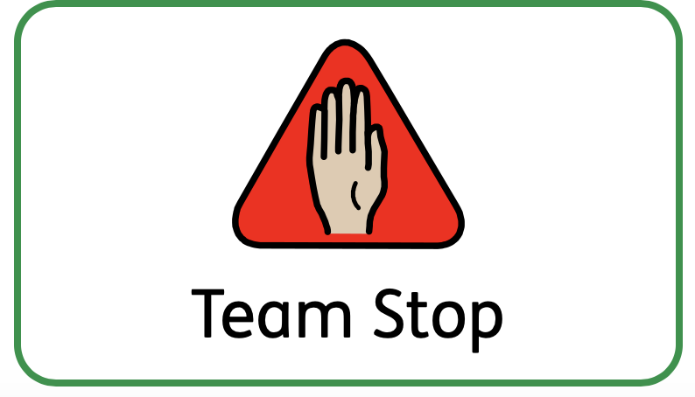 | The team stop signal helps staff to stop pupils in a  calm manner, ready for what’s next.  The stop signal is used in assembly, in lessons, during transitions, at lunchtime, on trips and in staff meetings.  The signal to gain attention.  - Staff will hold one hand in the air with a flat palm.  - Staff scan the room to check every pupil has responded. Every pupil:  - raises one hand in response;  - checks their partner and others at their table have also raised their hands – gently tapping an arm if necessary;  - looks attentively at staff –to show they are ready to listen.  3. Staff lower their hand and scan to check everyone is looking at them attentively, ready to listen. Staff do not start talking until they have their attention.
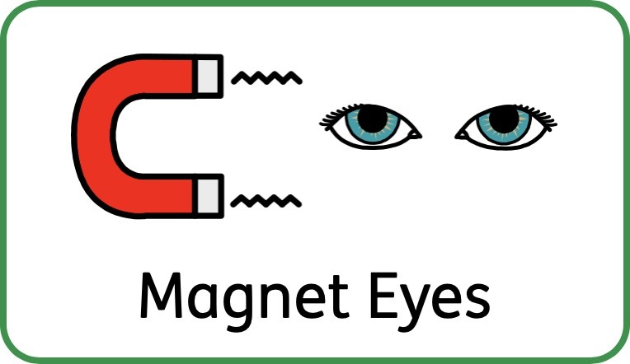 | When staff need to ensure that pupils are listening, they will point to their eyes with two fingers. This indicates that their eyes should be facing the front and their bodies should be ready to learn.*  *Reasonable adjustments are made for neurodiverse children.
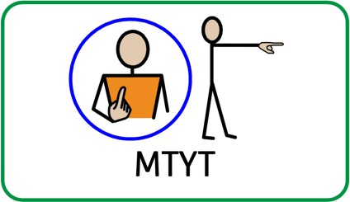 | 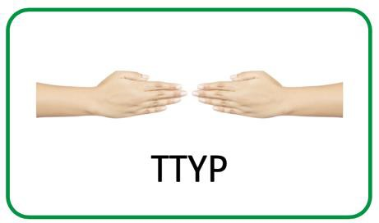
My Turn Your Turn  This is a silent signal staff use when they want pupils to repeat something after them. My turn: staff gesture towards themselves with one or two hands. Your turn: staff gesture towards the pupils with one or two open palms. | Talk to Your Partner  Partner work is used consistently in all lessons to allow all children to work collaboratively and have their voices heard.  Staff hold both hands pointing forward as if they are two open gates. Staff close the gates as soon as they have finished asking the question.  This signal is practised until pupils turn automatically to their partners to answer the question.

Appendix B

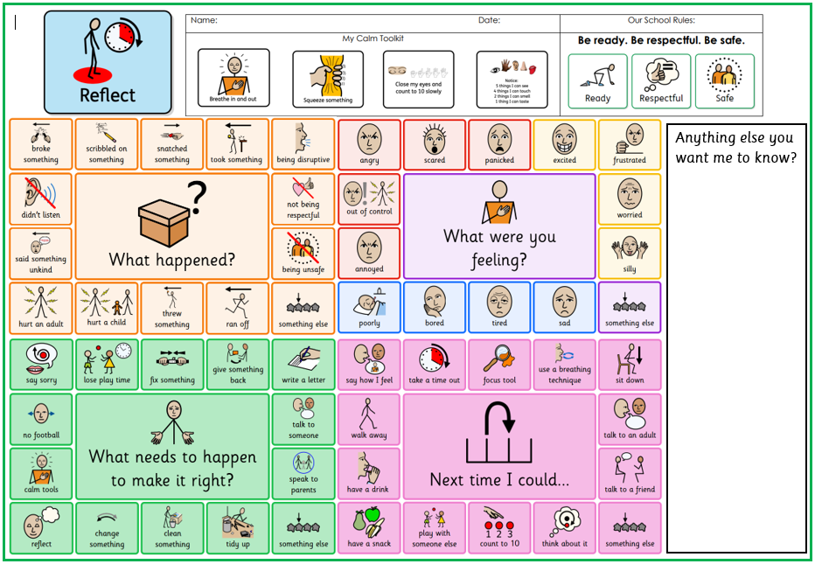

Appendix C (Add new parent letter for multiple reflections)

Dear Parents and Carers,

Your child, (name), has received (number) of reflection sheets in (time period). This indicates that they are finding it challenging to follow our school behaviour policy and their behaviour is not consistently in line with our school values.

I would like to invite you to meet with (class teacher) and I, to discuss your child’s behaviour, and agree our collective next steps to support an improvement in your child’s behaviour.

Please contact the school office to make an appointment.

Thank you for your continued support.

Kind regards,

Mrs Holland

Executive Headteacher

