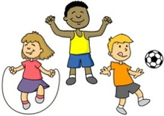
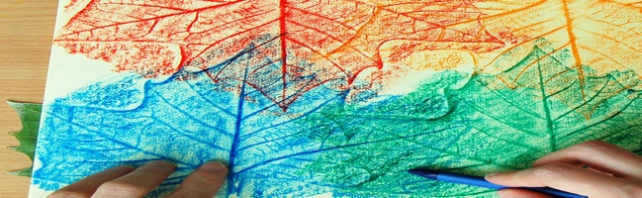

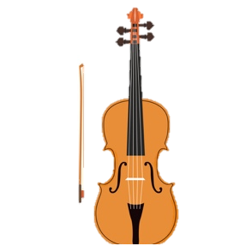
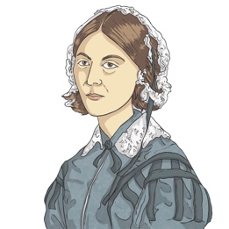
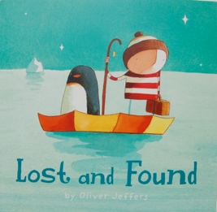
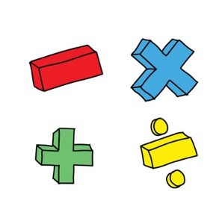
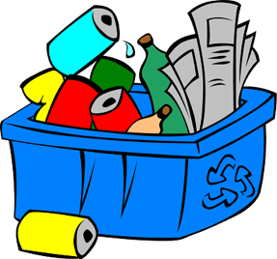
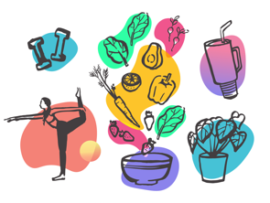
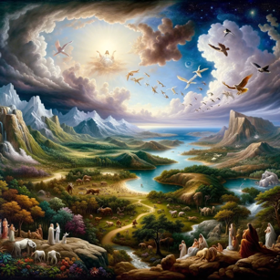
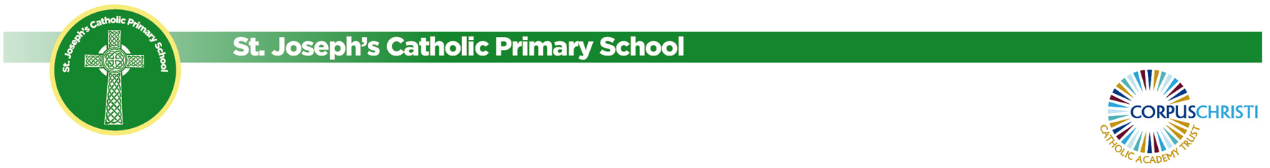
Our book is called ‘Lost and Found’. We are working towards writing our stories about finding an animal.
Newsletter Autumn 1 - Year 1/2
Our topic is ‘Everyday Materials’. In this topic, we are learning about different materials and their uses.
Our topic is ‘Health and Wellbeing’. We will learn about healthy lifestyles and being unique.
Our topic is ‘Creation and Covenant’. We will be learning about God creating the world.

Our topic is, ‘How has the health Britain changed over time?’ We will be learning about Florence Nightingale and Edith Cavell.
In Year One, we are learning simple addition and subtraction to 10. In Year Two, we are learning about numbers to 100.
Foundation Subjects
In Art, we are exploring drawing techniques using a range of materials. Our end goal is to use tone and texture to create an observational drawing.

In PE, we are learning to attack, defend and shoot.

In Computing, we are learning about how to stay safe online.

In Music, we are learning how to play the violin and how to read music.

PSHE

Religion and Celebration of the Word

History
Science

Maths

English & Phonics

