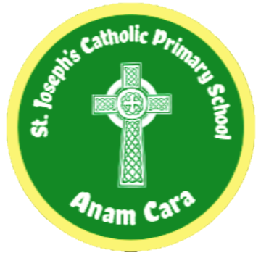

ST. JOSEPH’S CATHOLIC PRIMARY SCHOOL
Where every child is known and loved as a child of God

Mission Statement
At St. Joseph’s we live in faith,
grow in love and serve one another
as children of God.

Reading Policy
Document Control
Name of Policy | Reading
Date approved and adopted | September 2025
Date to be reviewed | September 2026

‘Reading is fundamental to education. Proficiency in reading, writing and spoken language is vital for pupils’ success. Through these, they develop communication skills for education and for working with others: in school, in training and at work. Pupils who find it difficult to learn to read are likely to struggle across the curriculum, since English is both a subject in its own right and the medium for teaching. This is why the government is committed to continuing to raise standards of literacy for all.’

Taken from The Reading Framework July 2023

Context

We want the pupils at St Joseph’s Catholic Primary School to love to read, reading is at the forefront of everything we do. St Joseph’s is located in an area of high deprivation, with the number of children that receive pupil premium funding well above national average. We are passionate about ensuring that the links between deprivation and low Literacy skills are tackled. With this in mind, at St Joseph’s we need to ensure that all children learn to read. We need to be relentless in our strategies when breaking down the barriers to reading. Our reading curriculum has been designed to help tackle the effects of deprivation, whilst promoting the love of reading, as well as developing fluent and motivated readers who feel confident to talk about books and authors.

How is the Subject Content from the National Curriculum Covered?
(See pages 13 - 73 in the National Curriculum)

At St Joseph’s Catholic Primary School, we aim to ensure our reading curriculum enables all children to learn to read. We are relentless in our strategies when breaking down the barriers to reading. Our reading curriculum is based on the expectations and aims of the 2014 national Curriculum for English and Statutory Framework for the Early Years Foundation Stage 2021.
Purpose of Study

Early Years Foundation Stage

In the EYFS Framework, pupils are expected, by the end of Reception Year, to have attained a level of development as defined by the Early Learning Goals (ELGs).

For the Comprehension ELG, this states that children at this expected level of development will:
- Demonstrate understanding of what has been read to them by retelling stories and narratives using their own words and recently introduced vocabulary.
- Anticipate – where appropriate – key events in stories.
- Use and understand recently introduced vocabulary during discussions about stories, non-fiction, rhymes and poems and during role-play.

The non-statutory Development Matters 2021 guidance provides age-banded stepping stones that track the typical expected progression towards this Comprehension ELG. These stepping stones have been usefully reorganised and restructured within the EYFS Assessment Framework.

The programmes of study for reading at key stages 1 and 2 consist of 2 dimensions:
- word reading
- comprehension (both listening and reading)

At St Joseph’s Catholic Primary School, we ensure that teaching focuses on developing pupils’ competence in both dimensions; different kinds of teaching are needed for each.

Word Reading
Skilled word reading involves both the speedy working out of the pronunciation of unfamiliar printed words (decoding) and the speedy recognition of familiar printed words. Underpinning both is the understanding that the letters on the page represent the sounds in spoken words. This is why phonics is prioritised in the early teaching of reading to beginners; this happens as soon as pupils join St Joseph’s Catholic Primary School.

Comprehension
Good comprehension draws from linguistic knowledge (in particular of vocabulary and grammar) and on knowledge of the world. Comprehension skills develop through pupils’ experience of high-quality discussion with the teacher, as well as from reading and discussing a range of stories, poems and non-fiction. All pupils must be encouraged to read widely across both fiction and non-fiction to develop their knowledge of themselves and the world they live in, to establish an appreciation and love of reading, and to gain knowledge across the curriculum. Reading widely and often increases pupils’ vocabulary because they encounter words they would rarely hear or use in everyday speech. Reading also feeds pupils’ imagination and opens up a treasure house of wonder and joy for curious young minds.
It is essential that, by the end of their primary education, all pupils are able to read fluently, and with confidence, in any subject in their forthcoming secondary education.

Aims
(taken from the National Curriculum page 13)

The overarching aim for English in the national curriculum is to promote high standards of language and literacy by equipping pupils with a strong command of the spoken and written word, and to develop their love of literature through widespread reading for enjoyment.

The national curriculum for English aims to ensure that all pupils:
- read easily, fluently and with good understanding;
- develop the habit of reading widely and often, for both pleasure and information;
- acquire a wide vocabulary, an understanding of grammar and knowledge of linguistic conventions for reading, writing and spoken language;
- appreciate our rich and varied literary heritage;
- write clearly, accurately and coherently, adapting their language and style in and for a range of contexts, purposes and audiences;
- use discussion in order to learn; they should be able to elaborate and explain clearly their understanding and ideas;
- are competent in the arts of speaking and listening, making formal presentations, demonstrating to others and participating in debate.

Rationale

Our reading curriculum sets out an evidence-based approach to developing whole school reading adapted from, ‘The Art and Science of Teaching Primary Reading’ by Christopher Such.
If children are to develop as competent fluent readers it is essential that they have a secure phonemic awareness. Phonics skills are essential to developing competent and confident readers. At St Joseph’s Catholic Primary School, we currently follow Read, Write Inc. which is a DfE validated scheme and is a synthetic, systematic programme that ensure consistency and a uniformity to teaching Phonics.

The programme is for:

- Pupils in their last term of Nursery who are ready! (Prior to this the focus is on the repeated reading of stories and rhymes to children and developing their love of books).
- Pupils in Reception to Year 2 who are learning to read and write.
- Any pupils in Year 2 to 6 who need to catch up rapidly.

Teaching Reading Comprehension

For Years 1 to 6, the comprehension elements of the programmes of study for the English National Curriculum state that pupils should be taught to comprehend as per the statements below:

Year 1
Develop pleasure in reading, motivation to read, vocabulary and understanding by:
- Listening to and discussing a wide range of poems, stories and non-fiction at a level beyond that at which they can read independently.
- Being encouraged to link what they read or hear read to their own experiences.
- Becoming very familiar with key stories, fairy stories and traditional tales, retelling them and considering their particular characteristics.
- Recognising and joining in with predictable phrases.
- Learning to appreciate rhymes and poems, and to recite some by heart.
- Discussing word meanings, linking new meanings to those already known.

Understand both the books they can already read accurately and fluently and those they listen to by:
- Drawing on what they already know or on background information and vocabulary provided by the teacher.
- Checking that the text makes sense to them as they read and correcting inaccurate reading.
- Discussing the significance of the title and events.
- Making inferences on the basis of what is being said and done.
- Predicting what might happen on the basis of what has been read so far.
- Participate in discussion about what is read to them, taking turns and listening to what others say.
- Explain clearly their understanding of what is read to them.

Year 2
Develop pleasure in reading, motivation to read, vocabulary and understanding by:
- Listening to, discussing and expressing views about a wide range of contemporary and classic poetry, stories and non-fiction at a level beyond that at which they can read independently.
- Discussing the sequence of events in books and how items of information are related.
- Becoming increasingly familiar with and retelling a wider range of stories, fairy stories and traditional tales.
- Being introduced to non-fiction books that are structured in different ways
- Recognising simple recurring literary language in stories and poetry.
- Discussing and clarifying the meanings of words, linking new meanings to known vocabulary.
- Discussing their favourite words and phrases.
- Continuing to build up a repertoire of poems learnt by heart, appreciating these and reciting some, with appropriate intonation to make the meaning clear.

Understand both the books that they can already read accurately and fluently and those that they listen to by:
- Drawing on what they already know or on background information and vocabulary provided by the teacher.
- Checking that the text makes sense to them as they read and correcting inaccurate reading.
- Making inferences on the basis of what is being said and done.
- Answering and asking questions.
- Predicting what might happen on the basis of what has been read so far.

Participate in discussion about books, poems and other works that are read to them and those that they can read for themselves, taking turns and listening to what others say.
Explain and discuss their understanding of books, poems and other material, both those that they listen to and those that they read for themselves.

Years 3 and 4
Develop positive attitudes to reading and understanding of what they read by:
- Listening to and discussing a wide range of fiction, poetry, plays, non-fiction and reference books or textbooks.
- Reading books that are structured in different ways and reading for a range of purposes.
- Using dictionaries to check the meaning of words that they have read.
- Increasing their familiarity with a wide range of books, including fairy stories, myths and legends, and retelling some of these orally.
- Identifying themes and conventions in a wide range of books.
- Preparing poems and play scripts to read aloud and to perform, showing understanding through intonation, tone, volume and action.
- Discussing words and phrases that capture the reader’s interest and imagination.
- Recognising some different forms of poetry [for example, free verse, narrative poetry].

Understand what they read, in books they can read independently, by:
- Checking that the text makes sense to them, discussing their understanding and explaining the meaning of words in context.
- Asking questions to improve their understanding of a text.
- Drawing inferences such as inferring characters’ feelings, thoughts and motives from their actions, and justifying inferences with evidence.
- Predicting what might happen from details stated and implied.
- Identifying main ideas drawn from more than one paragraph and summarising these.
- Identifying how language, structure, and presentation contribute to meaning.

Retrieve and record information from non-fiction.
Participate in discussion about both books that are read to them and those they can read for themselves, taking
turns and listening to what others say.

Years 5 and 6
Maintain positive attitudes to reading and understanding of what they read by:
- Continuing to read and discuss an increasingly wide range of fiction, poetry, plays, non-fiction and reference books or textbooks.
- Reading books that are structured in different ways and reading for a range of purposes
- Increasing their familiarity with a wide range of books, including myths, legends and traditional stories, modern fiction, fiction from our literary heritage, and books from other cultures and traditions.
- Recommending books that they have read to their peers, giving reasons for their choices.
- Identifying and discussing themes and conventions in and across a wide range of writing.
- Making comparisons within and across books.
- Learning a wider range of poetry by heart.
- Preparing poems and plays to read aloud and to perform, showing understanding through intonation, tone and volume so that the meaning is clear to an audience.

Understand what they read by:
- Checking that the book makes sense to them, discussing their understanding and exploring the meaning of words in context.
- Asking questions to improve their understanding.
- Drawing inferences such as inferring characters’ feelings, thoughts and motives from their actions, and justifying inferences with evidence.
- Predicting what might happen from details stated and implied.
- Summarising the main ideas drawn from more than one paragraph, identifying key details that support the main ideas.
- Identifying how language, structure and presentation contribute to meaning.

Discuss and evaluate how authors use language, including figurative language, considering the impact on the reader.
Distinguish between statements of fact and opinion.
Retrieve, record and present information from non-fiction.
Participate in discussions about books that are read to them and those they can read for themselves, building on their own and others’ ideas and challenging views courteously.
Explain and discuss their understanding of what they have read, including through formal presentations and
debates, maintaining a focus on the topic and using notes where necessary.
Provide reasoned justifications for their views.

Reading is a key life skill and we strive to embed a culture of reading into the core of what we do. This is done through the teaching of comprehension skilled through daily guided reading and shared reading in EYFS, KS1 and KS2. At St Joseph’s, we provide opportunities for children to read both independently aloud and with their partner as well as allowing them the chance to discuss books they have read with their peers. On a daily basis, children have a class text that is shared with the children during the school day. Reading and quality literature is interwoven into our curriculum through the use of key texts called ‘St Joseph’s Reading Spine’. These key texts expose our children to various genres and famous authors and to enhance the variety of exciting topics that we teach. We have also developed a St Joseph’s Anthology, which is a collection of ambitious age-appropriate texts to extend children’s reading outside the curriculum and at home. These books encourage children to develop a broad vocabulary, a deeper understanding of the world and a stronger foundation for future reading. The ultimate goal is to foster a lasting love of reading in children.

How do we Prioritise Reading at St. Joseph’s Catholic Primary School?

Funding/ Resourcing
Each academic year a proportion of the budget for English will be set aside to maintain and enhance the school texts. This will allow the school to meet the demands and needs for the academic year and children. The budget will allow the school to replenish and update stock to maintain children’s interest and pleasure of reading.

Timetabling
In St Joseph’s Catholic Primary School we teach reading every day.

Nursery

Monday | Tuesday | Wednesday | Thursday | Friday
Phonics
15 minutes daily
Shared Reading
Daily Story X 5

Reception

Monday | Tuesday | Wednesday | Thursday | Friday
RWI Phonics
30 minutes daily
RWI Review
15 minutes daily
Shared Reading
Daily Story X 5

Year 1

Monday | Tuesday | Wednesday | Thursday | Friday
RWI Phonics
40 minutes daily
RWI Review
15 minutes daily
Shared Reading
15 minutes daily

Year 2

Monday | Tuesday | Wednesday | Thursday | Friday
RWI Phonics or RWI Comprehension Modules
40 minutes daily
RWI Review
15 minutes daily
Shared Reading
15 minutes daily

Year 3

Monday | Tuesday | Wednesday | Thursday | Friday
Vocabulary Instruction
5 minutes daily
Spelling  15 minutes |  |  |  | Spelling Test
Fluency Practice  25 minutes | Extended Reading  25 minutes | Fluency Practice  25 minutes | Extended Reading  25 minutes | Close Reading  25 minutes
Shared Reading
15 minutes daily

Year 4

Monday | Tuesday | Wednesday | Thursday | Friday
Vocabulary Instruction
5 minutes daily
Spelling  15 minutes |  |  |  | Spelling Test
Fluency Practice  25 minutes | Extended Reading  25 minutes | Fluency Practice  25 minutes | Extended Reading  25 minutes | Close Reading  25 minutes
Shared Reading
15 minutes daily

Year 5

Monday | Tuesday | Wednesday | Thursday | Friday
Vocabulary Instruction
5 minutes daily
Spelling  15 minutes |  |  |  | Spelling Test
Extended Reading  25 minutes | Close Reading  25 minutes | Fluency Practice  25 minutes | Extended Reading  25 minutes | Close Reading  25 minutes
Shared Reading
15 minutes daily

Year 6

Monday | Tuesday | Wednesday | Thursday | Friday
Vocabulary Instruction
5 minutes daily
Spelling  15 minutes |  |  |  | Spelling Test
Extended Reading  25 minutes | Close Reading  25 minutes | Extended Reading  25 minutes | Close Reading  25 minutes | Extended Reading  25 minutes
Shared Reading
15 minutes daily

Planning/ Monitoring

Reading is a priority to school leaders and we rigorously monitor the teaching of reading. We ensure reading is always on our school improvement plan. In our action plan we indicate how and when reading will be monitored in the school. We use data from our termly assessments to ensure that the teaching of reading and the interventions for reading are impacting on the reading outcomes for all children. We conduct pupil voice questionnaires and interviews to ensure children develop a love for reading! On a termly basis, we quality assure the teaching of reading through an external review.

Training and coaching

Training is identified for the staff in the action plan. Through observations and discussions, we identify which teachers may need more support with subject knowledge. All new teachers to the school are given a thorough induction of how we teach reading at St Joseph’s Catholic Primary School, to ensure that all children are receiving the best quality first teaching. We ensure all staff that teach phonics are given training to deliver Read Write Inc Phonics to an excellent standard and Fresh Start to those children in Years 5 and 6 who need it. The phonics leader also attends frequent reading leader training to ensure practice is up to date and assessment knowledge is current. We also use our Read Write Inc. reading lead to coach teachers to ensure consistency and quality.

How do we develop a love of Reading?

‘Becoming a lifetime reader is based on developing a love of reading (Sanacore, 2002)

At St Joseph’s Catholic Primary School, the active encouragement for reading for pleasure is a core part of every child’s educational entitlement, whatever their background or their entitlement. St Joseph’s take the view that extensive reading and exposure to a wide range of texts makes a vital contribution to every child’s educational achievement. We aim to establish each child as a lifetime reader.

The school undertakes and implements plans to ensure that there is a wide range of texts within the school classrooms. Texts include:
- Age related fiction and non fiction, including high quality poetry.
- A reading spine for each year group of suggested texts and texts that will be studied in class. These maybe linked to the curriculum topics the children are studying.
- A school anthology of well chosen quality texts for pleasure.
- Books which represent children of all ethnicities, family backgrounds and religions.
- Provision is made to provide texts which accommodate all reading ages and abilities. Books phonically link with the sounds children know.
- Book clubs are delivered throughout the year to provide ambitous challenge

Reading aloud

Regular time is spent reading aloud by the teachers at St Joseph’s Catholic Primary School and these designated time slots are on the timetable as ‘shared reading’. Teachers model good practice by reading aloud to the children. Children benefit tremendously from being read aloud to and studies show that those who are read aloud to are likely to do better in school both academically and socially. All year groups have a variety of authors of which they will read a range of books by and build up a familiarity and love of themes and authors books. These will vary in types in order to both encourage a love of a series of books but also expand children’s horizons and allow them to experience new horizons and spark new interests. It is the duty of the children to ensure children’s Cultural Capital is developed. By this we take the wording of the National Curriculum; ‘It is essential knowledge that pupils need to be educated citizens, introducing them to the best that has been thought and said and helping to engender an appreciation of human creativity and achievement!’ We believe this can be done by ensuring children have a rich and varied diet.

St Joseph’s Catholic Primary School Reading Spine – Please see document on website for full termly reading spine

The class novels that teachers read to the class are from the Reading Spine and are for pure enjoyment. These texts have been carefully selected to ensure each phase children are exposed to:

- Classic texts (e.g ‘The Velveteen Rabbit’)
- BAME main characters (e.g ‘Christophe’s Story’)
- Other cultures (e.g ‘The Proudest Blue’)
- Characters with disabilities (e.g ‘We are Giants’)
- A range of family circumstances (‘An That’s Why She’s My Mama’)

All teachers will have designated displays and areas in their class to promote the class novel each term and the spine books for the term. These books will allow children to develop a wider understanding of the world around them as well as developing their literacy skills.

Stockport Library

We organise for all classes to visit Stockport Library. Stockport Library gives children the chance to discover a wealth of information about Stockport’s past and their own family history. We are dedicated to connecting children with the library at a young age so that they know they can access the valuable resources and are exposed to a wide range of choice of texts.

Getting parents involved

Reading records are the main form of communication with parents with regard to their reading progress. Children are encouraged to every day. Our 1:1 reading invervention also support children who require further support. This require parents and teachers to work together and commit to reading with the child daily. In addition to this regular communication between home and school, selected year groups also hold reading and phonics meetings for parents to gain a better understanding of how to support their child’s reading development. Throughout the year, class teachers invite parents to attend stay and read sesssions, masked reader events and celebrate children’s achievements through assemblies.
Classroom Reading Areas

All classrooms in EYFS and Key Stage 1 will have a reading corner to promote reading for pleasure. Children will have access to a variety of books which they can read by choice. These books will be focused on children re-reading books which they have heard read as well as teachers recommending books to children. They will include a variety of genres and authors, and cover a wider range of potential areas of interest.

‘Ideally, every book corner should be a mini library, a place for children to browse the best books, revisit the ones that the teacher has read to them and borrow books to read or retell at home.’

School Library

The school library is central to developing a love of reading and supporting literacy across the curriculum. It provides pupils with access to a wide range of diverse, high-quality texts and regular opportunities for independent and guided reading. The library is reviewed regularly to ensure it continues to meet the needs of all learners and promotes reading for pleasure. School librarians made up of Year 5 and 6 children ensure that the library is well stocked with texts which are of interest to the children of our school.

Reading Framework 2023

In Key Stage 2 there will be an area of the classroom to celebrate and promote reading. Additionally, there will be access to a wide variety of texts including books and comic accessible to all ages and abilities. By providing a variety of places and stimulating environments to read, teachers promote increased reading frequency and more diverse reading experiences for each child. In addition, we believe a rich classroom reading are will increase children’s literacy skills by allowing access to dictionaries and thesauri to allow children access to understand and learn through reading. They will also promote phonemic awareness, vocabulary, comprehension and writing.

Implementation

How do we teach reading at St Joseph’s Catholic Primary School?

We use The Simple view of Reading which illustrates how reading is split into strands, as stated in the National Curriculum; word decoding and comprehension. The simple view of reading demonstrates how synthetic phonics should be the prime approach to reading, along with comprehending the meaning of the text as part of the daily reading routine in school.
The Simple View of Reading

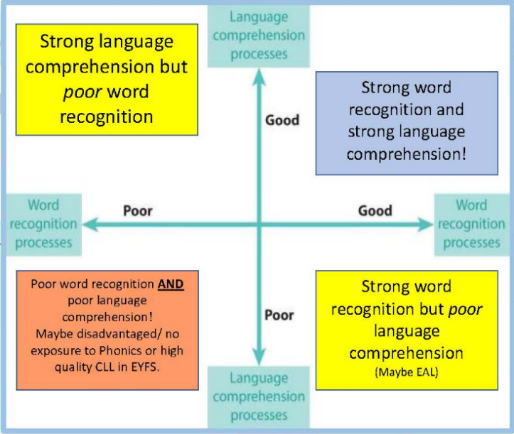
This model was in the original National Literacy Strategy and it was devised by Gough & Turner in 1986. It demonstrates that both word recognition and language comprehension are equally important in children becoming successful readers.
The ideal situation is to be in top right quadrant!


At St. Joseph’s Catholic Primary School, we use Read, Write Inc. This DfE validated scheme supports the systematic and synthetic teaching of phonics to support children in the process of learning to read and write.

Phonics from the Start

From Nursery, we use the ‘talk-a- lot, read- a lot’ approach. The main focus in nursery classrooms are reading stories and rhymes to children and developing their language. Children read the same story 3 times a day in a morning session all week. They also have a nursery rhyme a week.

Before starting to teach Set 1 sounds:
- we practise using ‘pure sounds’
- use ‘Fred talk’ to teach oral blending
- teach children to name the pictures

In the Summer term of Nursery before starting Reception, we teach a new sound every day for about 15 minutes and once the children can read all the single letter set 1 sounds speedily teach children to blend in small groups, or as individuals.

In Read Write Inc. Phonics pupils:

- Decode letter- sound correspondences quickly and effortlessly, using their phonic knowledge and skills

- Read common exception words on sight

- Understand what they read

- Read aloud with fluency and expression

- Write confidently, with a strong focus on vocabulary and grammar

- Spell quickly and easily by segmenting the sounds in words

- Acquire good handwriting

In addition, we teach pupils to work effectively with a partner to explain and consolidate what they are learning. This provides the teacher with opportunities to assess learning and to pick up on difficulties such as pupils’ poor articulation, or problems with blending or alphabetic code knowledge.

We group pupils homogeneously, according to their progress in reading rather than their writing. This is because it is known that pupils’ progress in writing will lag behind progress in reading, especially for those whose motor skills are less developed.

In Reception we emphasise the alphabetic code. The pupils rapidly learn sounds and the letter or groups of letters they need to represent them. Simple mnemonics help them to grasp this quickly. This is especially useful for pupils at risk of making slower progress. The learning is consolidated daily. Pupils have frequent practice in reading high frequency words with irregular spellings – common exception words.

We make sure that pupils read books that are closely matched to their increasing knowledge of phonics and the common exception words. This is so that, early on, they experience success and gain confidence that they are readers. Re-reading and discussing these books with the teacher support their increasingly fluent decoding.

Pupils will learn the initial letter sounds and their matching graphemes as they progress from Nursery to Reception and then Year 1. They will be explicitly taught the skills of segmenting and oral blending, which is vital for the initial stages of early reading. This consistent and rigorous approach will provide our children with the foundations to become enthused readers with a passion for storytelling, literature and vocabulary.

Outcomes for children assessing and tracking progress

Expectation of progress- Our goal is for children to:

- Work out unfamiliar words quickly – including new vocabulary and names.
- Read familiar words speedily – that is, words they have been taught.
- Read texts – including the words they have been taught – fluently.

Please note: these are the expectation for the lowest 20% of children. Other children should be well in advance of this.

All children should achieve these expectations, if they have followed the programme from Reception.

 | YR children can | Y1 children can | Y2 children can
End of Autumn 1 | Read single-letter Set 1 sounds (first 16) | Read Purple Storybooks Read Set 2 sounds | Read Set 2 sounds Read Blue Storybooks with increasing fluency
End of Autumn term | Read all Set 1 single letter sounds Blend sounds into words orally | Read Pink Storybooks Read first 5 Set 3 sounds | Read Grey Storybooks
End of Spring 1 | Blend sounds to read words Read short Ditty stories | Read Orange Storybooks Read 11 Set 3 sounds | Read Grey Storybooks with fluency and comprehension
End of Spring term | Read Red Storybooks Read Set 1 Special Friends | Read Yellow Storybooks Read 17 Set 3 sounds | Access RWI Comprehension and Spelling programme
End of Summer 1 | Read Green Storybooks Read 4 double consonants | Read Yellow Storybooks Read 22 Set 3 sounds | Access RWI Comprehension and Spelling programmes
End of Summer term | Read Green Storybooks Read first 6 Set 2 sounds | Read Blue Storybooks Read all Set 3 sounds and additional graphemes. | Access RWI Comprehension and Spelling programmes

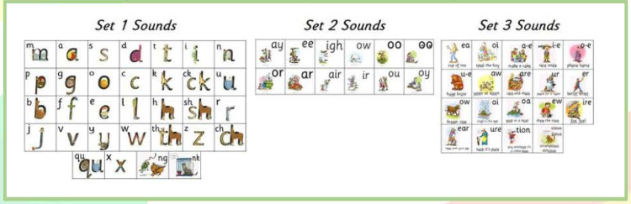

We assess all pupils following Read Write Inc. Phonics using the Entry Assessment. We use this data to assign them to a Read Write Inc. group. This gives us a very good indication of how well they are making progress relative to their starting points. We do this for all pupils, whenever they join us, so we can track all of them effectively. From those on the Read Write Inc. Phonics programme, we record their starting date and entry point on the tracker to monitor the rate at which they are making progress. We can also identify those who joined the programme later.

Pupils who are making slower progress usually complete the programme by the end of Year 2. We support pupils who have identified special needs for however long it takes until they can read. For example, we identify those who are at risk of falling behind their peers immediately - whatever their age. Highly trained staff tutor them for 10 minutes a day using Read Write Inc. One-to-one tutoring programme. If a child arrives in Key Stage 2 reading below the chronological age or with English as an additional language they are taught Read Write Inc. Phonics until they too catch up with their peers.

By the end of Key Stage 1, our pupils are able to read age-appropriate texts accurately and with sufficient speed for comprehension. This means that we can focus on developing their comprehension, preparing them well for transition to Key Stage 2. Their good decoding skills mean that they have a sound strategy for decoding unfamiliar words when they come across them at whatever stage and in any subject even into secondary school.

Quality of teaching, learning and assessment

The programmes’ ‘cycle of instruction’ means that, after direct instruction and guided practice, the pupils teach another pupil. In this way they all rehearse and consolidate what they have been learning. This helps the pupils to make their understanding clear to themselves and helps the teacher deal with any misconceptions. ‘Partner teaching’ is a key assessment tool. In Read Write Inc. Phonics, because the pupils are grouped across the school in terms of their reading ability, they are reading at an appropriate decoding level every day. The homogenous groups in the Phonics lessons help us to focus the teaching and ensure pupils learn to read quickly.

The reading leader or class teacher assesses each child in Read Write Inc. Phonics and records the results from the assessments every half term on the RWI portal. This data allows us to intervene in different ways. For instance, we quickly move pupils to another group if they are progressing faster than their peers. Those who continue to struggle have one-to-one tutoring so that they keep up. All the pupils are engaged, with a positive impact on their behaviour. They learn to participate fully: we agree with them the rules for working in a group or discussing with a partner. We discourage ‘hands up’ for answering questions because we believe that all pupils should answer every question. The teacher selects pupils to answer.

The Read Write Inc. programmes have detailed lesson plans. These give the teachers practical day-to-day guidance, but we work hard to build on these plans so that the lessons are matched carefully to the needs of their particular group. Every activity is prepared thoroughly and has a clear purpose.

The teacher explains this at the beginning so that the pupils understand, during the activity, what they are learning and why.

Quality of teaching and pupils’ progress

The reading leader monitors pupil’s progress until every child can read. No child is left behind to struggle. When doing lesson learning walks and coaching we check that there is a correlation between the quality of the teaching and the progress pupils make.

- The Read Write Inc. ‘cycle of instruction’ is embedded - MTYT (My turn, your turn.) TTYP (Turn to your partner). Pupils do not raise their hands to answer questions.
- Close grouping in Phonics is maintained - pupils are moved on quickly.
- The purpose of each activity is clear to both teachers and pupils.
- In Phonics, pupils read books at home that closely match their word reading ability.
- Beyond the RWI phonics programme, pupils read widely and often at home.
- Teaching is monitored thoroughly.

Reading books in EYFS and KS1

There are ten sound blending books for practising blending words that are made up on the speed sounds set 1. These are given to Reception in the autumn term.
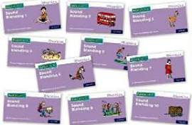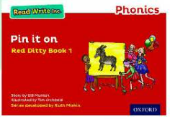
When children move into Reception Spring term they apply their phonic knowledge to reading and writing. They decode short passages to give children further practise in sound blending which is an important bridge between reading single words and reading stories. These are called: Ditties (PCM) which then leads onto Red Ditties as children progress.

As children progress (into Years One and Two) they then read 75 core decodable books which are matched to their phonic knowledge. These are book bag books.
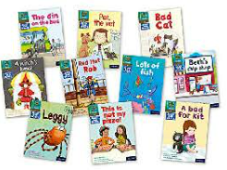

What to teach when?
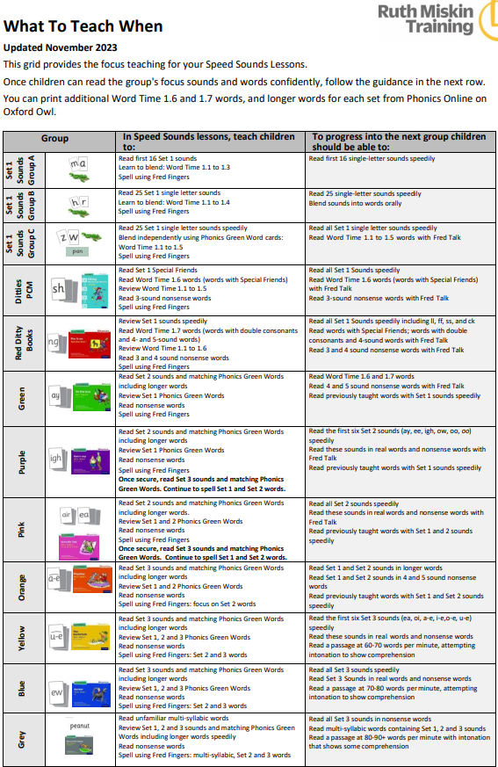

The Teaching of Reading in KS2

To reach the expected standard of reading in KS2, we researched the most effective methods for teaching children how to read. Our reading curriculum sets out an evidence-based approach to developing whole school reading adapted from, ‘The Art and Science of Teaching Primary Reading’ by Christopher Such and is made up of different elements.

Vocabulary Instruction – Please see website for full termly vocabulary instruction progression document

All three types of reading lessons begin with a discrete 5 – 10 minute vocabulary focus, as highlighted in the above lesson structures for fluency reading, extended reading and close reading. The tier 2 section below contains a list of tier 2 words to focus on during daily KS2 vocabulary instruction and there is also a list of common Latin and Greek root words that pupils should learn. A subsequent section then sets out weekly vocabulary plans, systematically splitting these word lists into weekly blocks for Years 3-6.

Although vocabulary development occurs naturally during the three types of reading lessons taught at St Joseph’s, discrete component vocabulary instruction ensures that an understanding of important tier 2 words and root words is systematically developed.

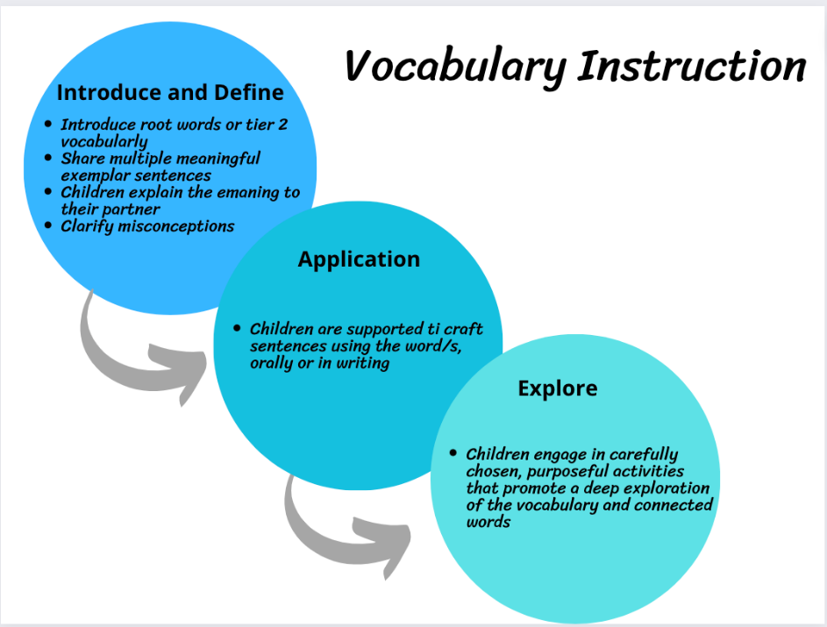
Weekly Vocabulary Instruction
Monday | Learning and exploring the weekly tier 2 vocabulary.
Tuesday | Learning and exploring the weekly root words and associated examples
Wednesday | Engaging in retrieval practice, focussing on tier 3 vocabulary from previous weeks.
Thursday | Engaging in retrieval practice, focussing on root words and associated vocabulary from previous weeks
Friday | Assess with a ‘low stakes quiz day’, testing the weekly content, including words and vocabulary retrieved from previous weeks.

In addition to discrete daily vocabulary instruction (outlined above) that systematically focusses on tier 2 vocabulary and root words, ongoing encounters with challenging and unfamiliar vocabulary throughout the exploration of chosen text are also carefully planned for during fluency, closed and extended reading lessons.

Class teachers preview the reading material for the week and then determine the following:
- How difficult is this reading material to understand?
- What words are most important to understand the text?
- What words are unlikely to be part of a child’s prior knowledge?
- What words lack helpful, directive contexts?
- What words appear repeatedly in the text?
- What words are interrelated, and help children know additional words?
- What words are frequently encountered in many subject disciplines?

Fluency Practice
Taken from, ‘The Art and Science of Teaching Primary Reading’ by Christopher Such
To comprehend, pupils need to be fluent readers - they need to have accuracy, automaticity and prosody. The fluency practice whole class reading lesson is most important when pupils are still developing their component decoding skills (i.e. Year 2 and 3) subsequently these lessons reduce in frequency as pupils move through the school.
Sessions should begin with discrete component vocabulary instruction. Refer to ‘Vocabulary Instruction’ section.
The fluency practice lesson focusses on developing fluency via repeated oral readings of bite-sized texts and extracts. These extracts should take approximately 1-1.5 minutes to read and be set at a level just beyond what an average reader is able to fluently read without modelling. Extracts should be 5-6 sentences for Y2, and 1-2 pages for Y6. Fluency practice begins with the teacher reading a text extract aloud. At this point, important tier 2/3 vocabulary and concepts central to the text should be discussed, although time before and after the teacher read can also be used for this purpose.
Following the modelled teacher read and subsequent teacher-led discussions, mixed ability pupil pairs then take turns to read the text to each other three times, with improved fluency on each occasion. The non-reading partner should be closely tracking the text with a ruler. This is devoid of questioning and discussion because the aim here is fluency, rather than comprehension. This should then be repeated with another short section of text.
During these multiple paired readings, partners can be trained to provide support (e.g. sensitively supporting the decoding of a challenging word). Teachers should use this time to assertively monitor the reading fluency of individuals, checking for required fluency and providing individual/whole class feedback and re-model as needed.
Carefully select individual/s to read a maximum of two or three sentences aloud to the class.
The teacher should then end the session by leading a brief discussion regarding the content of the text, in order to establish meaning, including appropriate whole class comprehension questioning for pairs to discuss and feedback to the class.
Generating written evidence is not the focus of this session.

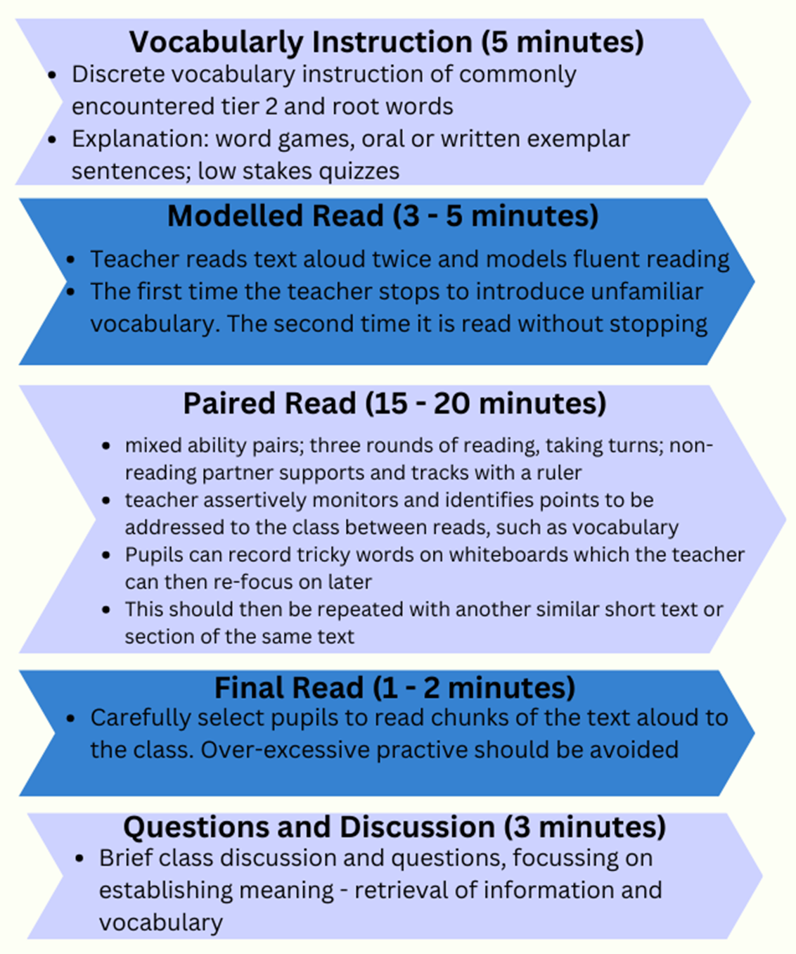

Extended Reading
Taken from, ‘The Art and Science of Teaching Primary Reading’ by Christopher Such
The whole class extended reading lesson should follow fluency practice and increase in frequency as pupils become more fluent. It involves prolonged engagement with a longer text and focusses on stamina, fluency, component word knowledge, background knowledge and text knowledge though extended exposure to a text.
Sessions begin with discrete component vocabulary instruction. Refer to the ‘Vocabulary Instruction ‘section for detailed guidance.
Relative to close reading, extended reading involves more reading and less text analysis. According to the ages and stages of the pupils, there are four approaches to extended reading:
- The teacher reads aloud and pupils follow with a ruler. Pupils are kept engaged by periodic chanting in unison of key words.
- Selected pupils take it in turns to read sentences aloud with other pupils following the text with a ruler.
- The teacher may also periodically read sentences aloud. Pupils are kept engaged via quick transitions from pupil to pupils and by periodic chanting in unison of key words when the teacher is reading.
- Pupils independently and silently read small sections of the text, with the size of each section managed carefully so that differences in reading speeds do not create issues. Older pupils will generally read longer sections of text compared to younger pupils.

Pupils independently and silently read larger sections of the text. Comprehension questions are prepared for pupils who finish.
Approaches 1 and 2 above are generally more suited to early readers (e.g. Year 2), whereas approaches 3 and 4 are generally more suited to Key Stage 2 pupils and/or more fluent readers.
Phases of discussion and whole-class questioning should be embedded throughout extended reading, at carefully selected points. This requires planning and should involve teachers supporting pupils to clarify and explore meaning, understand new vocabulary and summarise. Refer to the separate sections on vocabulary and questioning for detailed guidance.
As a rough guide, two thirds of the time should be spent reading, and one third should be dedicated to related discussion and answering questions.
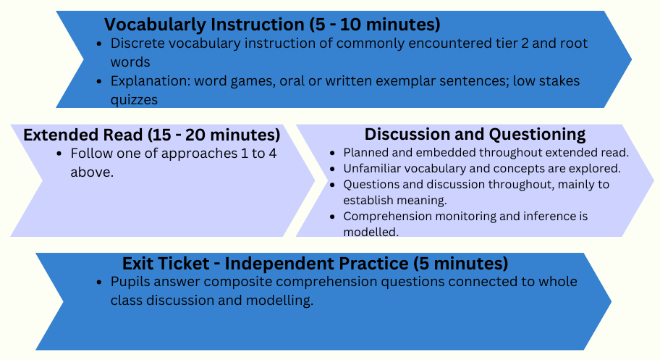
Extended Reading Lesson

Close Reading
Taken from, ‘The Art and Science of Teaching Primary Reading’ by Christopher Such
The whole class close reading lesson should follow extended reading and increase in frequency as pupils become more fluent readers. It involves the sustained, detailed analysis of a short text and focusses on the development of component vocabulary knowledge, text knowledge, authorial intent and comparisons with other texts, through deep discussion and analysis. Relative to extended reading, close reading involves less reading and more text analysis.
In a close read, meaning is established and analysed. Establishing meaning is working out what the author is communicating. Analysing meaning is deeper - underlying themes, comparisons and interpreting authorial intent.
Sessions should begin with discrete component vocabulary instruction. Refer to the ‘Vocabulary Instruction’ section for detailed guidance.
The first read of the text focusses on developing overall sense and understanding of a text. This may incorporate a combination of the teacher reading aloud, paired reading or independent reading, as per the needs of the class.
Unfamiliar vocabulary and concepts should be explored with the class within an environment of rich discussion.
Second (and further additional) reads should focus on particular pertinent aspects that the teacher judges to be important to a particular text, such as underlying themes, powerful vocabulary choices or the use of technical vocabulary, use of literary devices, plot points, text-level features of a non-fiction text, the use of anaphors and other cohesive devices, and other features deemed important. Here, instruction goes beyond establishing meaning, and also focusses on analysing meaning beyond what the author is doing to why the author is doing it.
Examples of themes and foci that may be the focus of analysing meaning during a close read include: character traits, text structure of genre, use of descriptions, use of ambiguity, stylistic features, use of punctuation, humour, tone, irony, the level of formality, plot devices and the use of rhetoric.
Deep and prolonged phases of class discussion and questioning should be embedded throughout the close reading.
Some of these phases of questioning should include the modelling of written comprehension strategies, culminating with pupils independently answering composite comprehension questions in writing.However, it is the reading of the text and the related deep discussion that has greatest impact on pupils’ developing abilities to read, rather than engaging in prolonged written comprehension evidence.
As a rough guide, one third of the time should be spent reading, and two thirds should be for discussion/questions.
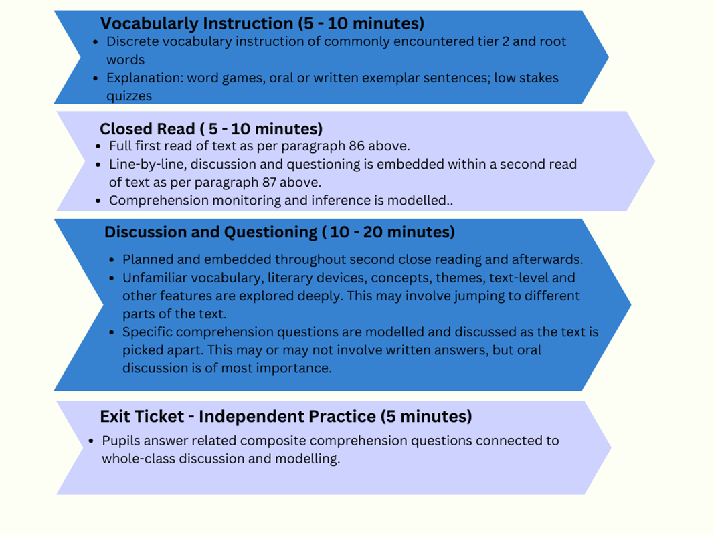

Reading at home in KS2 – Books Match Sounds
Books taken home should be read with 95+% accuracy by the child. This ensures that we are encouraging children to read fluently. The table below ensures children are reading the correct banded book, taking into account their actual reading age and the expectations of the National Curriculum. We have changed the books in Reception, Year 1 and Year 2 to the ‘book bag books’ that match the RWI phonics programme.
Key stage 2 children are assessed on Accelerated Reader, which is a programme that helps students build regular reading habits by matching them with books at the right level and checking understanding through short quizzes. Children are assessed on a termly basis and results are recorded on Insight.
Children in Year 2 are also assessed on Accelerated Reader and are encouraged to take a book home from their ZPD.
Guidance for Parents

- We offer guidance and support for parents to help their children with their reading. This includes:
- We have a Reception Phonics Breakfast – Parents are informed about how we teach Phonics
- We have a Year One Phonics Parents Meeting – Parents are invited to come and learn about how we teach Phonics and the requirements of the Phonics Screening Check.
- Year Six have parent meetings about the requirements in terms of reading for the end of Key Stage 2 SATS.
- Our home school reading records are bright and engaging, with further guidance inside them with phonics and comprehension questions parents can ask children.

Tips to Make Reading Fun at Home

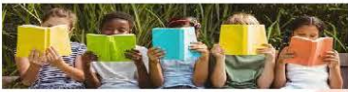
- Make books a part of your family life - always have books around so that you and your children are ready to read whenever there’s a chance.
- Join your local library - get your child a library card. You’ll find the latest video games and DVDS plus plenty of fantastic books. Allow them to pick their own books encouraging their own interests.
- Match their interests - help them to find the right book – it doesn’t matter if it’s fiction, non-fiction, comics, graphic novels, magazines and leaflets.
- Get comfortable - snuggle up somewhere warm and cosy with your child.
- Ask questions - to keep them interested in the story, ask you child questions such as, ‘What do you think will happen next?’ or ‘Where did we get to last night? Can you remember what had happened already?’
- Read whenever you get the chance – bring along a book or magazine for any time.
- Read again and again - encourage your child to re- read favourite books and poems. Re-reading helps to build up fluency and confidence.
- Bedtime stories - regularly read with your child or children at bedtime. It’s a great way to end the day and spend valuable time with your child.
- Rhyme and repetition - books and poems which include rhyme and repetition are great for encouraging your child or children to join in and remember the words!

