We are pleased to be able to share the content of the curriculum that your child will receive this half term. We will now send these newsletters at the start of each half-term and hope that they provide you with an overview of teaching to enable you to support your child in their learning
St. Joseph’s Catholic Primary School
EYFS Curriculum Newsletter
Autumn 2
Communication and Language
Our Literacy texts for this half term will focus on our topic of ‘People Who help up in our locality’ and ‘Winter’. These books are part of our reading spine. We hope you will enjoy reading these books with your child at home. The focus for our lessons and provision will be develop the children’s vocabulary, especially around people who help us and Winter.
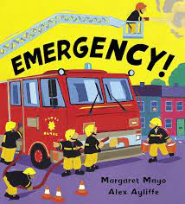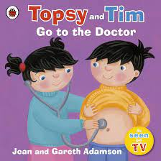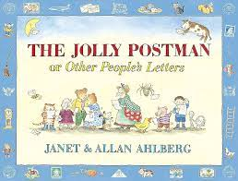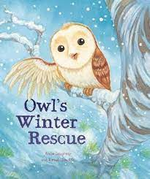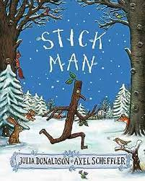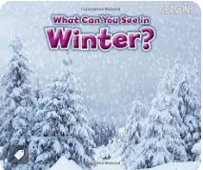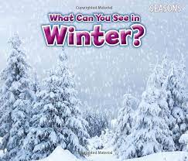

Physical Development
This half term we will be working on the following skills:
Reception:
We will use lots of different ways of moving with fluency and control. We will also practise climbing over, under and through obstacles.

We will mark make, draw, use cutlery and other one handed equipment
Nursery:
We will be running, jumping and hopping. We will be waving flags and streamers and use other large scale muscle movement.
We will start to show a preference for a dominant hand and use the toilet independently.

Personal and Emotional
Development
This half term the children will be focusing on the understanding of their own feelings and those of others and begin to regulate their behaviour. We will also be focusing on building resilience, independence and self-confidence skills.
Maths
Our main aim this half term is to build a strong foundation of knowledge surrounding number and numerical patterns through the use of practical activities using manipulatives. We will practise reciting numbers, counting objects and comparing different quantities and begin to build a deep understanding of numbers to 5. We will also learn about shape, time and positional language
Understanding the World
In our ‘People who help us’ topic we will be looking at the roles of different people in the community.

In our Winter topic we will make observations of the world around us. We will talk about the weather linked to seasonal change and talk about freezing and melting.

Literacy
We will be leading our topic with the stories in the ‘Communication and Language’ box. In Reception, we will be writing simple labels and captions about our stories and spelling c-v-c words such as c-a-t.
In Nursery, we will be using some print knowledge for writing e.g pretending to make a shopping list and we will begin to write the first letter of our name.
Expressive Art and Design
We will be recreating our own versions of ‘Starry Night’ by Vincent Van Gogh
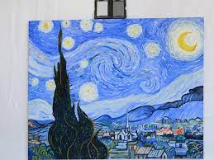
Understanding the World
In our ‘People who help us’ topic we will be looking at the roles of different people in the community.

In our Winter topic we will make observations of the world around us. We will talk about the weather linked to seasonal change and talk about freezing and melting.

