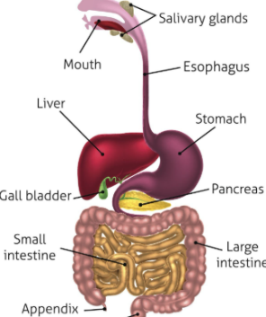
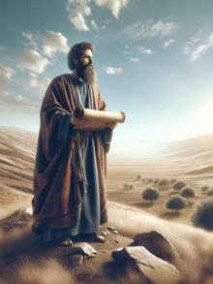
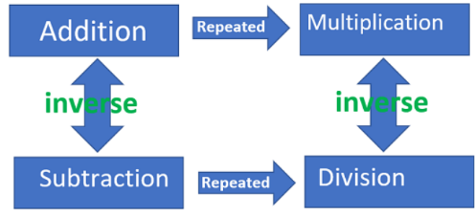
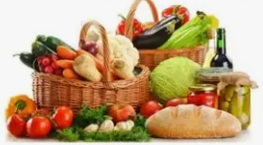
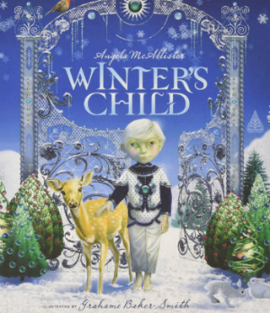
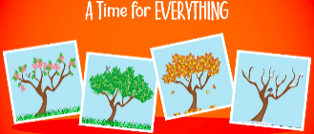
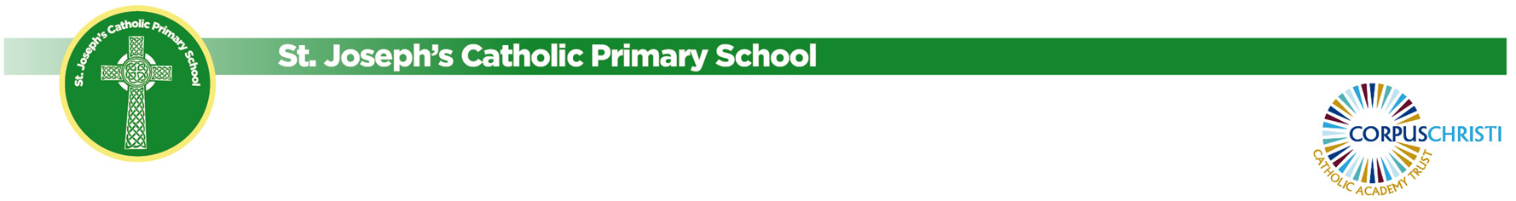
We will be looking at our multiplications up to 12 x 12.
Foundation Subjects

PE
The children will be learning about dance in their topic this half term.

Music
Mrs McGovern from the Stockport Music Service will continue to teach the children violin. They will soon be ready to perform for you all!

Computing
We will be learning about Computing Systems & Networks: collaborative learning.

DT
Our art lessons this term will focus on mechanical systems, designing and making mechanical cars.

French
Our topic for French this half term is ‘Family and friends’.
Religion & Celebration of the Word
Our branch this half term is learning about prophecy and promise. We will be focussing on understanding what a prophet is.
Science
This half term we are looking at animals including humans. We will be making a model of the human digestive system and investigating teeth.
Geography

Our topic this half term is
‘Where does our food come from?’ The children will develop their understanding of how and where certain foods are produced. We will visit Stockport market to carry out research about this topic.
English
We are looking at the book Winter’s Child The children will continue to develop their writing skills, retelling the story and using speech to write their own fantasy story.

PSHE/RHE

Our topics are learning about healthy lifestyles, ourselves, growing and changing and keeping safe.
Maths
We have continued to develop our addition and subtraction skills.
Year 3/4 Newsletter – Autumn 2

