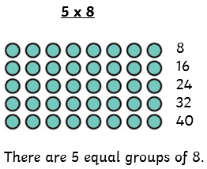
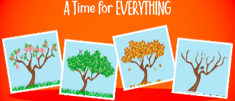
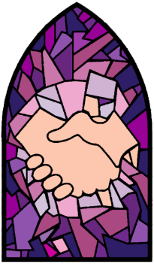
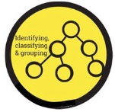
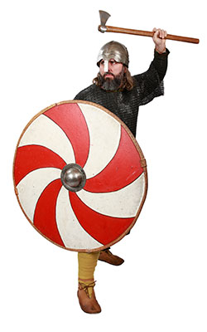
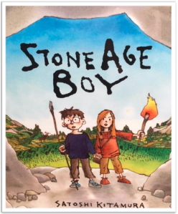
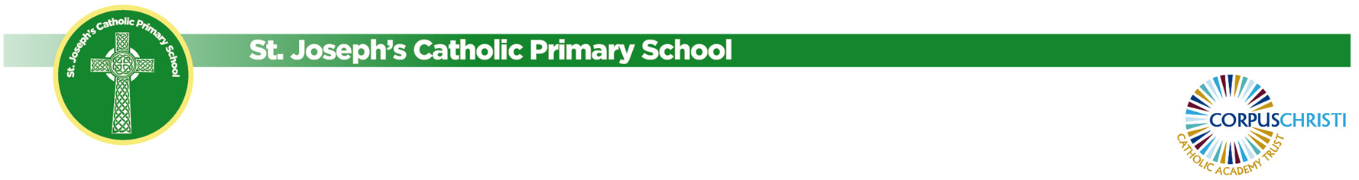
Foundation Subjects

PE
The children are going swimming on Tuesdays and completing a series on sessions learning how to play cricket on Wednesdays.
Music
Mrs McGovern from the Stockport Music Service will continue to teach the children violin. They will soon be ready to perform for you all!
Computing
We will be learning to programme using Scratch.
Art
Our art lessons this term will focus on developing painting skills; using tints and shades to create dimension.
French
Our topic for French this half term is ‘Our School’
Religion & Celebration of the Word
Our branch this half term is learning about Galilee to Jerusalem focusing on sacraments.
Science
This half term we are looking at living things and their habitats. Children will be learning about classifying animals based on their characteristics.
We will be looking at multiplying 2-digit and 3-digit numbers by a 1-digit number next.
English
We are looking at the book Stone Age Boy. The children will continue to develop their writing skills, retelling the story and using speech to show the relationship between the characters.

History
Our topic this half term is ‘Were the Vikings invaders or peace living settlers?’ The children will develop their understanding of chronology and change between periods of time. We will make links to our previous topic of Anglo-Saxons.
PSHE/RHE
Our topics are learning about feelings and emotions, healthy relationships and valuing difference.
Maths
We have continued to develop multiplication and division skills.
Year 3/4 Newsletter - Spring 1

