Arghi Class
WK 21st Feb and 28th Feb
Area | Activity | Links
English | Watch / read Chocolate Cake by Michael Rosen  Communication: Sign Along: Practise signs for chocolate and other foods you might have as a treat or find them on Proloquo2Go on your IPad – you could also see if you can find the ingredients and the equipment you would need to make a chocolate mug cake.  When Michael Rosen is reading the poem, he uses lots of expression and actions. This is called performance poetry. Can you think of some actions to go with the poem? Choose a section of the poem and see if you can act it out  Reading & Phonics: –  Some of my favourite things begin with ch  e.g. chocolate, chips, chickpeas  Make a list of all the things you can think of that begin with ch  ( it doesn’t have to be food)  In the poem, Michael Rosen uses onomatopoeias – words that describe sounds. (You might remember we looked at some of these words in our Superheroes topic e.g. bang! Zapp!)  Make a list of some of the onomatopoeias in the Chocolate Cake poem. | https://www.youtube.com/watch?v=7BxQLITdOOc  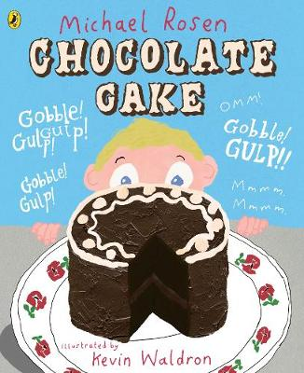  for PDF version  https://www.poemhunter.com/i/ebooks/pdf/michael_rosen_2004_9.pdf  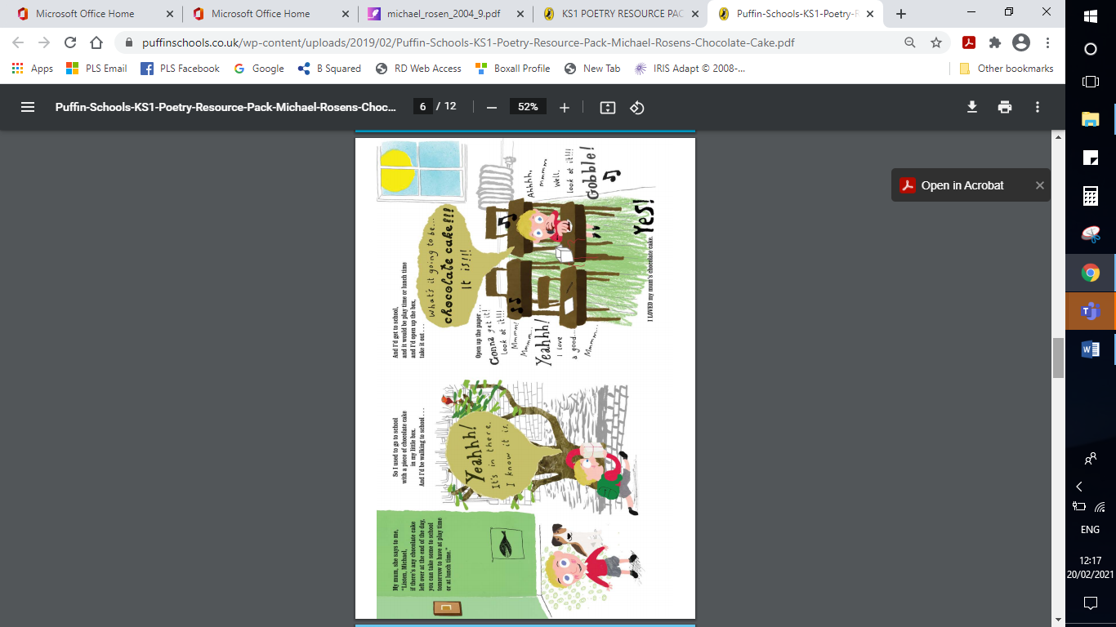
Maths | Make a chocolate microwave mug cake  (Try to use Fairtrade cocoa)  Follow the recipe using a tablespoon to measure the ingredients.  Take some different spoons put them in size order  Can you find a teaspoon, a desert spoon, a tablespoon, a wooden spoon?  Which is the biggest and which is the smallest?  Next time you have a cake or a bar of chocolate see if you can find a half by cutting or breaking it into two equal parts. | https://www.bbcgoodfood.com/recipes/microwave-mug-cake  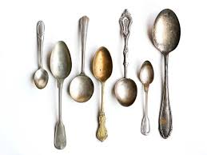  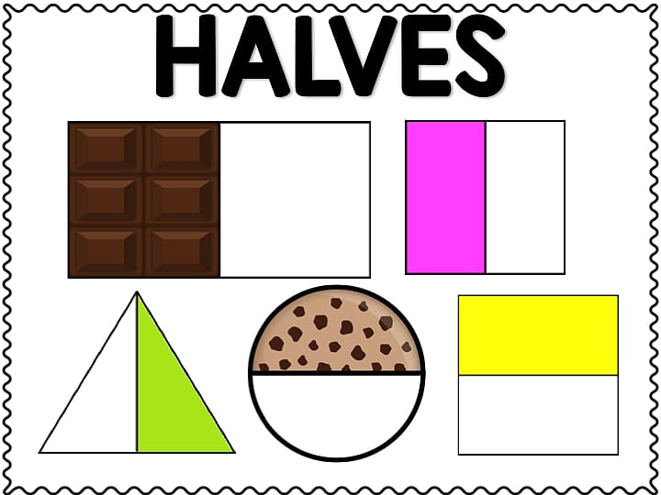
Creativity | Design a chocolate bar  Think of a name  What colours would you use?  What flavours wll you add?  Think about what Fairtrade ingredients you might use  Don’t forget to add the Fairtrade symbol  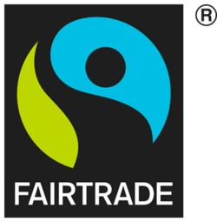 | https://www.chocolatarium.co.uk/wp-content/uploads/2019/11/Chocolatarium-Schools-Resources-1-Design-your-own-chocolate-bar-Lesson-ALL-RESOURCES.pdf  Here are some examples  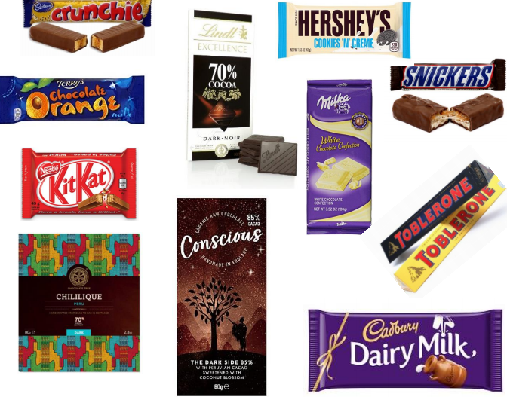
Individuality | Do the Fairtrade step  Make a list of all the sweets and treats you eat each day for a week  Do you eat too many unhealthy treats?  Can you think of healthy alternatives to sweets and crisps?  Can you find any healthy Fairtrade snacks? | https://www.youtube.com/watch?v=s1uVpzFeQgs
Community | 22 February to 7 March 2021 is Fairtrade fortnight  Fair trade is a way of buying and selling products that allows the farmers to be paid a fair price for their produce, and have better working conditions. Trade is 'unfair' when farmers receive very low income and have poor conditions while the companies that sell their products make lots of money from them.  watch the video clip  My Fairtrade Adventure (for ages 7 to 11)  using pictures from the internet or your own drawings  Make a poster to show how Fairtrade helps cocoa farmers  ( money for schools, running water, electricity better homes,fair wages etc  or  on a paper plate make a fair trade symbol using coloured paper or paint  See how many products you can find with Fairtrade symbol in you r food cupboard. | https://www.youtube.com/watch?v=VeUGvhINwHw  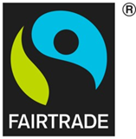
Challenge | Which chocolate melts first?  Take a piece of Fairtrade dark chocolate  a piece of Fairtrade milk chocolate and a piece of white Fairtrade chocolate all the same size and thickness.  Put them in a foil tray and place that in some hot water (so the try is floating on the hot water.) Set a timer.  Which piece do you think will melt first?  Which piece did melt first?  How long did each piece take to melt?  If you can record your experiment in table  Why do you think this is?  Have a look at the ingredients. Does that give you any clues? | 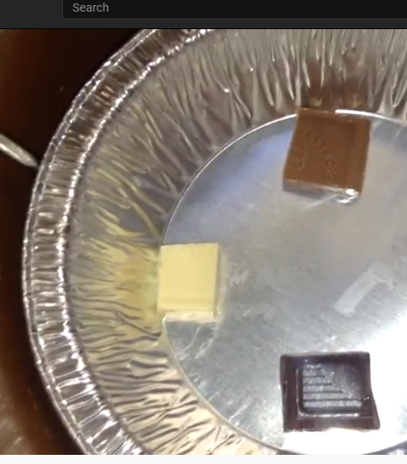  https://www.youtube.com/watch?v=Cx5nTBmTpEc
- Please refer to annual reviews for your child’s personalised targets.

I would love to see and hear about what you have been doing, feel free to email myself anytime – swright@parklane,cheshire.sch.uk

