6th Form 2
Wk Beginning 22nd Feb. (Wed,Thursday,Friday )
Area | Activity | Links
PE/ Outdoor Education Healthy Living | 1. Go for a walk/cycle.  - While on the walk complete the ‘wildlife watch’,  - or identify some of the different OS map symbols you have been learning. Use the symbols work sheets to help and if can take some photos of the features to stick to the symbols worksheets.  - Revise the different compass points and complete the compass point worksheet.  - Complete the quick symbols worksheets to test your knowledge of the different OS map symbols.  2. Take part in on online fitness session. Joe wicks  3. Complete and evaluate weekly healthy living plan. Evaluate how well you have done at the end of each week. (use sheets on distance learning web site)  4. Some home PE ideas from Panathlon  Map Coordinates activity  Work through the coordinate’s power point. | Lesson materials/worksheets  Wild life watch worksheets 1 and 2  OS map symbols worksheets  Healthy eating plan and evaluation sheet(from last week)  https://panathlon.com/panathlon-launches-at-home-sporting-challenges/  Coordinates PowerPoint/treasure map  Ext work sheet
Cookery/Daily living skills | 1.Make cupcakes  The class have been enjoying making different cupcakes each Thursday morning. They have been making them using cupcake kits purchased from the local supermarket.  Here are some of the different cup cake mixes they have used.  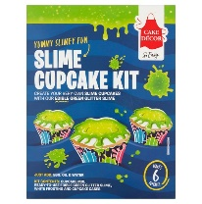  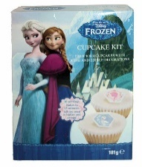  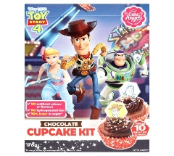  2. Make pancakes.  Design your own pancake.  Take a photo of your end pancake  3. Help around the house. Helping to wash and dry up, dusting, hoovering, making your own bed etc. | Lesson materials /worksheets  Perfect pancakes recipe - BBC Good Food  Pancake template  Example of pancake face design
Vocational Studies | Vocational – Recycling  Sort your families recycling into different sections (e.g. plastic, tins, food, and cardboard). Then place them in the correct bins.  Link with the Big Garden birdwatch  Make a birdfeeder from a recycled plastic bottle  Make a speedy bird cake  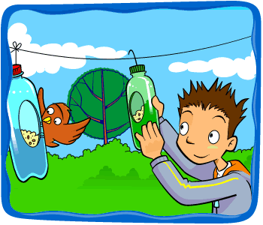  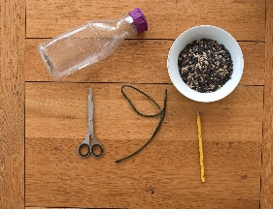  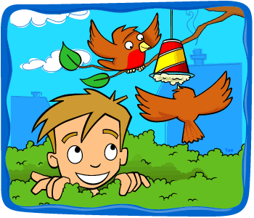 |   Make a Recycled Bird Feeder | Fun Activities for Kids - The RSPB  Homemade Bird Food Recipe | Make Bird Seed Cakes - The RSPB  Bottle bird feeder instructions  Speedy bird cake instructions
Countries and Cultures | This term the Countries and Cultures group will also be learning about USA. Here are some things you could do. (see separate sheets) 2weeks work  - Look at other traditional USA things. (See Power point)  - USA Food tasting  - Colour a template of the USA flag  - Complete USA worksheet using pictures provided.  - Watch video clip of Line dancing  - Locate USA on the map of world and label with labels provided.  - Complete USA word search  - Make Popcorn  - Listen to rhinestone cowboy  - Listen to National Anthem.  - Watch clip of American football. | Lesson materials/worksheets  USA Power Point  USA Food tasting sheets  USA word search  Map of world  USA label /symbol for map  USA worksheet  USA pictures  USA flag colouring page  Youtube clips  Glen Campbell - Rhinestone Cowboy (Official Music Video) - YouTube  Best Game Winning Touchdowns in NFL History || HD - YouTube  Star Spangled Banner with Lyrics, Vocals, and Beautiful Photos - YouTube  ONE HUNDRED line dance - Wild Country - Voghera 2017 - YouTube
English | Weekly Log.  Complete a simple weekly log using sheets provided. Using 2 photos (optional) and write a short sentence describing 2 things you have done this.  Include key information what ,where, who and what | Weekly Log recording sheet.
Art and  Extra | Andy Warhol. Pop art (linked with USA)  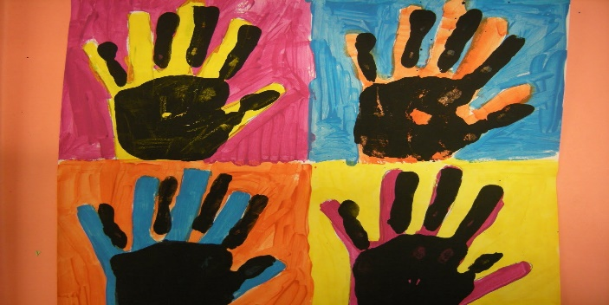  Jackson Pollock drip art (Linked with USA)  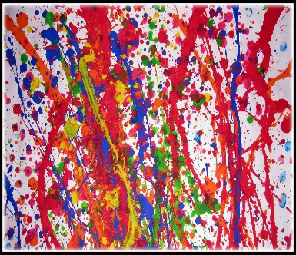  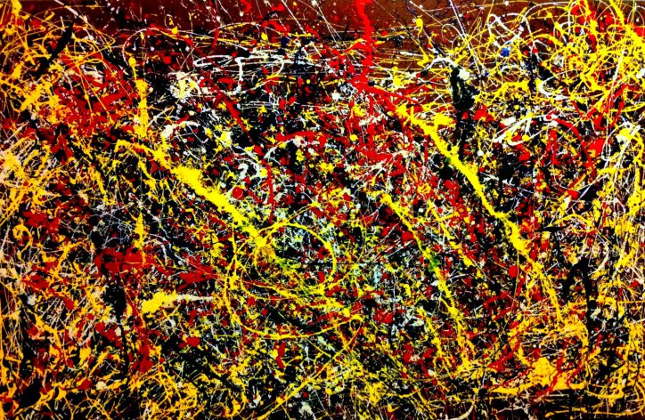  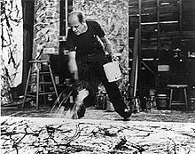 | Paint/ paper  Hand or foot prints  Use different balls/ straws/ brushes to flick and roll paint on to paper.
- Please refer to annual reviews for your child’s personalised targets.

I would love to see and hear about what you have been doing, feel free to email myself anytime – eshaw@parklane,cheshire.sch.uk

