Mulberry Class
WK: 22nd Feb & 1st March 2021
Area | Activity | Links /resources
English | - Read the story Stuck!  - Read the story or watch the story being read on YouTube. Use the ‘Stuck’ communication storyboard below to join in with the story, pass comments and answer questions about the book. Can you make full sentences using the symbol board? Think about who was in the story, where it took place and what happened?  - Read the captions below and draw a picture to go with each sentence.  - Fine motor skills: Ribbon dances, dough disco, using index finger to point to symbols/words and using hands to perform signs.  - Read the story What We’ll build, or watch it on YouTube  The story is about a parent and child working together to build a safe and happy home.  Activity:  - Draw a picture of your home and the people who live there. Have a discussion with your parents or siblings about what makes you feel safe at home.  - Reading & Phonics: – Reading books or free reading books / Education City login. | YouTube story - https://www.youtube.com/watch?v=hipx6HJs4XQ  YouTube Story-  https://www.youtube.com/watch?v=HARoCl2p5P4  Sentences below & sent home.  Education City Homework Spring 2021 page– parent login
Maths | - Watch the video (Emma pre-recorded session) Ask your child to show you different numbers up to 10 with their fingers – if this is tricky for some use items instead. Mark a dice (you could use any cube you have and add the dots or make one out of paper.) and roll, can you make that number on your hands or with items. *Extend – mark the dice 5, 6,7, 8, 9, 10. Try to start counting from 5 rather than counting out the first 5 fingers/items. As we already know that a hand has 5 fingers.  - Watch our number video ‘add 1 more’ (Emma pre-recorded session) and complete the task at the end.  - Watch https://www.youtube.com/watch?v=EIxaxnageTo to learn how to tell the time o’clock  - Time: Explore a clock on https://www.topmarks.co.uk/time/teaching-clock or use an old clock at home to find o’clock.  - Play a time matching game on https://www.topmarks.co.uk/Flash.aspx?f=matchingpairstimev3 | Class YouTube Link sent by email.  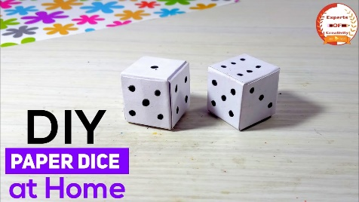  Education City Homework Spring 2021 page– parent login
Creativity | Can you paint a sunset sky?  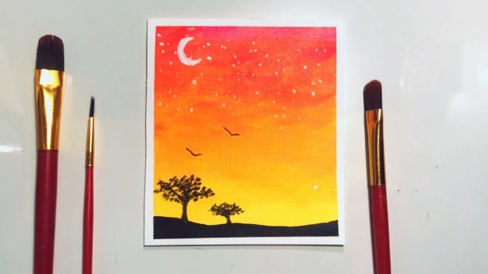  Watch https://www.youtube.com/watch?v=76jpCIZTq2E up to 2:30 to practice how to paint a sunset sky using lines. If you haven’t got paint at home try making your own paint by using this recipe:  - 1/2 cup flour  - 1/2 cup salt  - 1/2 cup water (you may need more water for runnier paint)  - Food colourings of your choice | https://www.youtube.com/watch?v=76jpCIZTq2E
Individuality | Beanbag target throw.  Warm up your arms and hands by watching Debbie Doo on YouTube  Use a ball/small cushion/teddy if you haven’t got a bean bag at home.  - Use hoops/baskets/boxes as targets.  - Increase the distance little by little and use different sized targets for an extra challenge.  - Can you get your ball/bean bag to the target by using different hands? | https://www.youtube.com/watch?v=EAPmy1SxDdQ
Community | What’s Fairtrade? Fairtrade is about better prices, decent working conditions, local sustainability, and fair terms of trade for farmers and workers in the developing world.  https://www.twinkl.co.uk/resource/t2-t-16633-fair-trade-information-powerpoint  https://www.fairtrade.org.uk/what-is-fairtrade/  Have a hunt around you house and find Fairtrade products. Colour in the fairtrade sheet and explore the logo – see symbol instruction pack sent home.  Using the fairtrade chocolate can you make something delicious?  Explore Cocoa Lite symbol on the hot chocolate and investigate what this means. Enjoy a fairtrade hot chocolate – can you help to make it? | Resource bag sent home
Challenge | Thinking about your toys you have already explored and investigated – can you produce two toy reviews? - Some things to consider when compiling toy reviews:  Which age group is the toy aimed at?  Is it more likely to appeal to girls or boys?  Is the toy only for use by one person at a time or can others play with it?  Does it encourage children to work together or compete against each other?  What will children learn by playing with the toy?  Price - Does it represent good value for money?  Does the toy need additional equipment (e.g. batteries) or special skills from the player (e.g. ability to read / spell)?  Fun - Is the toy fun to play with?  Overall rating - How many stars would children give the toy (out of five or ten) or thumbs up/thumbs down?
- Please refer to annual reviews for your child’s personalised targets.
We would love to see and hear about what you have been doing, feel free to email anytime
twu@parklane.cheshire.sch.uk eshaw@parklane.cheshire.sch.uk

