Hovis Class
Week Beginning 25/01/21 – 01/02/21
Spring Term Topic –How things work Focus- Lifestyles
Area | Activity | Links
English | Story, song or rhyme: Choose a story to share either a physical book, or an interactive book available on Youtube/Twinkl ebooks or alternatively, if you are feeling energetic, you can choose a story from Cosmic Yoga- and complete the actions to each story you read. Ask students comprehension questions about each story- name/recognise characters, talk about events in the story, why events happened etc. Use communication books or voice to describe characters e.g big/small, what colours are they wearing. Practice using yes/no symbols to answer questions about the story too, did you like it? Do you think a certain character is funny or grumpy etc.  Reading & Phonics: – Reading books / Education City login for phonics songs and letter recognition activities.  Also use Letters and Sounds website to access online games for each phase.( Please contact me if you want specific games to play on or any resources making and I would be happy to do this)  Fine motor skills: Practice mark making, writing letters from your name or writing words of your choice. You could even make a diary of your what things you have been able to do at home, how you are feeling or any other thoughts. Work on fine motor skills activities such as threading, picking up items with tongs or tweezers, inset jigsaw puzzles, pegging out washing etc.  Communication: Learn new Signalong signs. Practice signs on Signalong website and Park Lane Facebook group/Website. Use any opportunity to make and confirm choices using personalised communication systems e.g making choices at playtimes, mealtimes, snacktimes etc. Work on Communication Targets outlined in Annual Reviews.  ( If you would like more specific targets or any resources for any section of the English work please let me know)  Weekly SALT sing and sign session- see link that was emailed out. | https://www.youtube.com/user/CosmicKidsYoga  https://www.vooks.com/  https://www.educationcity.com/  http://www.letters-and-sounds.com/  https://en-gb.facebook.com/signalongcharity/  https://en-gb.facebook.com/pages/category/Elementary-School/Park-Lane-Special-School-1641122062807137/
Maths | Shape  Recognising 2D shapes (Square, triangle, rectangle, circle)  For each shape practice the name and counting how many sides it has. You can make some of your own shapes by cutting them out of a thick cardboard box if you don’t have any plastic ones.  Play games such as which shape is in the bag. Students to pick out a shape from the bag and then communicate which shape they have found.  Pass the parcel shapes- make a pass the parcel but wrap a different shape in each layer, identify each shape at each layer.  A shape treasure hunt- hide shapes around the room or around the house and students to go and find them and bring them all back.  If you have multiple versions of each shape- students can practice grouping them.  Play shape recognition games on Education City and/or find different shapes around your house e.g in patterns of fabric, what shape is the door, window, mirror etc.  Then 3d shape recognition.  Sphere, cube, cuboid, pyramid, cylinder, triangular prism. You can collect examples from round the house or use old packaging, use things like a ball, toblerone box, etc.  Play games like find the matching shape, shape hunt around the room, blindfolded guessing game, can you feel the shape and guess the correct name?  Measure- Role play playing ‘shops’ Set up a shop, it could be a toy shop or snack café- label each item with either a number, coin or price ( depending on the level of your child) – get the child to pay for what they want to buy  Repeat the following steps until the concept is grasped and then move on to the next one….  Start by asking students to hand over any amount of coins to get used the concept of transaction.  Then for the next step students should purchase by giving you the same coin as the one on the item, limit this to 2 or 3 coins at first then expand.  Then counting out the number of coins e.g six coins, 4 coins etc  Then extend by telling students which coin you need e.g find me a £1 | Some links to online games  https://www.topmarks.co.uk/early-years/shape-monsters  https://www.topmarks.co.uk/ordering-and-sequencing/shape-patterns  https://www.ictgames.com/mobilePage/shiftingShapes/index.html
Creativity | Houses/architecture  Look at pictures of different buildings  BBC Teach proud to be an architect  https://www.bbc.co.uk/teach/class-clips-video/pshe-ks1-ks2-proud-to-be-an-architect/zbf76v4  create collage of a landscape / cityscape urban landscape- ideas bon below link  https://www.bbc.co.uk/teach/class-clips-video/art-and-design-ks1-ks2-creating-a-collage-landscape/zfrfbdm  look at different types of dwellings  think about building materials, feel the texture of some building material, wood slate brick, concrete, straw,  explore internal and external surfaces around the home and garden , make rubbings of different surfaces with wax crayons  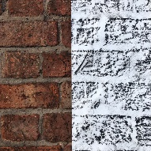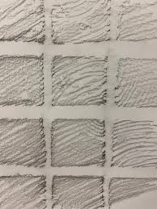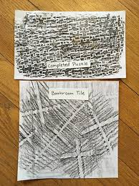  Compare the different textures and patterns  Use Lego bricks to make a House  Who would live there?  Describe some of the features you find on a house, windows doors etc.  look at images of different dwellings: terraced houses, detached houses , bungalows, flats, mobile homes, cardboard boxes etc.  compare pictures Lowry  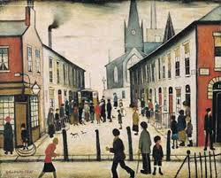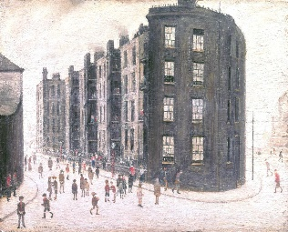  Edward Hopper House by the railroad  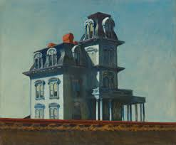  Vincent van Gogh, The Vicarage at Nuenen, 1885  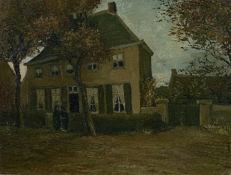  build a model house from cardboard and recycled materials  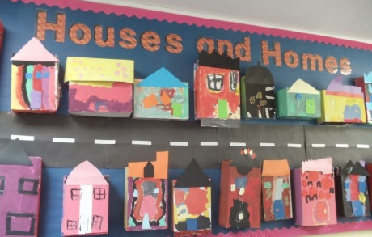  you could use houses model pack on twinkl  https://www.twinkl.co.uk/resource/t-t-15170-houses-and-homes-model-pack  and  https://www.twinkl.co.uk/resource/t-t-7311-houses-and-homes-build-a-house-using-shapes
Individuality | P.E  Keep active-  Can you move around the room or garden in different ways? Walk, run, hop, crawl , jump, skip etc.  Can you take part in a P.E with Joe Wicks workout, copying the movements?  https://www.youtube.com/watch?v=ke04O2ma7eI  Take part in a cosmic yoga session  https://www.youtube.com/user/CosmicKidsYoga  Healthy eating  Watch –  - Healthy Food Song for kids – Jack Hartmann  https://www.youtube.com/watch?v=5dR22hbln6w  - Healthy Eating: An introduction for children aged 5-11  https://www.youtube.com/watch/mMHVEFWNLMc  Get some food and drink items from the kitchen, can you sort them into healthy/unhealthy. Offer students two food items one healthy one unhealthy can they choose the healthy or unhealthier option.  Remind every child that all foods are ok to be consumed but some we should have more of than others as they keep us healthier.
Community | Chinese New Year - Dragons in the City- ebook on Twinkl  https://www.twinkl.co.uk/resource/t-l-54364-dragons-in-the-city-ebook-english  Refresh memory by reading story above about Chinese new year. What things happen at the celebration – Lion and dragon dancing, red envelopes, special food, wishing tree etc.  Make a wishing tree – gather small branches and fix red ribbons or paper to the branches- with a wish, hope or simply a child’s mark marking to contribute.  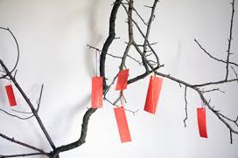  Have an early Chinese new year celebration – The actual date is Friday 12th February  Taste some Chinese food, you can either buy it or make your own together. Take part in your own dragon dancing or watch it one YouTube. Watch Fireworks together, again clips are accessible on YouTube links below.  Fireworks  https://www.fireworkscrazy.co.uk/chinese-new-year-fireworks-2019/  Parade clips  https://www.youtube.com/watch?v=2ZGQb3FFh7U  Chinese food ideas.  https://www.bbcgoodfood.com/recipes/collection/chinese-recipes  You could make your own Dragon face mask  https://www.twinkl.co.uk/resource/t-t-26168-chinese-dragon-mask-design-sheet  Explore Chinese Culture including Buddhism- China’s main recognised religion and focus on spirituality.  Story of Buddhism- PowerPoints available on the below links  https://www.twinkl.co.uk/resource/t-t-2548045-eyfs-all-about-buddha-powerpoint  https://www.twinkl.co.uk/resource/t-t-2548025-ks1-buddhism-activity-powerpoint  There is also a video link below  https://www.youtube.com/watch?v=J-UwlloVveI&list=PLcvEcrsF_9zIQm-KPGujuZkNRk_jTcehV&index=2
Challenge | Seasons- can we recognise the seasons.  Spring  Read the traditional tale (with a twist) the Three Billy Goats Fluff  There is a link below to the story been read if you don’t have access to it or don’t want to buy it.  https://www.youtube.com/watch?v=ghblvxSBKqQ  Link to the season of spring – the grass beginning to grow again after winter and the goats wanting to cross the bridge to get to the meadow.  If you can, explore sowing your own seeds and making sure you get ‘spring weather’ in order to grow – sunlight & water. Ideas for simple and quick growing seed activities are below.  https://www.youtube.com/watch?v=6Stm5ZhhjaU  https://www.youtube.com/watch?v=4kmKPyv_VUc  Explore activities people can do in spring & familiar events that happen in spring – go out and splash in puddles, do an Easter egg hunt, plant seeds, explore lighter clothing, make a birds nest out of twigs and moss etc, find some baby ducklings on the pond/canal, look at flowers beginning to bloom – snowdrops, tulips, daffodils, blossom.  If you can’t recreate any of these due to not being able to go out in the community then try to recreate in your garden or home or find example on Youtube. The video below is a lovely BBC Teach video- about spring. You can pause the video and discuss each spring event you can see happening. Students can use their communication books or voices to comment on what they see.  https://www.youtube.com/watch?v=vLAnt9__5Mg  Can you create some Spring time Art?  There is a video below with lots of lovely ideas, depending on what resources you have available.  https://www.youtube.com/watch?v=xSsdnC896pU
Please feel free to email me anytime if you have any questions, if you need any further support/resources or if you want to send pictures or an email to update me on your progress. I would love to see what you are getting up to. My email address is lrashleigh@parklane.cheshire.sch.uk

