Matisse Spring flowers

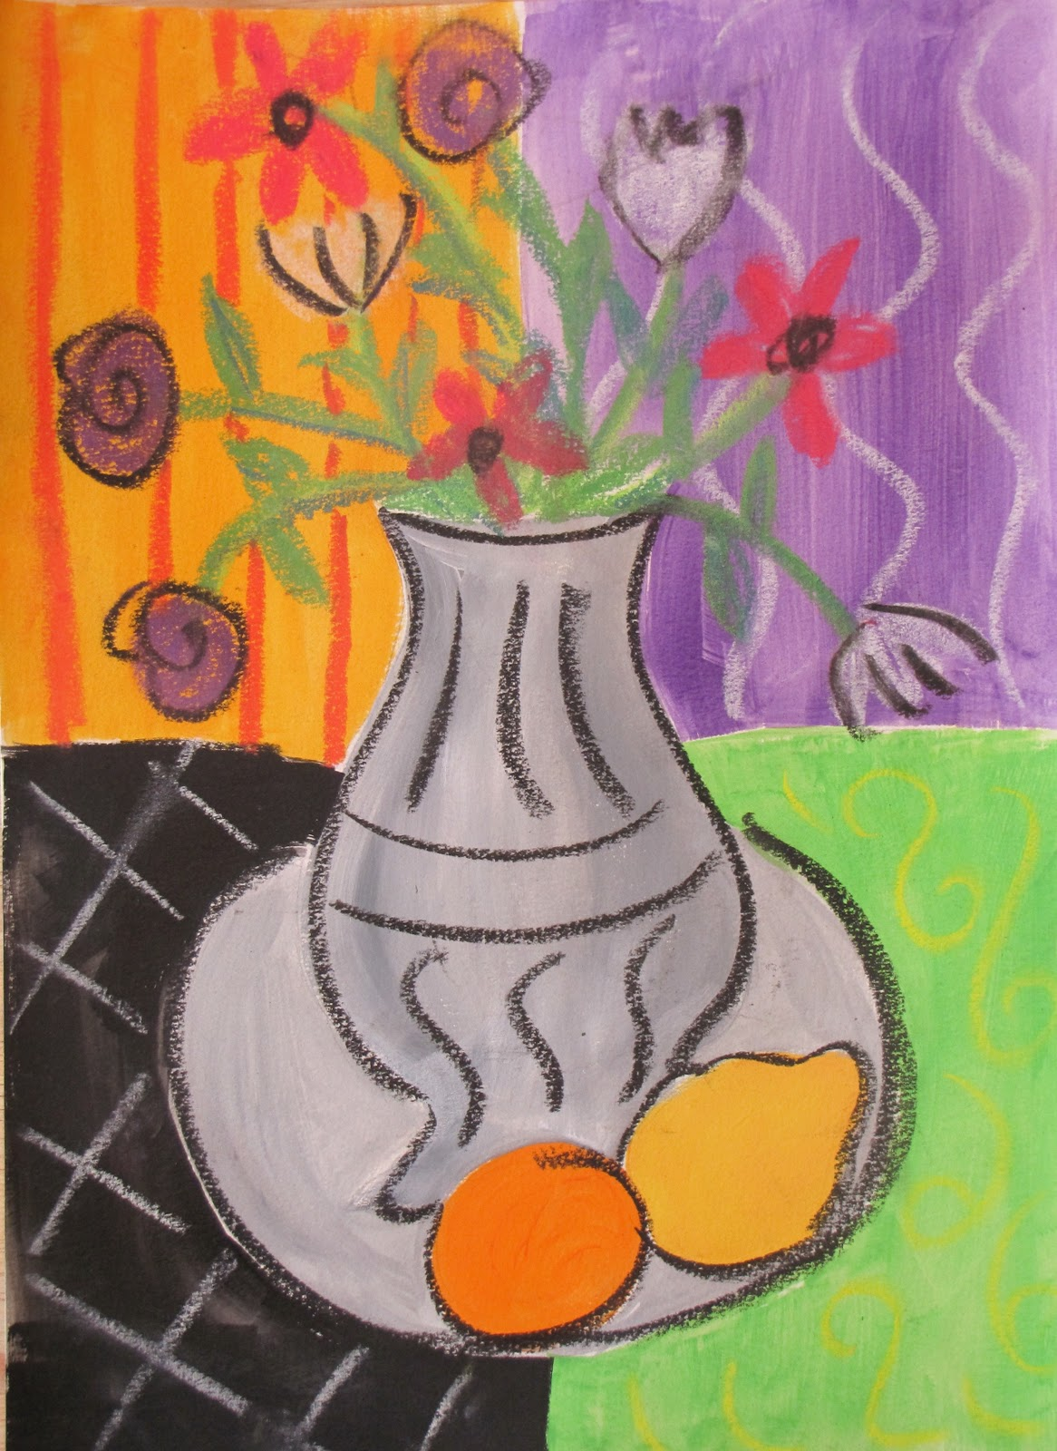
- Materials –
- 3 Sheets of white paper
- Piece of wax ( candle or crayon)
- Paints similar to watercolours ( water down thick poster paint)
- Coloured chalks

Techniques
- Make a background
- Cut one of your pieces of paper into 4 pieces.
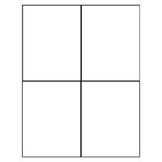
- Draw different patterns on the four squares of paper with your piece of wax

- Paint each square a different colour with your paint.
- Once dry glue the paper squares onto your other sheet of paper

- Now you need to make a vase

- Have a look at the attached examples of vases

- Choose which shape of vase you would like to draw – Square. circle, triangle, shaped

- Make a line drawing on a sheet of white paper using a black chalk to make bold lines

- Cut out your drawing, cutting close to the outline of the vase

- Glue this on top of your painted back ground

- You now need to put some flowers into the vase. Make sure to draw the stems of the flowers going into the vase as well as the petals .

- Have a look at the attached examples of flowers. You could have a go at copying these or draw your own flowers in the vase using bright chalks.
- Have fun, try using different colours to makr a bright spring bouquet

