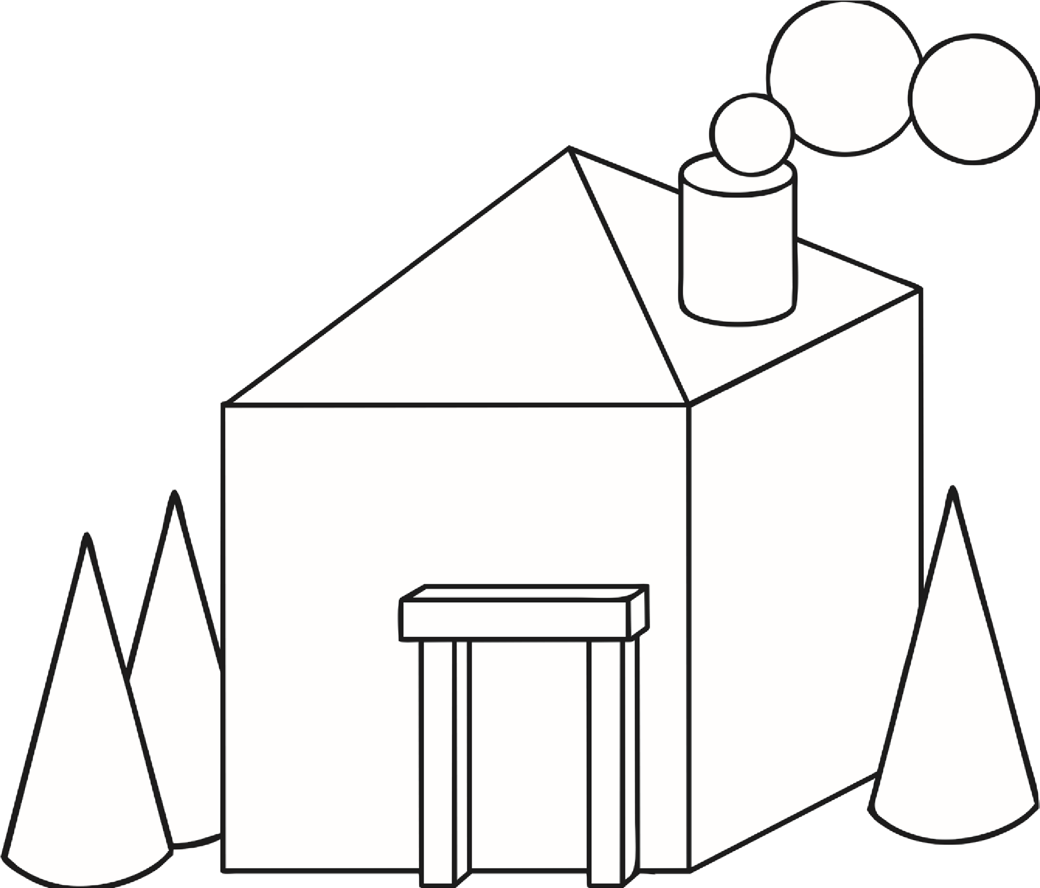
Key red

blue
green
purple
orange
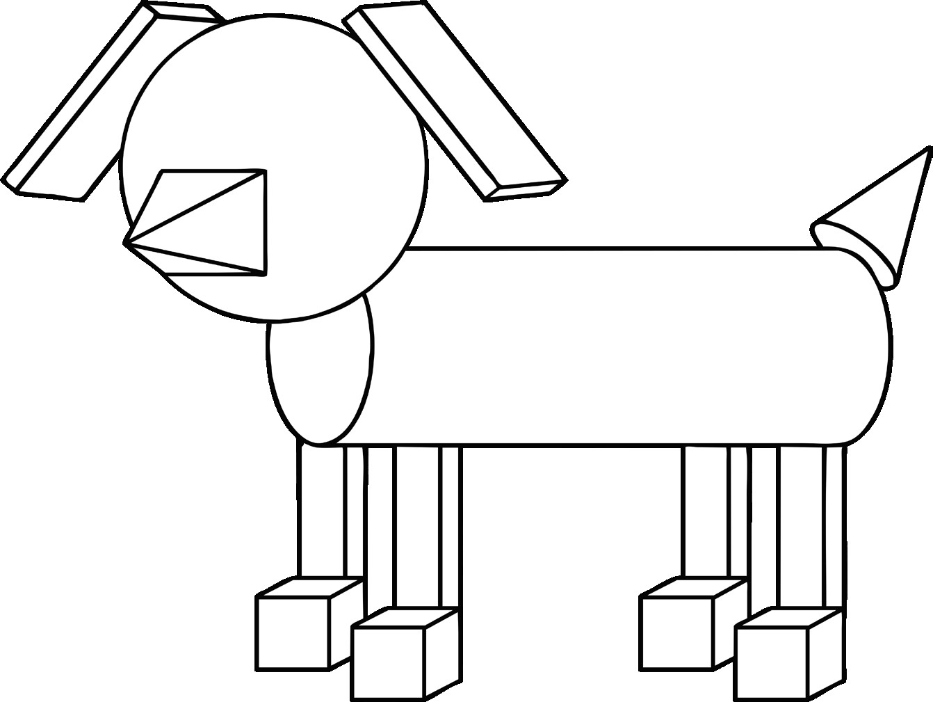
yellow Key red

blue
green
purple
orange

yellow Key red

blue
green
purple
orange
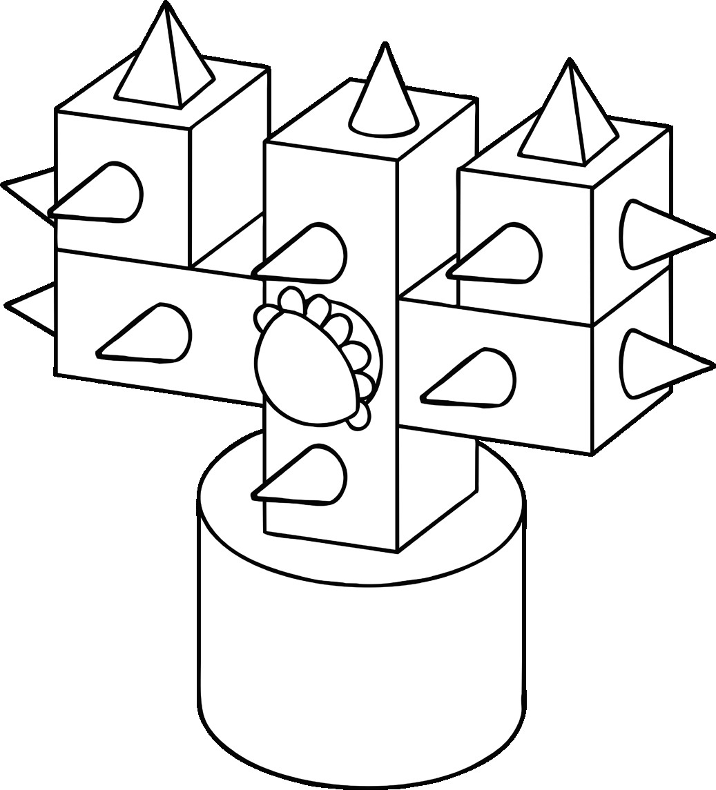
yellow Key red

blue
green
purple
orange
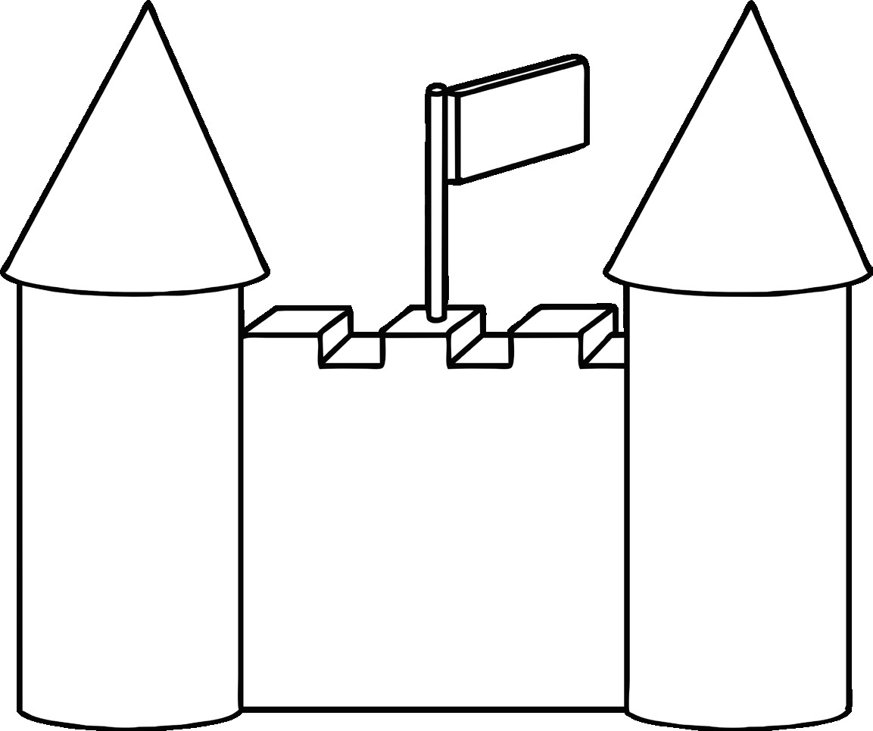
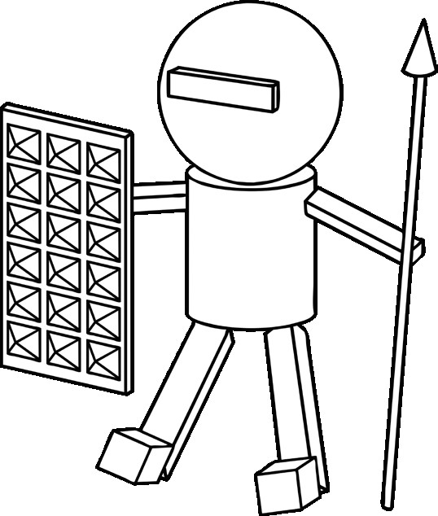
yellow Key red

blue
green
purple
orange
yellow

