Arighi Class
WK: & 13th and 20th July 2020
Area | Activity | Links
English | Listen to the story Blackbird, Blackbird What Do You Do?  or sensory story: Dozy Doris Duck and her missing egg  Props for sensory story  Duck toy/duck whistle)  plush fox / puppet or taste egg mayo  a box of hay ( for hiding items )  scented flowers  marigold/changing glove filled with warm water  football  fox toy / puppet large plastic egg  feathers or feather cat toy or feather duster  damp sponge  “Mamma” on single switch  Reading & Phonics: – Reading books / Education City login  https://www.booktrust.org.uk/books-and-reading/have-some-fun/storybooks-and-games/  https://www.oxfordowl.co.uk/for-home/find-a-book/library-page/ | https://www.youtube.com/watch?v=7OuMytyNrsU  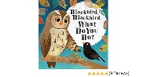  https://www.dropbox.com/sh/tolzregjoi34tod/AADiz_td_DbJLLk6YA3ppwrDa?dl=0&preview=Dozy+Doris+Signed.mp4  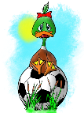
Maths | When you go for a walk or stand in your garden, can you see any birds? Do you know what they are?  Use the checklist attached below to record the number of different birds you can see.  ( complete the bar chart if you can )  explore textures , practice counting, siring scooping and filling and emptying containers using a sensory bin  MATERIALS NEEDED TO MAKE A BIRD NEST SENSORY BIN  Shallow plastic container  Bird Seed  Fake birds  Wooden birdhouse  Pretend nest /playdough nest ( see challenge for recipe )  Pretend bird eggs-you could use chocolate eggs .  Fishing worms or jelly worms  Natural materials- sticks, acorns, leaves, moss  scoops, spoons, containers
Creativity | Look at some of the other pictures of birds by the illustrator of the book Blackbird, Blackbird what do you do? ( Kate Mclelland)  Make a bird from an egg carton and items from your recycling  or  a paper bag owl  Bag Owl: Loosely stuff a bag full of crumbled newspaper. Bring the top together & fold the two outer edges in toward the centre & glue to form a point. Fold the point down. Cut eyes & feet from coloured paper  Painting with feathers  You will need:  Three or Four Large feathers  Four colours of paint on paper plates  Plain paper  Small, fluffy, colourful feathers  Use the large feathers to paint a picture  Remember the less paint you use, the more feathery the painting will be. When you have finished painting, stick small, fluffy feathers into the paint. | 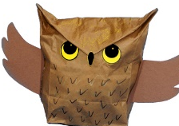  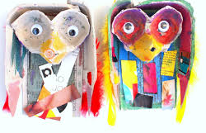  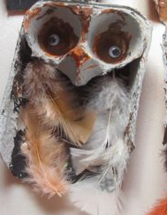  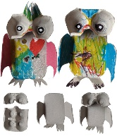  https:// katemclelland.com/  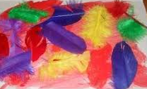
Individuality | Blackbird’s special talent was singing  With some help make a list of the things you are good at  Try  Dodgson the Dodo | A Cosmic Kids Yoga Adventure!  Make some bird moves  strut like a peacock, flap like a parrot, stand on one leg like a flamingo,  turn your head like an owl, waddle like a duck, shuffle like a penguin, peck like a chicken and hatch like a chick | https://www.youtube.com/watch?v=igE-o_Pd6DU  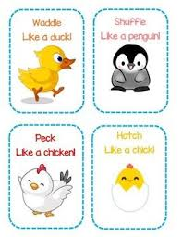  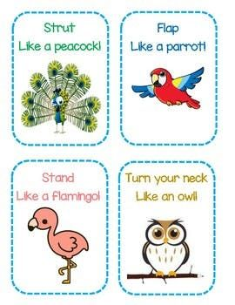
Community | Listen to the different bird songs  get up early and stand in your garden or yard  Can you hear the birds?  When you go for a walk listen out for the bird song can you identify any of the birds in your local area by their birdsong? | British Birdsong Montage | International Dawn Chorus Day  BBC Earth  https://www.facebook.com/bbcearth/videos/3087625171317426/
Challenge | find out about the different stages of the lifecycle of a bird  Find out how a bird makes a nest to lay its eggs  Have a go at making a nest with materials you find in your garden  or use playdough and twigs etc  Make a bird bath  you will need two large plant pots and a tray or large dish for the water  Turn one plant pot upside down. Fix the other one on top and decorate  Fix the dish to the plant pot stand and fill with cold water. | Add the pictures to the life cycle diagram ( see attached below)  https://www.bbc.co.uk/iplayer/episode/m000hlr8/maddies-do-you-know-series-4-2-birds-nest-and-helmet  playdough recipe: Ingredients  2 cups plain flour  1 cup salt  1 tbsp oil  1 cup cold water  2 drops liquid food  colouring  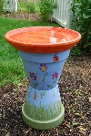
- Please refer to annual reviews for your child’s personalised targets.

I would love to see and hear about what you have been doing, feel free to email myself anytime – swright@parklane.cheshire.sch.uk
