Arighi Class
WK: & 15th /22nd June 2020
Area | Activity | Links
English | Jack and the Beanstalk  watch / read the story of Jack and Beanstalk from Roald Dahl Revolting Rhymes  Questions for discussion  1. Jack’s mum says they are ‘stony broke. ‘What does this mean?  2. What is the name of Jack’s old, brown cow?  3. Jack’s mother beat him, why is this wrong and what could Jack do about it?  4. How can you tell the bean was magic?  5. How does the Giant find people climbing the beanstalk?  6. Think of three words that describe the Giant  7. Put these sentences in the correct order.  The Giant eats Jack’s mother.  Jack spots the golden leaves on the beanstalk.  Jack’s mother asks him to sell their cow.  Reading & Phonics: – Reading books / Education City login  Phase 2 Matching Cards (Image to Sound) Twinkl free resources  free online reading books available at:  https://www.booktrust.org.uk/books-and-reading/have-some-fun/storybooks-and-games/  https://www.oxfordowl.co.uk/for-home/find-a-book/library-page/ | 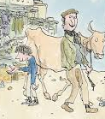  Revolting Rhymes_ Jack and the Beanstalk.mp4  https://www.youtube.com/watch?v=CpAoCUN4toE  for the text  https://www.flashlyrics.com/lyrics/roald-dahl/jack-and-the-beanstalk-63
Maths | Find or cut out 20 leaves  write the numbers on each leaf  draw or make a stalk with rolled up paper and add the leaves in the correct order from 1-20 ( try and make the beanstalk taller than you )  Now try measuring it  Make a list of other things or people in your house that are taller than you.  Make a list of people and things that are shorter than you  Can you find any items that are smaller than a bean?  make a there bean salad  with kidney beans, cannellini beans and chick peas  Look at the tins in your cupboard can you arrange them in size order from shortest to tallest? | 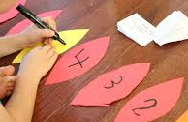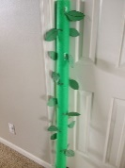  see recipe below / attached
Creativity | Listen to the songs by Kingsleigh Primary School from  Roald Dahl's Jack and the Beanstalk  find one you really like  Use some pots and pans/ wooden spoons and tins from your kitchen and play along | https://soundcloud.com/kingsleighprimaryschool/sets/roald-dahls-jack-and-the-beanstalk
Individuality | Make a Father’s day card for your Dad, Stepdad, Grandad or someone who is important in your life  PE  Play The Bean Game  Someone calls out the name of a bean and the child responds appropriately. Possible beans might include:  Runner Beans - run into spaces  Jumping Beans - jump into spaces  Kidney Beans - hop around holding onto a knee  Baked Beans - lay flat on their backs as if they are baking in the sun  Broad Beans - move around making broad shapes with their bodies  String Beans - move around making skinny, string-like shapes with their bodies  Chilli Beans - act as if they are chilly  Someone may also like to call out 'Freeze' from time to time for which the children should freeze in the position that they are in. | https://www.youtube.com/watch?v=j8pxuyFne08  Homemade Father's Day Card DIY Crafts for Kids  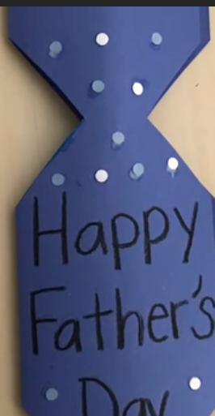
Community | Plant some seeds or tidy an area of your garden.
Challenge | Watch BBC bitesize lifecycle of a plant KS1  Put the pictures of the bean ( attached in the correct order) | https://www.bbc.co.uk/bitesize/topics/zpxnyrd/articles/z2vdjxs
- Please refer to annual reviews for your child’s personalised targets.

I would love to see and hear about what you have been doing, feel free to email myself anytime – swright@parklane.cheshire.sch.uk

