Arighi Class
WK: & 1st & 8th June 2020
Area | Activity | Links
English | read/ watch the story of The Very Hungry Caterpillar by Eric Carle  think of alliterations for the items of food in the story  lovely lollipops, scrumptious strawberries  There many V.H.C. related literacy activities available free on Twinkl  for sensory story :  Big and little caterpillars  torch for the light of the moon  rain stick for hungry sound  1 green leaf  1 edible seed or raisin (to represent the egg)  party popper for when he pops out of the egg ( or use bubbles and try popping them)  1 apple  2 pears  3 plums  4 strawberries  5 oranges  Cake, ice cream cone (no ice cream for the real cone), pickle, cheese, salami, lollipops, cherry pie, sausage, cupcake, watermelon  Brown towel-to represent the cocoon  brightly coloured scarf for the butterfly  Reading & Phonics: – Reading books / Education City login  Phase 2 Matching Cards (Image to Sound) Twinkl free resources | https://www.youtube.com/watch?v=75NQK  The Very Hungry Caterpillar - Animated Film  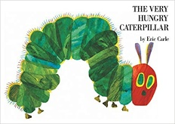  https://www.twinkl.co.uk/resource/t-l-131-phase-2-matching-cards-image-to-sound  The Very Hungry Caterpillar resources  WWW.twinkl.co.uk
Maths | Write out / copy the days of the week. Can you put them in order?  Try the addition (attached )  There many V.H.C. related maths activities available on Twinkl  complete the colour by numbers butterfly  look at how the pattern on a butterfly is the same on both sides this is symmetry  ( mirror image)  try drawing a butterfly ( see you tube video)  Make a very hungry caterpillar with apple slices, grapes, cucumber or whatever you have available. Count how many slices you have used. | colour by numbers butterfly  http://www.homemade-preschool.com/mw-color-by-numbers-butterfly-1-5.html  Teaching Kids to Draw: How to Draw a Butterfly  https://www.youtube.com/watch?v=MIAiglTFgLk  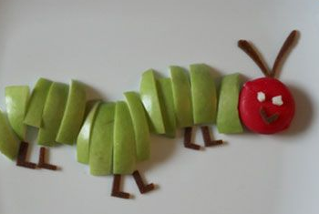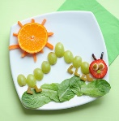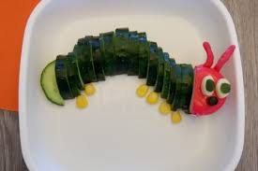
Creativity | Make a butterfly picture  blob some paint on a piece of paper, fold the paper in half and press to make sure all the paint has squished all over the paper  Unfold and let the paint dry. Cut into the shape of a butterfly add eyes and the antenna.  The book has holes cut into some of the pages  Cut a hole out of a piece of paper and create a picture around it. What could the hole represent? A window in a beautiful building? A missing piece of a puzzle? A gigantic hole in the ground? | 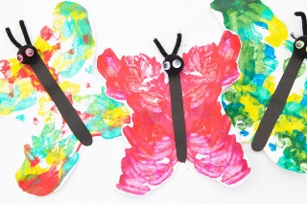
Individuality | try the Very Hungry Caterpillar cosmic yoga  PHSE Talk about what you might be like when you grow up  Have a go at The Who’s who quiz attached | https://www.youtube.com/watch?v=xhWDiQRrC1Y  The Very Hungry Caterpillar | A Cosmic Kids Yoga Adventure!
Community | See if you find any butterflies or caterpillars when you are out in the garden or out walking  Make a butterfly goodie bag and give it to a neighbour :  decorate a peg for the abdomen , add eyes and antennae, fill a clear plastic bag with sweeties to make the wings | 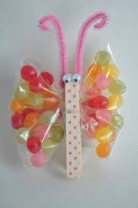
Challenge | Watch the bitesize clip and the cebeebies clip on the lifecycle of a butterfly  Make a model to represent the life stages  First - eggs , next- caterpillar , then - larva and finally - a butterfly | CBeebies EXCLUSIVE clip: Minibeast Adventure – Caterpillars  https://www.youtube.com/watch?v=a75Jqde8k1I  BBC bitesize The lifecycle of an animal  https://www.bbc.co.uk/bitesize/clips/zxcmp39  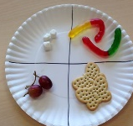  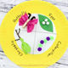
- Please refer to annual reviews for your child’s personalised targets.

I would love to see and hear about what you have been doing, feel free to email myself anytime – swright@parklane.cheshire.sch.uk

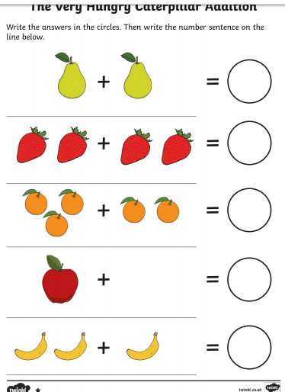
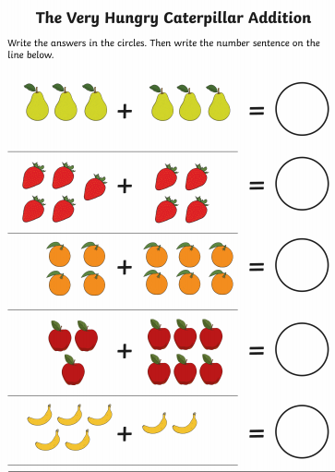
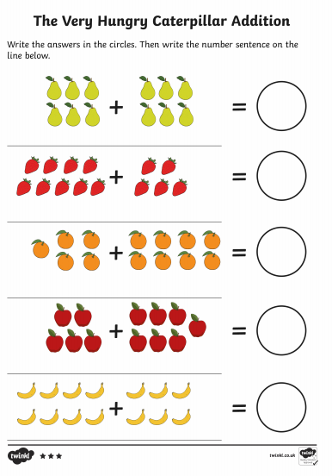

Who’s Who? !! Who did these beautiful babies grow up to be?
Answers:

