Arighi Class
WK: 18th & 24th May 2020
Area | Activity | Links
English | watch / listen to the story of Tad by Benji Davies on you tube  This book tells the story of a tadpole growing up and describes the lifecycle of a frog  Can you retell any part of the story in your own words?  can you describe what happened to Tad as she grew from a tadpole to a frog  Look at the front cover of the book. Can you find the Author and the Title?  colour in the picture ( see attached or download from Harper Collins website)  Make a list of CVC words that rhyme with Tad  e.g. sad  make an pond algae sensory bag  Squeeze hair gel and a few drops of green food colouring into a zipper bag.  Add some glitter  Secure with tape and lay the gel bag on a piece of white paper.  draw the letters onto the bag using your finger saying the sound of each letter as you do so  Reading & Phonics: – Reading books / Education City login | 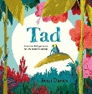  Tad by Benji Davies - DTT 85  Dantanian Tells Tales  https://www.youtube.com/watch?v=zItw2y1rDlc  https://www.harpercollinschildrensbooks.co.uk/2019/02/12/tad-activity-sheets/  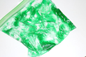
Maths | Draw pondweed with 10 leaves and number each one. (You could have 20 or 30 leaves if you feel up to it!)  draw or finger print the matching number of tadpoles on each leaf  ( or you could have lily pads and frogs )  Complete the spot the difference activity attached or download from the Harper Collins website  make an origami jumping frog  this is a bit tricky so you might need some help | https://www.harpercollinschildrensbooks.co.uk/2019/02/12/tad-activity-sheets/  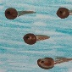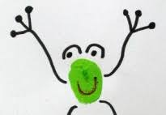  Kids easy origami - How to make a jumping frog ver.1  https://www.youtube.com/watch?v=1kZjq8f8Mpo
Creativity | Have a go at singing the frog lifecycle song ( See attached or download from Twinkl  look at images of Monet’s water Lilies  make your own water lily picture  cover a rolling pin with bubble wrap and add blue yellow purple and green paint  roll on a paper plate  add water lily pads by printing using a half inflated balloon dipped in green paint  add lilies made from pink and white cake cases | you tube  https://www.youtube.com/watch?v=U5MD3_PiCTI  https://www.twinkl.co.uk/resource/t-t-27385-frog-life-cycle-song  https://en.wikipedia.org/wiki/Water_Lilies_(Monet_series)  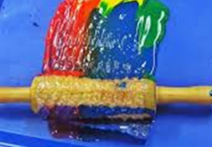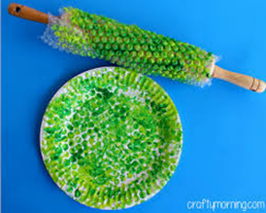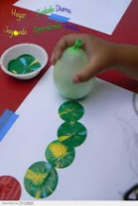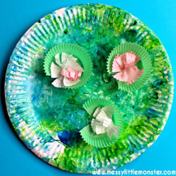
Individuality | PHSE  Discuss how Tad took a little longer to grow up than her brothers and sisters  How did she feel when they all left?  but “tiny hearts have the biggest dreams and – and take the biggest leaps of all”  Taken from the blurb  Play the lily pad game  Lay out several different coloured circles on the floor. Decide what activity you will have to do on each circle or lily pad  e.g. star jump, arm stretch or balance on one leg.  Jump like a toad (with both feet together) or hop like a frog from one lily pad to the next until you have completed all the actions | 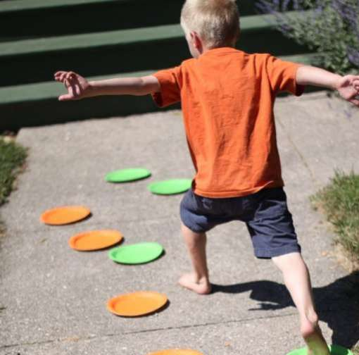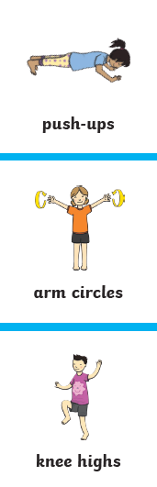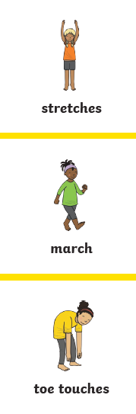
Community | Visit a local pond and see if there are any tadpoles or frogs  See what else you can find there  Try pond dipping with your family!  See attached | https://www.harpercollinschildrensbooks.co.uk/2019/02/12/tad-activity-sheets/
Challenge | Make a diagram to show the lifecycle of a frog ( see attached)  Make frogspawn jelly – add raisins or blue berries to lime jelly before it sets  make an edible pond  or frogspawn bubble tea  using chai seeds or tapioca pearls  For sensory pond  in a large bowl or large deep tray  use tapioca pearls, chai seeds or basil seeds soaked in water for a short time to represent frogspawn  water with a little blue or green food colouring  use craft foam circles for lily pads.  Add pieces of sponge, pebbles or gravel and some sand and taste safe plants or leaves such as mint for pondweed. | https://www.twinkl.co.uk/resource/au-t-1398-australia---frog-lifecycle-worksheets  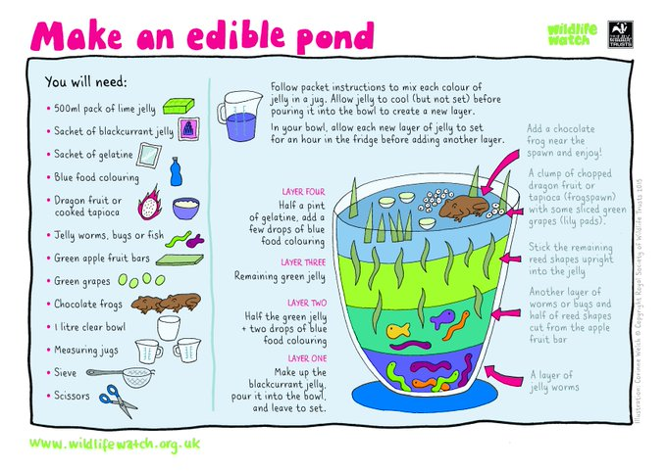
- Please refer to annual reviews for your child’s personalised targets.

I would love to see and hear about what you have been doing, feel free to email myself anytime – swright@parklane.cheshire.sch.uk
