Arighi Class
WK: 20th & 17th April 2020
Area | Activity | Links
English | Story  listen / watch the story on YouTube  the three little pigs  CBeebies: The Three Little Pigs, read by Lisa Riley  recite familiar lines form the story from memory  find some stones.(7) Draw or stick on pictures of the characters on the stones ( 3 pigs the wolf and the 3 different houses)  feel and explore the tactile properties of the stones  *Order the stones to prompt sequencing or the re telling of the story  using first .. next .. then.. to support  *Hide the stones in e.g. sand / shredded paper pick out one at a time and describe the character or picture  read the Roald Dahl version of the three little pigs from the Revolting Rhymes ( possibly as sensory story with props )  - discuss how this version differs from the traditional story  - find the words that rhyme. Look at the spelling patterns  - parents could write out some of the rhyming words on cards for students to match)  - Make a list of other words that rhyme with e.g. pig, house  Communication: practice the sign for pig / house  Make animal sounds for pig and wolf  Reading & Phonics: – Reading books / Education City login | https://www.youtube.com/watch?v=oanczCDuSrk  Lisa Riley reads the three little pigs  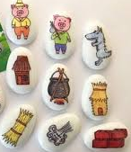  https://www.familyfriendpoems.com/poem/the-three-little-pigs-by-roald-dahl  Sensory story prop suggestions for Roald Dahl’s Three little pigs  Balloon /cycle tyre pump/ hairdryer to blow air  Ham or smokey bacon crisps  Fur fabric for wolf  Pig noises on you tube or DIY  Stone/ brick, straw, twigs  Mouse cat toy  Shampoo to smell  Water pistol /Party popper  Leather bag or purse (Real or fake)
Maths | Make shortbread pigs 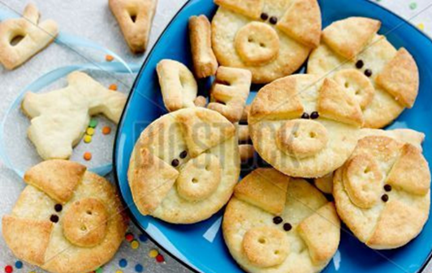 (Symbol Recipe on website)  weigh/ measure ingredients  identify more less heavier lighter  shapes circles / triangles | Three little pigs Counting  https://www.twinkl.co.uk/resource/t-t-7960-the-three-little-pigs-counting-sheet  Three little pigs Count to 10  https://www.twinkl.co.uk/resource/t-tp-5672-the-three-little-pigs-i-spy-and-count-activity-to-10  Three little pigs Count to 20  https://www.twinkl.co.uk/resource/t-tp-5673-the-three-little-pigs-i-spy-and-count-activity-to-20
Creativity | Watch the cbeebies Northern Ballet version of the Three Little Pigs  on bbc iplayer  Make paper plate pig and wolf masks / stick puppets  re -enact the story | https://www.bbc.co.uk/iplayer/episode/b041mc85/cbeebies-presents-three-little-pigs-a-cbeebies-ballet  on bbc iplayer  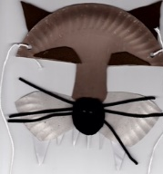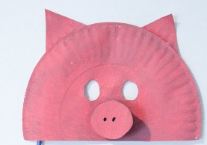
Individuality | Play piggy in the middle using a balloon or ball  Start to collect pictures of different life stages  e.g. baby pics / christening / school photos  to copy and make a timeline scrap book
Community | If you can walk outside look at all the different buildings in your local community. Can you see what they are made of?  what is their function i.e. shed - storage, house- living , shop- retail, office - workplace etc.?
Challenge | find different materials e.g. straw, spaghetti, paper, Lego anything from the recycling etc explore properties of different materials  build a model of a house, use the hairdryer to see if it can be blown down. | 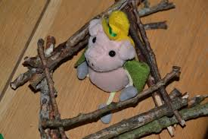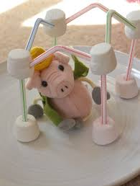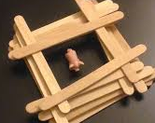
- Please refer to annual reviews for your child’s personalised targets.

I would love to see and hear about what you have been doing, feel free to email myself anytime – swright@parklane,cheshire.sch.uk

