Arighi Class
WK: 6th & 13th April 2020 (Easter Activities)
Note to parents:
Some of these activities may not be suitable for all the students in the group
I do not expect students to attempt or complete all the activities. This is just a selection of things students might be doing if we were in school. Please just take what you feel is helpful. I do not want to put you or your young people under any undue pressure. Life is hard enough right now.
Please feel free to email me.
Area | Activity | Links
English | Story  listen / watch the story on YouTube  THE STORY OF THE EASTER BUNNY by Katherine Tegen and Sally Anne Lambert  Write their name. Say the name and the sound of each letter  identify words beginning with any of the letters of their name in the story  colour in the Easter pictures ( Print from free websites including twinkl or clip art ) using coloured pencils trying to stay in the lines  use communication systems to name colours  make chocolate playdough  Make egg / bunny shapes. Roll, squeeze, tear, mould it to decorate  Communication:  Reading & Phonics: – Reading books / Education City login | 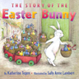https://www.youtube.com/watch?v=xP__j1Fviaw  PV story time THE STORY OF THE EASTER BUNNY  http://clipart-library.com/easter-pictures-to-print.html  https://www.twinkl.co.uk/resource/t-t-751-easter-colouring-posters  chocolate playdough recipe  https://theimaginationtree.com/easy-chocolate-play-dough-recipe/
Maths | Make Easter chocolate egg nests  Counting cake cases / eggs  putting eggs in groups of 3  Weigh and measure ingredients. Explore which items are heavier/ lighter  which containers hold more/ less  Make Easter bunting ( add numbers to make Easter themed number line )  Explore patterns / symmetry  Use a template to make egg shaped, colour each one in differently using repeat patterns e.g. ,zig zag, stripes, spots etc.  ( discuss how it might look the same on both sides )  or stick on tactile materials e.g. rice, cotton wool, foil, bubble wrap, cheerios, cake sprinkles etc. | 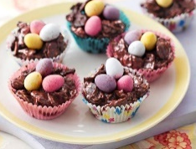  https://www.bbc.co.uk/newsround/35890002  (For easier recipe see cbeebies https://www.bbc.co.uk/cbeebies/makes/lets-celebrate-easternests )  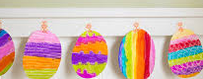
Creativity | Make an Easter chick Easter card using a cork or fork or shower puff with envelope | 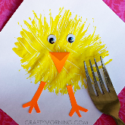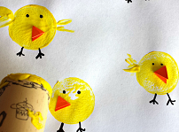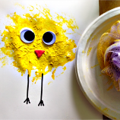  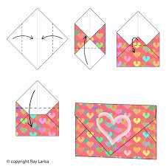
Individuality | Egg and spoon races, throwing and catching skills using balloons (easier and safer inside!)  Balancing eggs on kitchen roll tubes  Spring cleaning  make natural cleaning products from vinegar lemon and baking soda  Washing the dishes or cleaning the windows  continue to practice washing hands and using tissues and elbows when sneezing and coughing | 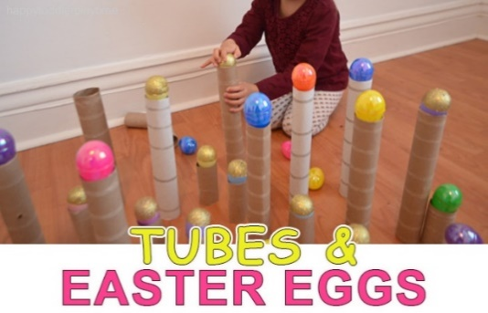  https://www.madeleineolivia.co.uk/blog/20-diy-natural-cleaning-recipes-hacks-tips
Community | Send / deliver your Easter cards to a quarantined Neighbour perhaps?  In some Latin America countries e.g. Guatemala Easter is celebrated with Easter carpets made of flowers and coloured sawdust  find some pictures on the internet  type in Easter Carpets and look at the images  with help cut and paste some of the pictures into a PowerPoint or word document and give it a title  Using coloured chalk or coloured paper or fabric or anything from your recycling make a pattern or Easter carpet outside, take a photo of it. | 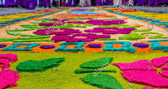
Challenge | Feed the birds  make a simple bird feeder. Take the flesh out of half an orange. Make some holes with a pencil. Thread string through the holes. Fil it with bird seed and hang it on a branch. | 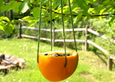
- Please refer to annual reviews for your child’s personalised targets.

I would love to see and hear about what you have been doing, feel free to email myself anytime – swright@parklane.cheshire.sch.uk

