This school's data covers the financial year April 2024 to March 2025 consistent financial reporting return (CFR).

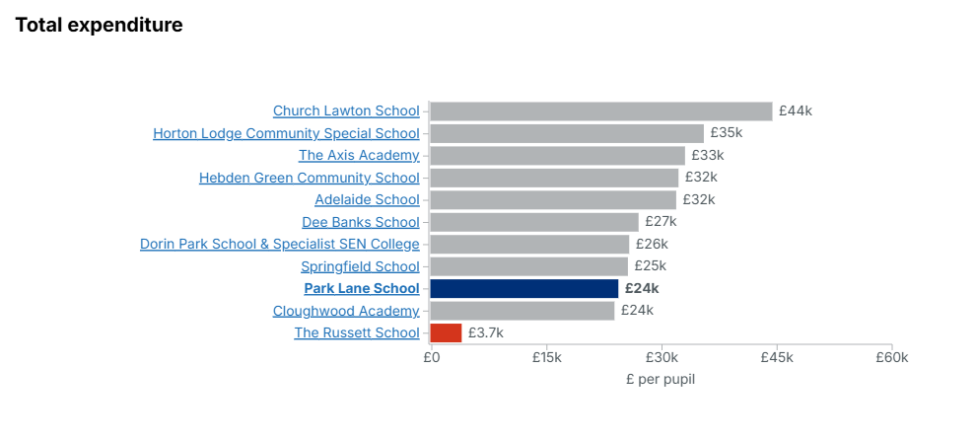
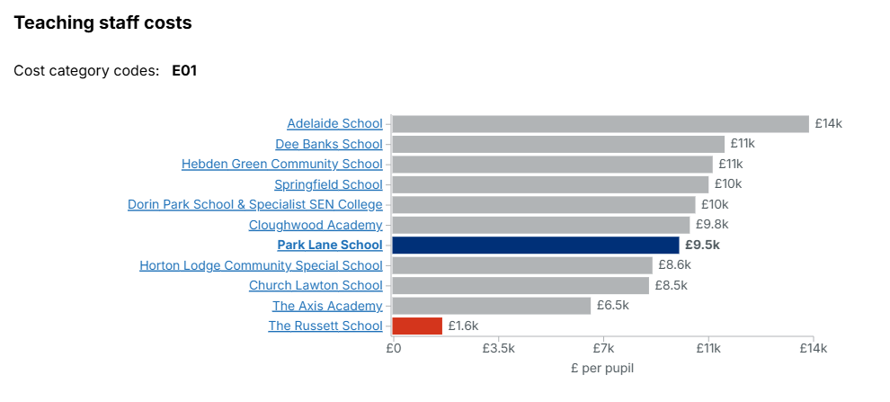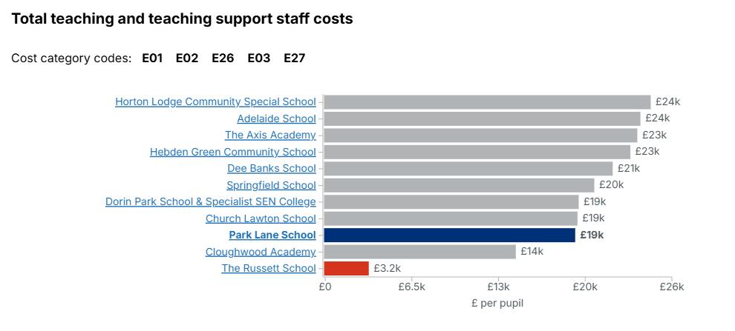
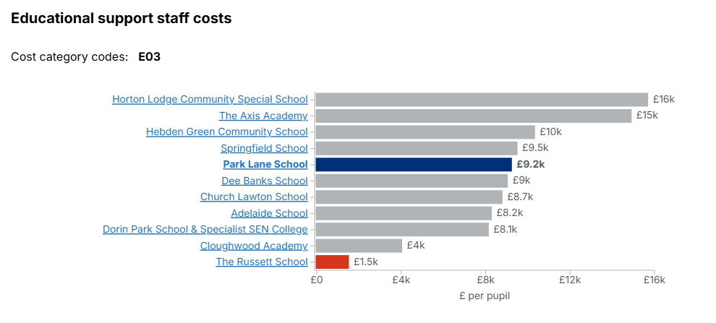
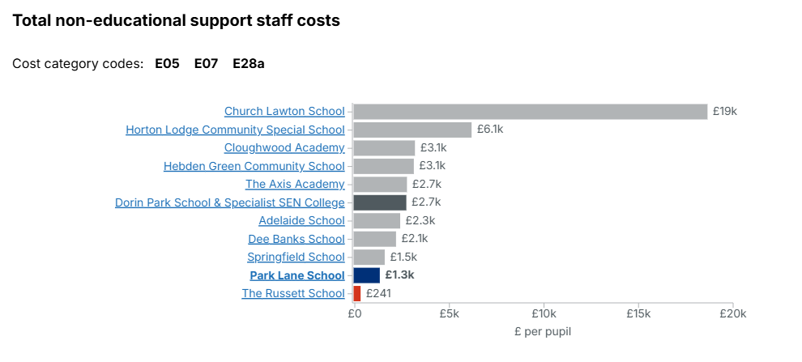
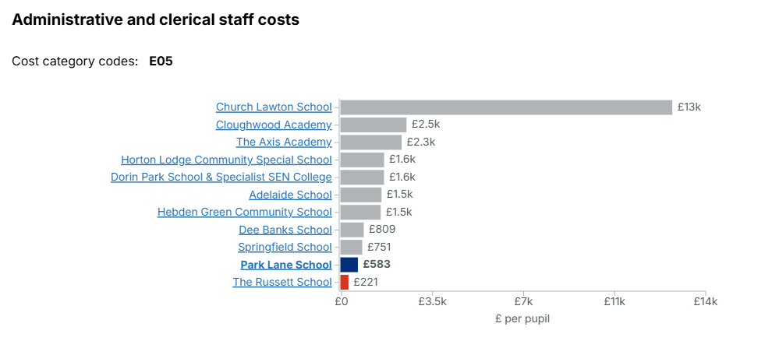
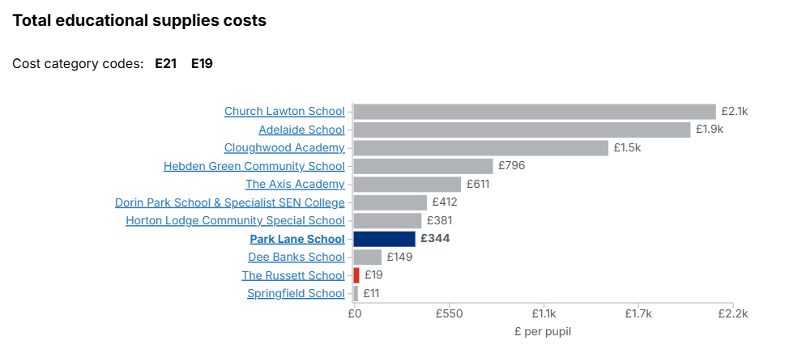
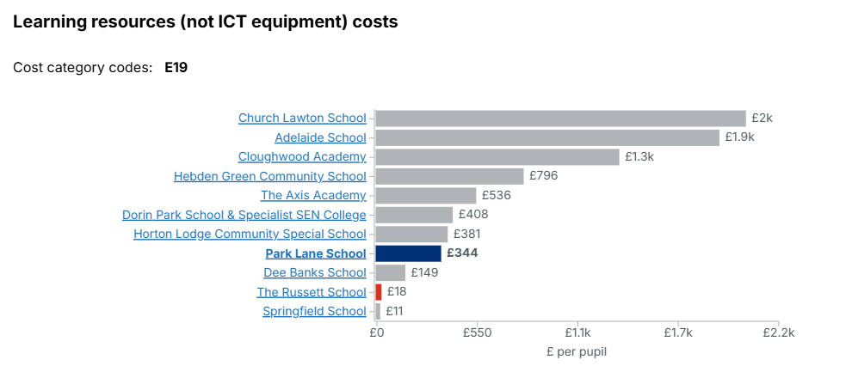
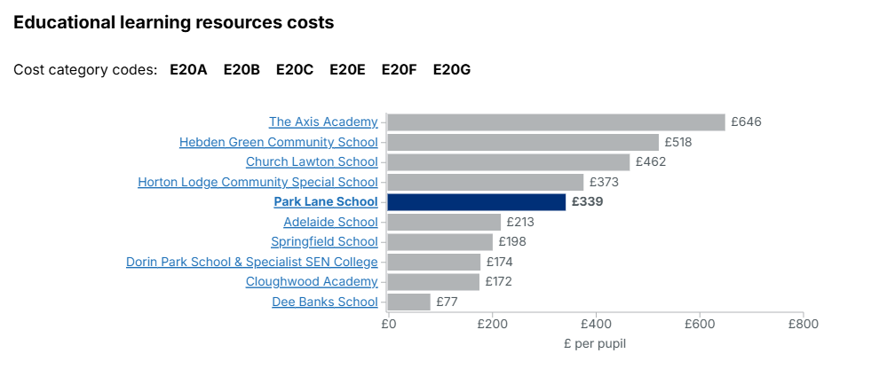
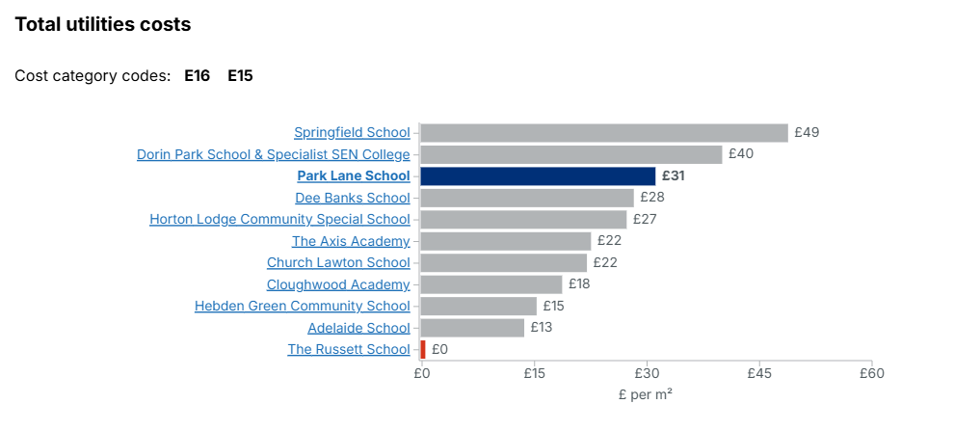
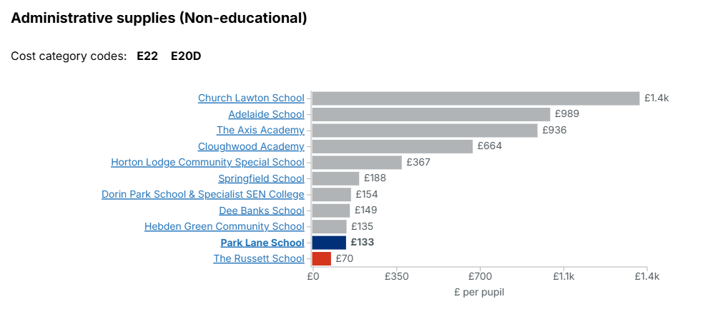

Guide to cost categories
- E01 Teaching Staff: Salary costs for teachers employed directly by the school.
- E02 Supply Teaching Staff: Salary costs for casual supply teachers employed directly by the school.
- E03 Education Support Staff: Includes welfare assistants, classroom assistants, and education welfare officers who are school-based.
- E04 Premises Staff: Salary costs for directly employed premises-related staff, such as caretakers and cleaners.
- E05 Administrative and Clerical Staff: Costs for administrative and clerical support.
- E06 Catering Staff: Costs for catering employees.
- E07 Cost of Other Staff: Costs related to any other directly employed staff not covered by E01-E06.
- E08 Indirect Employee Expenses: Includes recruitment advertising, car allowances, DBS checks (external), and other incidental expenses.
- E09 Staff Development and Training: External training expenses and recharges for internal training.
- E10 Supply Teacher Insurance: Premiums paid to insurers for supply teacher absence cover.
- E11 Staff-Related Insurance: Covers long-term sickness insurance premiums.
- E12 Building Maintenance & Improvement: Charges for contractors, materials used by direct staff, and related professional/technical services.
- E13 Grounds Maintenance & Improvement: Costs related to maintaining and improving the school grounds.
- E14 Cleaning & Caretaking: Charges by contractors for cleaning and caretaking services.
- E15 Water and Sewerage: Utility costs for water and sewerage services.
- E16 Energy: Costs for all fuel and energy, including electricity and gas.
- E17 Rates: Non-domestic rates costs.
- E18 Other Occupation Costs: Includes rent, refuse collection, security services, and health and safety costs.
- E19 Learning Resources: General learning resources, transport costs, and school trip expenses (not ICT related).
- E20 Educational ICT: Includes ICT learning resources and dedicated internet lines.
- E21 Examination Fees: The costs of test and examination entry fees and related accreditation costs.
- E22 Administrative Supplies: General administrative supplies, printing, postage, bank charges, and telephone charges.
- E23 Professional Services (non-curriculum): Auditor costs, legal fees, and other non-curriculum professional advice.
- E24 Other Supplies and Services: General supplies not covered elsewhere.
- E25 Catering Supplies: Food and beverage costs.
- E26 Agency Supply Teaching Staff: Costs for supply teachers provided via an agency.
- E27 Educational Consultancy: Costs for educational consultancy services.
- E28 Other Consultancy: General consultancy and advice costs for administration.
- E29 Interest Charges for Loans: Related to loan repayments.
- E30 Private Finance Initiative (PFI) Charges: Charges associated with PFI contracts.
- E31 Community Focused School Staff: Staff costs related to community use of the school.
- E32 Community Focused School Costs: Other costs for community facilities and services.

