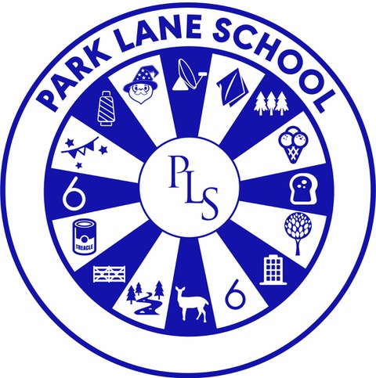

School Development Plan Overview
2025 – 2026

Curriculum and Teaching
At Park Lane, our curriculum is ambitious, multi-layered and tailored to meet the diverse needs of all learners. We are committed to evolving our curriculum through key developments: embedding our ‘Steps Towards Independent Lifelong Learners’ approach to promote independence through structured routines and visual supports; expanding work experience opportunities; implementing the new Relationships, Sex and Health Education (RSHE) curriculum; and reviewing Early Years Development Matters to personalise it for our setting. Professional development will be strengthened, with subject leaders guiding staff to ensure strong subject and area knowledge across the school. These enhancements will ensure our curriculum remains purposeful, engaging and fully inclusive.

Achievement and Inclusion
At Park Lane School, our mission is to raise attainment and celebrate progress for every pupil. We are rewriting our assessment system to better reflect individual achievement and embedding extended maths and English qualifications to broaden opportunities. Our focus on a personalised approach to sharing progress with families will strengthen partnerships and celebrate success in meaningful ways. Inclusion is at the heart of everything we do. We are working towards the Inclusion Quality Mark, increasing inclusive practice within our own diverse cohort, and investing in outdoor equipment to ensure all pupils can access play and learning. As a new inclusive lead school for sports, we will support other schools across Cheshire and Warrington in delivering inclusive sport, and we will continue to develop our role as lead music specialist school with the Love Music Trust. We believe the impact of our school is powerful and can be far-reaching. By sharing our inclusive culture of removing barriers, and promoting equity over equality, we aim to raise expectations and outcomes for all in our local community and beyond.

Behaviour and Attendance Overview
We are committed to creating a nurturing, inclusive and responsive environment where students are “Ready to Learn”. Attendance will continue to be a key focus, with enhanced capacity, refined tracking systems, and tailored proactive support to ensure all students are fully engaged in learning. A whole-school behaviour and achievement system will be introduced through house points, celebrating positive choices, achievements, and fostering a sense of belonging. To support regulation and well-being, students will have access to sensory toolkits tailored to their needs, and staff will be equipped with portable resources to provide immediate support. Behaviour data will be monitored more closely to inform responsive strategies, and staff will receive ongoing training in positive behaviour support, anxiety management, and specific areas of SEND. We will continue to collaborate with the Cheshire Specialist Schools Consortium to review county-wide policy and aim to achieve the Rights Respecting Schools Silver Award, embedding pupil voice and values at the heart of our culture.
Personal Development and Wellbeing
At Park Lane, we are committed to enriching pupils’ personal development and wellbeing across all aspects of school life. We will be reviewing lunchtimes and break times to ensure they are inclusive, engaging and supportive, with improved outdoor spaces and a refreshed indoor environment. Beyond academic achievement, we will expand enrichment opportunities such as clubs, increase residential experiences, and extend our Duke of Edinburgh programme as we work towards the Silver Award.
Mental health and wellbeing will remain a golden thread throughout these developments, closely linked to our behaviour strategy. We will also pursue the Quality in Careers Standard, recognising our strong Preparing for Adulthood curriculum from Early Years to Sixth Form. Through these initiatives, we aim to build resilience, independence and aspiration in every pupil.

Leadership and Governance
At Park Lane Special School, strong leadership and strategic oversight from our governors is vital to driving meaningful and sustained improvement. Monitoring visits will be aligned with our School Development Plan priorities, and governor link roles will deepen engagement and accountability across key areas. We are expanding our senior leadership team to strengthen capacity and ensure robust support for pupils and staff.
Recognising the value of our dedicated staff, we are launching further programs to nurture talent and build leadership for the future. Staff wellbeing remains a central focus, with ongoing initiatives to promote a healthy, supportive working environment. We are also working closely with the local authority to advocate for equitable funding that reflects the complex needs of our learners.
Strengthening parental engagement is a key priority, ensuring families are active partners in their child’s education. By aligning policy review, staff development, and stakeholder collaboration, we will continue to build a resilient and forward-thinking school community that delivers the best possible outcomes for every pupil.

