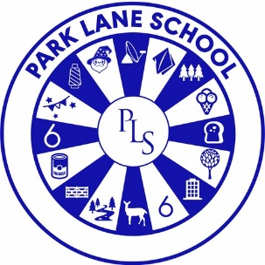

PUPIL PREMIUM POLICY

Person responsible for policy: | Emma Shaw
Date approved: | September 2024
Reviewed: | September 2025
Next Review date: | September 2026

Contextual Information

Park Lane School is part of Cheshire East’s provision for pupils with severe and complex learning difficulties. This includes pupils with additional physical and sensory impairments, Autism Spectrum Condition, and medical needs. The school serves Congleton, Wilmslow, Knutsford, and Poynton, with 152 pupils aged 5–19.

Rationale

Park Lane School is committed to giving all pupils every opportunity to achieve success at every stage of their education.
Pupil Premium funding was introduced in 2011–2012 to support children from low-income families, those eligible for Free School Meals (FSM), children looked after by the local authority, and children of armed forces personnel. In 2012, eligibility was extended to pupils who had been eligible for FSM in the past six years (Ever 6). In 2014, the premium was further extended to include all pupils adopted from care.
Schools are legally required to publish online how Pupil Premium is spent and its impact. Park Lane School complies fully, with all relevant information available on our school website.
Due to the severity and complexity of our pupils’ disabilities, the challenge for leadership and governors is to use this funding in ways that meaningfully impact individual achievement. For 2025–2026, priorities include:

- Development of communication strategies
- Enhancement of social skills#
- Specialist teaching approaches for pupils with Autism

Governors reserve the right to allocate Pupil Premium to benefit any pupil identified as requiring additional support, regardless of FSM eligibility.

Aims

Park Lane School uses Pupil Premium to:

- Enhance education, progress, and attainment for eligible pupils
- Provide additional interventions and therapies beyond core budget provision
- Support participation in educational activities regardless of disability
- Enable access to educational visits, residentials, and extra-curricular activities

Preparation for Adulthood

“Preparation for adulthood is not something we should only think about at school transitions such as the end of each key stage or post-16 planning. Preparation for adulthood should be a continual process for the child and young person that happens at the end of each lesson, topic, unit of study and school day.”
This principle underpins our use of Pupil Premium to support long-term development and independence.

Monitoring and Review

- Progress and attainment of eligible pupils is monitored termly by the Assessment Manager
- Impact is reported termly to Governors via the Headteacher’s Report
- Funding use is reviewed by the Finance and Personnel Committee
- Annual reports are published on the school website for parents and stakeholders

Transparency and Accountability

Pupil Premium funding is separate from the school budget and fully accounted for. Park Lane School is committed to transparency and publishes annual spending reports online.

Policy Oversight

This policy is monitored by the Governing Board and reviewed annually.

