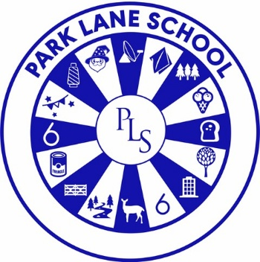

UNIFORM POLICY

Person responsible for policy: | Emma Shaw
Date approved:
Reviewed: | November 2025
Next Review date: | November 2026

Contextual Information
Park Lane School caters for pupils aged 5–19 with severe and complex learning difficulties. Many pupils have additional needs including visual and hearing impairments, Autism, physical, behavioural, and medical needs. The school serves the east of Cheshire, including Wilmslow, Knutsford, Poynton, and Congleton.

Rationale
Wearing school uniform can help pupils understand routines and transitions. However, due to sensory and other needs, uniform is not compulsory. Sixth Form pupils may wear their own clothes.

Aims
- Ensure uniform is affordable and offers value for money
- Avoid discrimination in line with the Equality Act 2010
- Clarify expectations for school uniform

Legal Duties under the Equality Act 2010
We will:
- Avoid gender-specific uniform lists
- Ensure uniform costs are equal for all pupils
- Allow long hair and personal styling choices
- Permit religious adaptations (e.g. headscarves, swimwear)
- Make reasonable adjustments for individual needs
- Allow for adaptations to our policy on the grounds of equality by asking pupils or their parents to get in touch with Emma Shaw, Head teacher, who can answer questions about the policy and respond to any requests

Affordability and Value for Money
In line with DfE guidance:

- No more than two branded items are required for primary pupils (sweatshirt and polo shirt)
- No more than two branded items are required for secondary pupils (blazer and tie)
- Branded items are limited to long-lasting or low-cost items
- Non-branded items can be purchased from any retailer
- Iron-on logos may be used as an alternative
- Second-hand uniform is available (see below)
- We avoid frequent changes to uniform
- We consult parents and pupils on significant changes

Second-hand Uniform Access
A stock of second-hand uniforms is available to all families. Information on how to access this is published on the school website or can be obtained by contacting the school office.

Expectations for School Uniform
- Primary: Branded sweatshirt and polo shirt
- Secondary: Branded blazer and tie
- Trousers/skirts: Black, from any retailer
- Optional adaptations: Pupils may wear joggers or other clothing that supports independence
- PE kit: Shorts and t-shirt
- Swimming: Costume and towel
- Daily bag: Should include personal items (e.g. incontinence pads, comforters, home-school book)
- Footwear: Comfortable shoes
- Extreme weather: Adaptations may be made to ensure comfort and safety

Where to Purchase
- Branded items: Classworx, Great King Street, Macclesfield
- Non-branded items: Any retailer
- Second-hand items: Available through school

Expectations for Our School Community
Pupils:
- Expected to wear appropriate clothing
- Sixth Form: No uniform required, but clothing should be suitable for school

Parents and Carers:
- Ensure clothing is clean, labelled, and in good condition
- Raise concerns or complaints in a timely manner
- Disputes will be resolved locally in line with the complaints policy

Staff:
- Monitor dress appropriately, considering individual needs

Governors:
- Review and ensure fairness, practicality, and safety
- Consider views of parents and pupils

Monitoring Arrangements
This policy will be reviewed biannually by Emma Shaw, Head Teacher.

Links to Other Policies
- Equality Information and Objectives Statement
- Complaints Policy
- Safeguarding and Child Protection Policy

