Mulberry Class
WK: 18th May 2020
Area | Activity | Links
English | Story, song or rhyme: Mad about Minibeasts – I have also sent this story in the post for you. Listen and join in with the story using the YouTube link or the sensory story – music.  Fine motor skills: Using the tactile cards or handwriting sheets have a go at the minibeast patterns or letters.  Communication: Use the communication storyboard or tactile minibeasts to join in the story, pass comments or answer questions about the minibeast story.  Reading & Phonics: – Reading books / Education City login. | 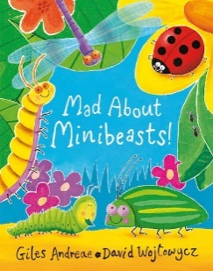  https://www.youtube.com/watch?v=SW-7MgHEZOE
Maths | Use your number charts/lines to count numbers of minibeasts / legs of minibeasts / spots and stripes! Use this wherever possible throughout your day.  Minibeast survey using the tally charts provided. | Education City – parent login
Creativity | - Make the Snails: Fill celery stalks with peanut butter or cream cheese and top with an apple, orange, kiwi, cucumber or tomato slice shell and a cashew head. Use peanut butter or cream cheese to glue on eyes.  - Make the Caterpillars: Fill celery stalks with peanut butter or cream cheese and top with grapes, blueberries or tomatoes for the body and head. Use peanut butter or cream cheese to glue on eyes and celery or radish matchstick for antennae. | 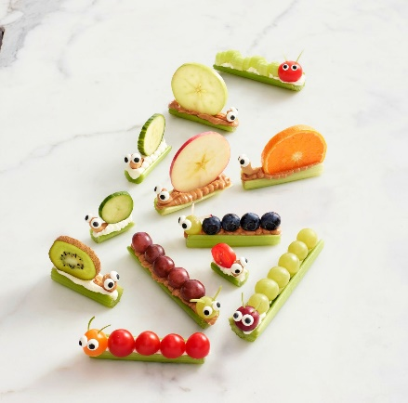
Individuality | Ugly bug ball – create a performance of the song using instruments (instruments could be anything you find in the house!) or have an Ugly Bug Ball – make appropriate head wear for different minibeasts and dance to the Ugly Bug Ball music. | https://www.youtube.com/watch?v=Pho7JPTa8P4  https://www.youtube.com/watch?v=XXSOJH4KmZw
Community | Go on a minibeast hunt….become a detective!  - In leafy plant areas lay out a sheet under their chosen shrub and give the shrub a gentle shake to see what minibeasts fall onto the sheet – they can also observe any minibeasts on the plants.  - In the natural ground they can gently lift items (logs, leaves etc.) and record what they find.  - Around hard Surfaces they can examine the nooks and crannies in walls/fences and carefully lift small rocks while recording what they find.
Challenge | Using the instructions sent in your pack – create your very own minibeast hotel!
- Please refer to annual reviews for your child’s personalised targets.
I would love to see and hear about what you have been doing, feel free to email myself anytime – eshaw@parklane,cheshire.sch.uk

