Mulberry Class
WK: 6th & 13th April 2020 (Easter Activities)
Area | Activity | Links
English | Story, song or rhyme: we’re going on an Easter egg hunt! Listen and join in with the song.  Fine motor skills: Using chocolate to write, mark make, draw or explore – use melted chocolate or Nutella.  Communication: Learn the signs (posted on Facebook) and symbols for the days of the week. Use any opportunity to make and confirm choices using personalised communication systems.  Reading & Phonics: – Reading books / Education City login | https://www.youtube.com/watch?v=TJhIfuIUJ3M  
Maths | Easter egg hunts – This could be with eggs, toys or even shoes! Inside or outside will work. Children could hunt independently or you could help them find and count the items - number symbols or create your own number line.  Mixing colours and naming colours using seal bags (great for the non-messy types!) – fill the bags with two colours then seal, name the colours using the symbols and help your child investigate new colours by mixing them together. colour symbols | 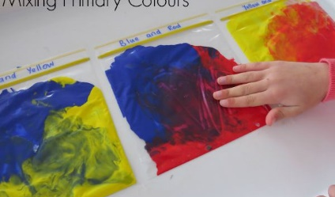  Education City – parent login
Creativity | Singing Easter songs and playing along to songs using instruments – instruments could be anything in your home e.g. pans and spoons (earplugs at the ready!) bottles filled with rice for shakers.  Vegetable printing (tops of veg or leaves from the vegetables) create and explore patterns | 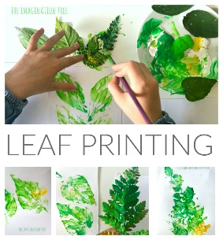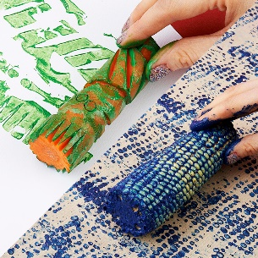
Individuality | Egg and spoon races, throwing and catching skills using balloons (easier and safer inside!)  Balancing eggs on kitchen roll tubes  Washing the dishes or cleaning the windows  Washing hands using the symbol sequence previously given out | 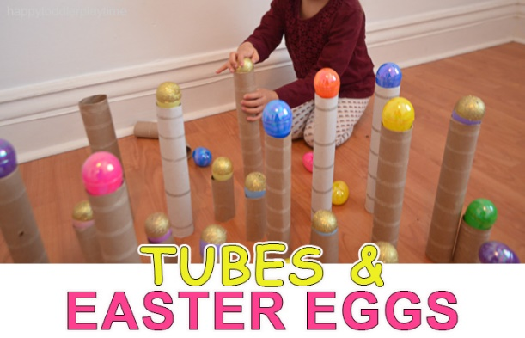
Community | Look at photographs, name friends & family members; do you have any Easter pictures from last year?  Go on an egg hunt around the house or in your garden – explore rooms in your house or places in your garden and find eggs from clues. Can you follow one or two instructions to find the eggs? | 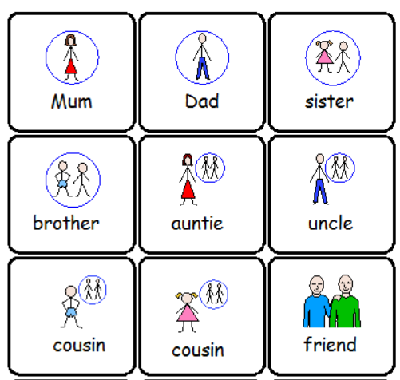
Challenge | Plant seeds from fruits or vegetables that you have eaten - make sure they are planted in soil, given water and placed in a sunny spot to grow.  Go on a minibeast or flower hunt outside  Play Slither.io – Challenge you parents, sisters or brothers, who can become the longest slither of the day? Download on the App store. | 
- Please refer to annual reviews for your child’s personalised targets.

I would love to see and hear about what you have been doing, feel free to email myself anytime – eshaw@parklane,cheshire.sch.uk

