
2026/2027 Medium Term Plans Year Group: EYFS Class: Silk Term: Autumn 1
Our curriculum approach is around the theme “Superstars: What Makes Me Special?”, which celebrates every child’s individuality, strengths, and sense of belonging. We focus on creating an environment where children feel seen, valued, and confident to express who they are, using rich, hands-on, sensory experiences that help them explore their identity in meaningful ways. Our provision grows from the children themselves—their interests, their preferences, and the moments of joy they share—so that learning feels personal, motivating, and deeply connected to their lived experiences. Through daily routines, play, and responsive interactions, we nurture self-awareness, communication, independence, and emotional security, ensuring every child has the opportunity to shine as the superstar they are.
Area of Learning | Week 1 | Week 2 | Week 3 | Week 4 | Week 5 | Week 6 | Week 7 | Week 8
Key Words/symbols: | Me, My, You, Head, Eyes, Nose, Mouth, Hands, Feet, Happy, Sad, Calm, Help, Eat, Drink, Home, School, Play
Key Themes and learning | This is my face – Super simple songs | From head to toe | Measuring me! | The Gingerbread man | The Gingerbread man | We’re going on a leaf hunt | We’re going on a leaf hunt | Autumn
Key Texts | 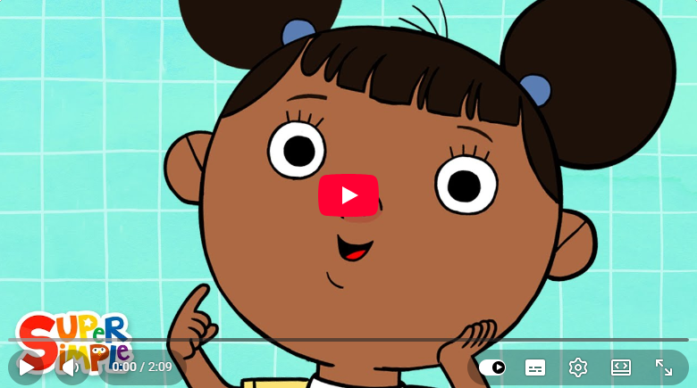 | 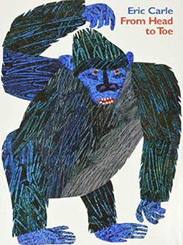 | 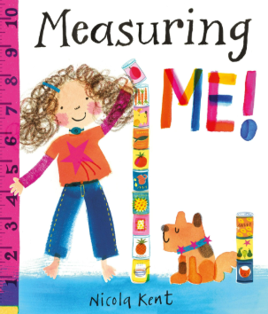 | 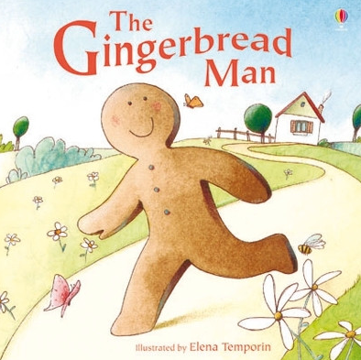 |  | 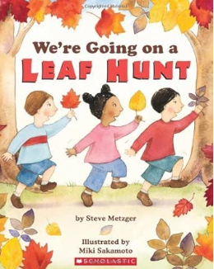 |  | 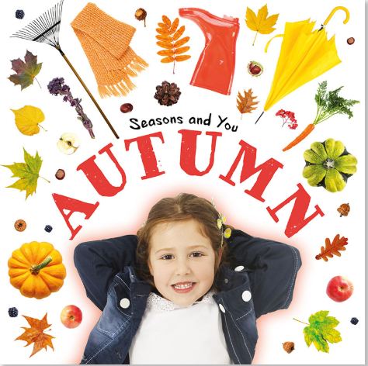
PSED (Personal, social, emotional development)  Self-regulation, managing self and building relationships. | Circle time – Promoting discussions  Knows what is expected in school in very simple terms, e.g. where we put our coat, we sit down when we eat, we listen to stories together. | Circle time – Promoting discussions  Find your photo/name  Emotion focus:  Happy  Green Zone.pptx  What makes you feel happy? What toys/objects textures do you like?  Nursery rhyme: If you’re Happy and You know it  Use mirrors to look at faces. Can we make happy faces. | Circle time – Promoting discussions  Emotion focus:  Sad  Blue Zone.pptx  What makes you feel sad?  Look at happy/sad faces. How do we know if someone is sad?  Use mirrors to look at our faces –  Listen to our song about feeling sad. | Circle time – Promoting discussions  Emotion focus:  Excited  Yellow Zone New.pptx  What can make us feel excited? How might our bodies and faces look and move when we are excited?  Use mirrors to look at our faces –  Model and name the feeling -excited – introducing an activity . | Circle time – Promoting discussion  Emotion focus:  Scared  Red zone.pptx  How does the gingerbread man feel when he is running away? Also relate to previous emotions we have learned about. | Circle time – Promoting discussion  Emotion focus:  Poorly  Blue Zone.pptx  Doctor dress up.  Look at the photos of who helps us in school when we feel poorly.  Ask Cassie/Sharon to come into this week? | Circle time – Promoting discussion  Emotion focus:  tired  Blue Zone.pptx  What does tired look like? Ask staff to model a tired face. Use mirrors to make a tired face.  Where can we go if we feel tired at school? What can we do to help ourselves -have a sit down in a quiet area/quiet activity etc | Circle time – Promoting discussion  Revisit previous emotions.  Watch song, model and copy actions and facial expressions.  Understanding Feelings | Emotions Song for Kids
CL (Communication and language) | Total communication approach used throughout. Core boards to promote key vocabulary across all subjects, where appropriate have these interwoven into powerpoints. | Think about specific activity boards with key vocabulary on. Ensure these are accessible for all.  Create a core board to accompany the key text. | Work on specific SALT targets for individuals and small groups.  Create a core board for key sessions e.g. ‘look and see’, again interwoven into powerpoints if appropriate. | Continue to intertwine communication and language throughout all aspects of the day. Focusing on familiarity with key vocab and core word of the week. | Continue to intertwine communication and language throughout all aspects of the day. Focusing on familiarity with key vocab and core word of the week. | Continue to intertwine communication and language throughout all aspects of the day. Focusing on familiarity with key vocab and core word of the week. | Continue to intertwine communication and language throughout all aspects of the day. Focusing on familiarity with key vocab and core word of the week. | Continue to intertwine communication and language throughout all aspects of the day. Focusing on familiarity with key vocab and core word of the week.
PD (Physical Development) including PE sessions  Daily fine motor activities including pencil control, scissor skills and finger gym  Additional activities – scarf and ribbon dances; dough disco and parachute sessions. | Shows some control over their body. Uses a range of tools and equipment.  PE: Throwing amd catching:  Scarf dance – throwing different coloured scarves up into the air to music.  Catching and popping bubbles.  Throwing soft balls into the air.  Throwing balloons into the air. | Shows some control over their body. Uses a range of tools and equipment.  Explore space safely using big body movements.  Imitate animal movements. Encourage students to copy Eg trot like a horse/crawl like a spider.  Cool down: Animal Yoga – Toddler Yoga: Animal Poses! | Shows some control over their body. Uses a range of tools and equipment.  PE: Throwing skills: Rolling  3 activity stations  Place balls onto cones and push to roll off. (ext – push the red ball)  Skittles game  Tower knock down – build a tower and take turns to roll a large ball at it. | Shows some control over their body. Uses a range of tools and equipment.  PE: Throwing skills: throwing  3 activity stations:  Animal throw – throw to the pictures from the story.  Beanbag throw into animal mouth boxes  Ball throw to Velcro target | Shows some control over their body. Uses a range of tools and equipment.  Encourage the children to follow the obstacle course of The Gingerbread Man.  Stepping stones  Forest tunnel  Bridge balance  River jump  Animal throw  Run to safety!  Will have visuals at each station. | Shows some control over their body. Uses a range of tools and equipment.  PE: Throwing skills Small group/ partner work.  Encourage the children to interact with each other/staff by – rolling/throwing the ball to each other.  Use the net to throw over to each other | Shows some control over their body. Uses a range of tools and equipment.  Sensory Forest Obstacle Course – over rivers (blue mats) along branches (beam) through caves (tunnel) etc  Will have visuals at each station | Shows some control over their body. Uses a range of tools and equipment.  Revisit a previous throwing/rolling activity the children enjoyed.
Literacy  Daily opportunities to mark make might include:  chalk/white boards  colouring sheets related to story  shallow sand/rice trays  squiggle whilst you wiggle sessions  Look and Listen  TacPac  HandyPac  Library visits | Core word of the week  Twinkl Phonics Level 1 & 2 (Dependent upon children and classes)  Reading pathway?  Look at our faces. Can we find our different facial features whilst listening to/after the song?  Activity: create play dough faces and/or use Mr Potato Head resources and talk about the different features. Can be done as a group activity with the children taking turns to identify and put on the different features.  .  DM links: L- I can enjoy rhymes, tune in and pay attention (0-3) I can join in with some songs and rhymes when led by an adult (3-4)  PD - I can develop manipulation and control | Core word of the week  Twinkl Phonics Level 1 & 2 (Dependent upon children and classes)  Encourage students to join in on actions and  refrain – I can do it! (sound button)  Animal sounds game (use picture board and OOR). Practise listening.  What Do You Hear? | Animal Song | Super Simple Songs  Ext: Colourful semantics retell: Subject/Verb  DM links: L –I can copy finger movements and other gestures (0-3) I can notice different sounds around me (3-4)  CL – I can engage in story times (R) | Core word of the week  Twinkl Phonics Level 1 & 2 (Dependent upon children and classes)  Hand/feet prints – compare big/small  Draw around each other with chalk –vocabulary cards – tall/short./big/small  DM links: L- I can pay attention and respond to pictures or the words (0-3) CL -I can use a wider range of vocabulary (3-4) PD I can use large muscle movements to make marks (3-4) | Core word of the week  Twinkl Phonics Level 1 & 2 (Dependent upon children and classes)  Explore the different characters through name cards and making props for the story – lolly sticks or masks to support retell and role play.  DM Links – L- I can develop play around favourite stories using props (0-3) | Core word of the week  Twinkl Phonics Level 1 & 2 (Dependent upon children and classes)  When reading the story, encourage students to join in with the refrain – ‘Run! Run! – using voices/sound button/fast patting their knees.  Storyboard to sequence the story. Find the characters and put them on.  Can you find any of the other characters.  Individual work -  Story sequencing cards beginning -middle-end  DM links: L- I can repeat words and phrases from familiar stories (0-3) | Core word of the week  Twinkl Phonics Level 1 & 2 (Dependent upon children and classes)  Sensory story – explore sensory props whilst reading the story.  Explore different sounds in the story – water/crunchy leaves  Mark making with sticks in mud  Leaf rubbing  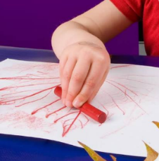  DM Links: L –I can notice different objects make different sounds (3-4) UW – I can explore natural materials (0-3).  I can enjoy drawing freely (0-3) | Core word of the week  Twinkl Phonics Level 1 & 2 (Dependent upon children and classes)  Listen to the story, model the rhythmic beat using rhythm sticks (or hands/ drums/shakers). Encourage the students to tap out the beat of the story. Explore loud/quiet tapping. Model different actions - scrape sticks when going through the forest. Alternate stick tapping when rowing etc.  DM Links: L – I can join in with some songs and rhythms when led by an adult (3-4)  I can show awareness of how acting upon an instrument affects the sound it makes (3-4) | Core word of the week  Twinkl Phonics Level 1 & 2 (Dependent upon children and classes)  Consolidate our learning about Autumn - exploring our book along with the sensory props -  Nursery Rhyme: Autumn leaves are falling down  Seasons Song for Kids ♫ Autumn Leaves are Falling Down ♫ Fall Kids Song ♫ by The Learning Station  Encourage children to join in with singing/actions/props.  DM links: L- I can join in with songs and rhymes copying sounds, rhythms, tunes and tempo (0-3)
Maths  Daily routine maths – countdowns during tidy up time, positional language to out away resources, counting how many chn are in class, how many resources go in pots/draws, counting out snacks, daily nursery rhymes | Number and place value focus  -Number awareness  DM Links – Explore numbers through play, respond to changes in amounts  Sensory trays with numerals hidden in sand/foam.  Number songs with props (e.g., 5 currant buns)  Sorting objects into “one” and “many”. | Number and place value focus  -Counting principles  DM Links - Say some number names in sequence, Recite numbers past 5  Count steps, claps, drum beats  Count 1–3 objects into bowls  Use finger puppets to count along | Number and place value focus  -Linking numerals to quantities  DM Links - Link numerals and amounts, Show ‘finger numbers’ up to 5  Numicon matching games.  “Find number ___” treasure hunts.  Build towers to match numeral cards. | Number and place value focus  -Comparing amounts  DM Links - Compare quantities using language: more, fewer, same  Snack-time comparisons (“Who has more grapes?”)  Fill-and-pour activities with containers  Compare towers, piles, or collections | Number and place value focus  -Composition of number  DM Links - Understand that numbers are made up of smaller numbers  “Make 3” using different objects (2+1, 3+0).  Numicon overlays to show composition.  Build small sets with two colours. | Number and place value focus  -Apply number knowledge  DM Links - Solve real problems with numbers  Shop role-play: counting items into baskets  “Number missions” around the classroom.  Simple board games with dice (1–3). | Geometry focus  -Explore circular objects  DM Links - Begins to notice shape through exploration.  Roll sensory balls between adults and children.  Watch bubbles and pop them.  Roll illuminated balls in a darkened space.  Explore circular objects using hands and feet. | Geometry focus  -Explore square shapes through touch and construction  DM Links - Explores similarities and differences between shapes  Build towers together.  Knock towers down.  Stack and carry cubes.  Explore textured square materials
UW (Understanding the World) | Starts to be curious about the people around them.  Shows interest and curiosity in very simple similarities and differences between people. Complete an activity where they decorate the first letter of their name. Identifying if it is the same as anyone else in the class.  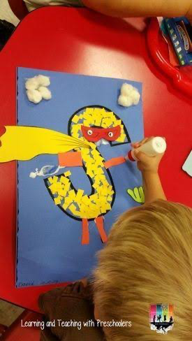 | 9th September – Teddy Bear Day – Celebrate Teddy Bear Day, set up a variety of activities to participate with their teddy e.g. teddy bear hospital, label head shoulders knees and toes on their teddy linked to key text. Have a Teddy Bear Picnic? | Read Bitsy Bat and Team Star – discuss the differences in the characters in how they move and how they communicate. Celebrate the differences we have within our class. n  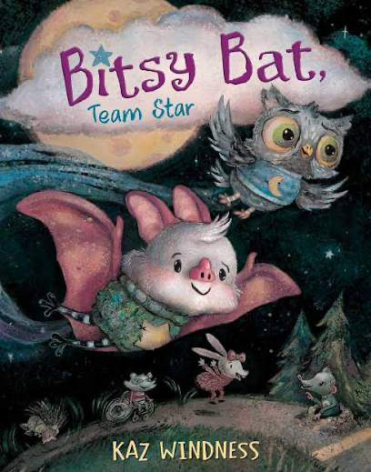 | Make gingerbread playdoh and encourage pupils to decorate their gingerbread person however they want. Again, celebrate the similarities and differences, see if the children can spot similarities and differences.  https://theimaginationtree.com/gingerbread-play-dough-recipe/  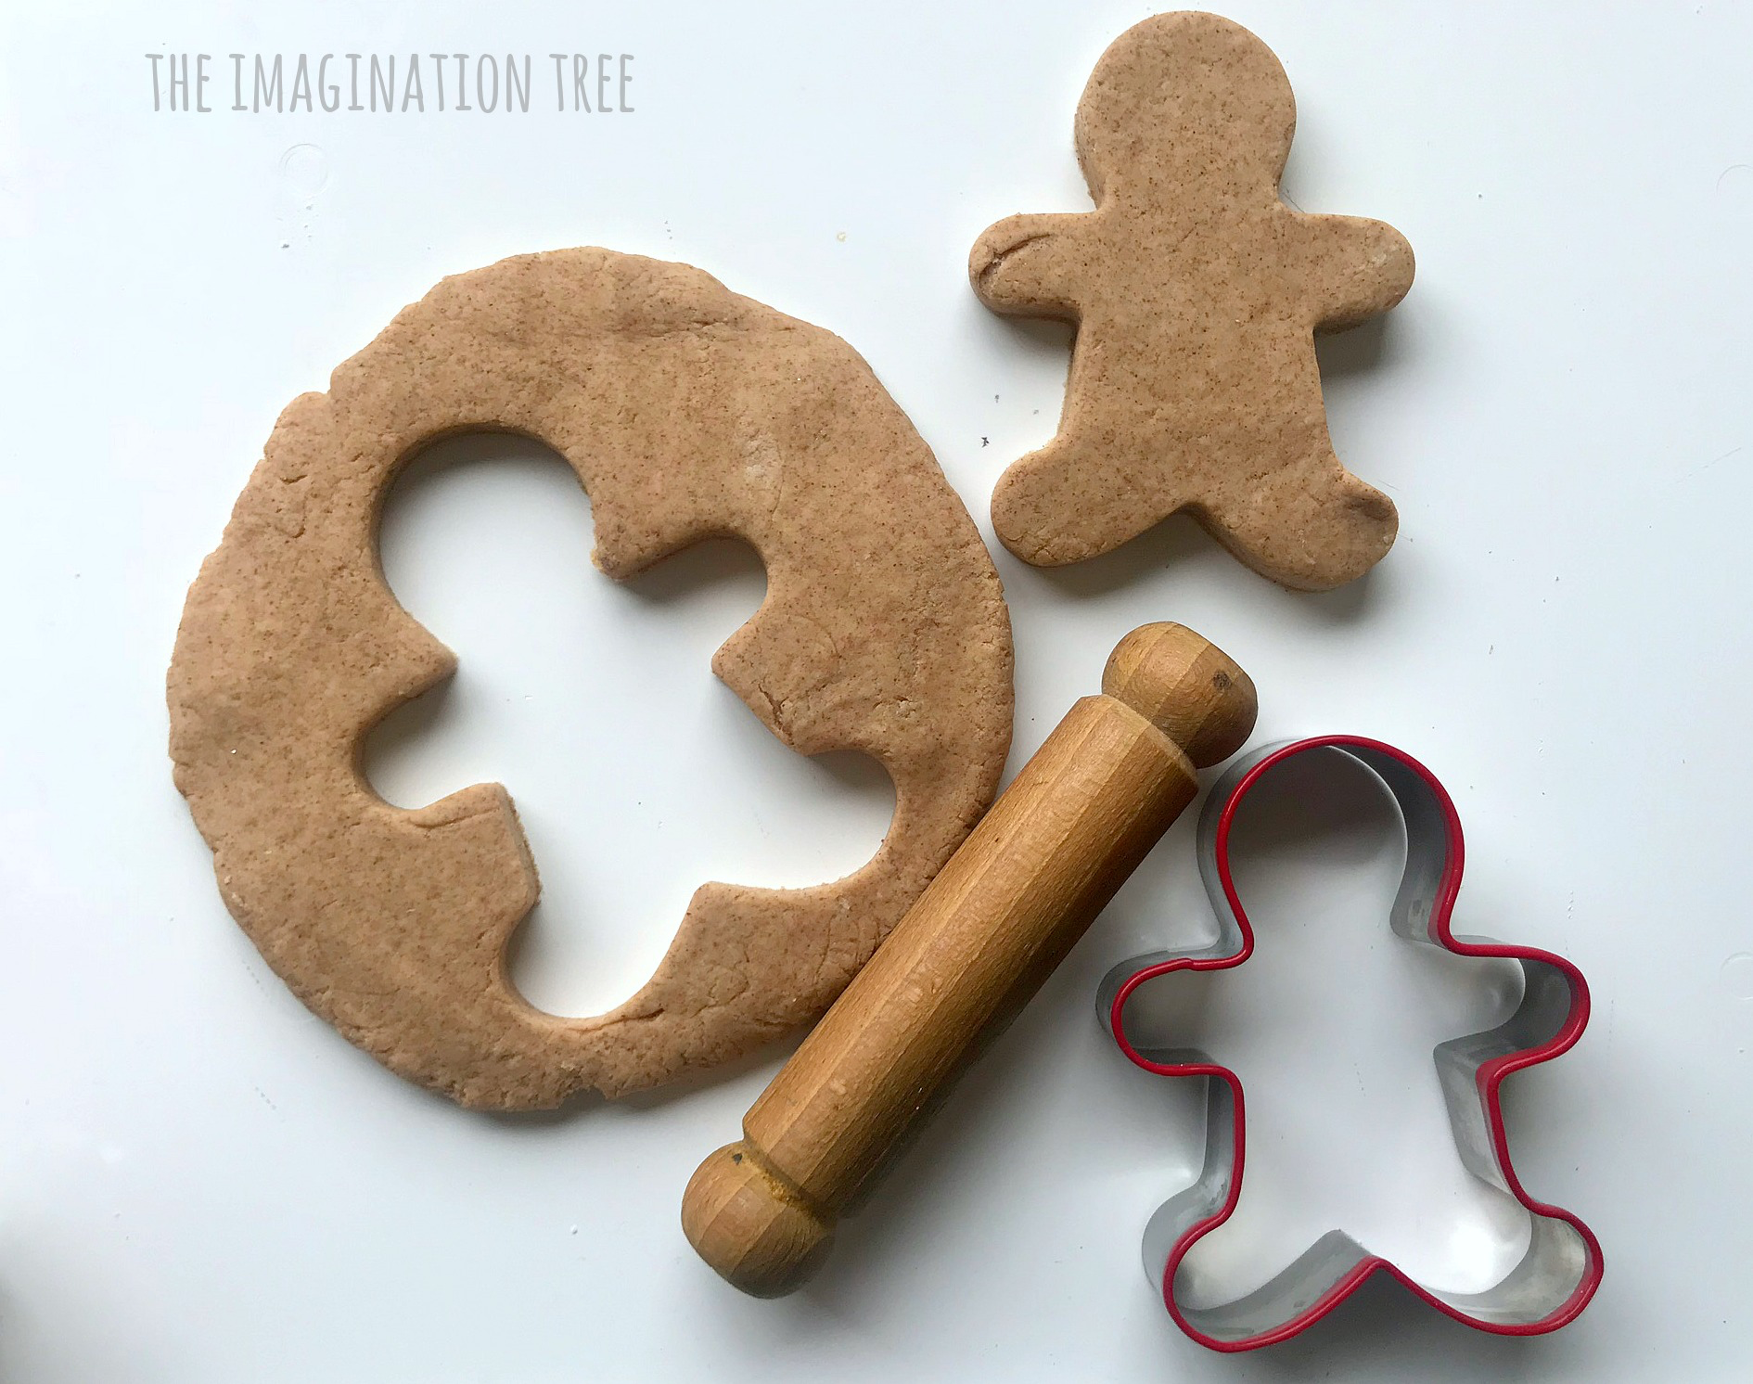 | Gingerbread Biscuit decoration. Have gingerbread people biscuits and then have a variety of icing pens, and decorations for children to decorate as they want. Have an activity board so pupils can request what they need to complete the task.  If not safe to complete as edible, do it as a paper task and have a variety of sequins and glitter pens to decorate.  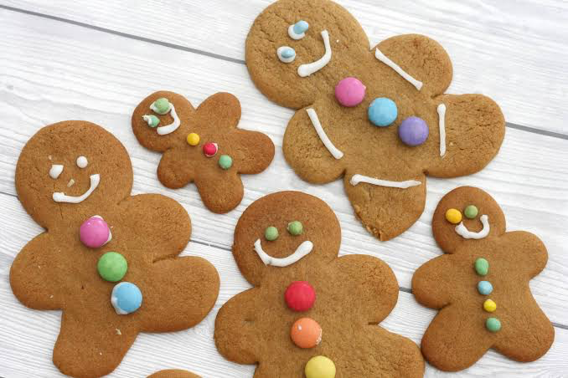 | Explore the immediate environment and go on a leaf hunt. Have a colour sheet and see if pupils can find leaves of the different colours mentioned.  Save the leaves for next week.  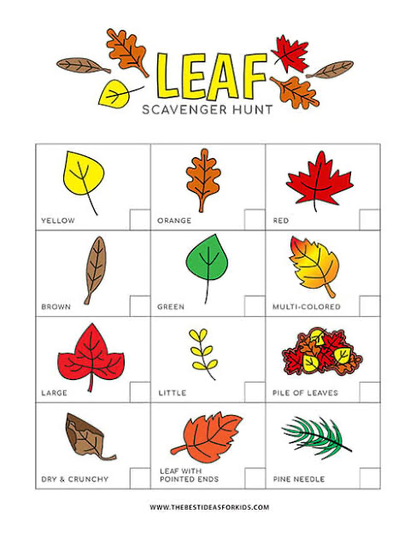 | Using the leaves from last week's leaf hunt. Create hair for their self-portrait. Use a photo of the child (but no hair.) Encourage them to look at the colour of their hair and choose the leaves that best suit that colour.  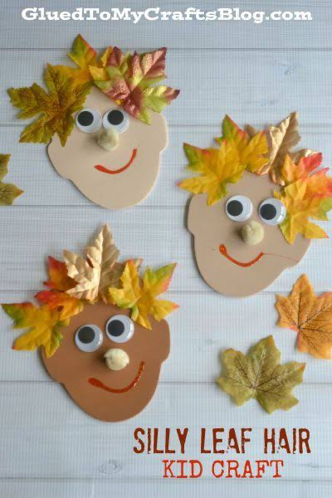 | Finish any ongoing projects
EAD (Expressive Art and Design) | Start work on class display by creating the background. On black paper either finger paint or have yellow squares cut out so children can form the windows of their building.  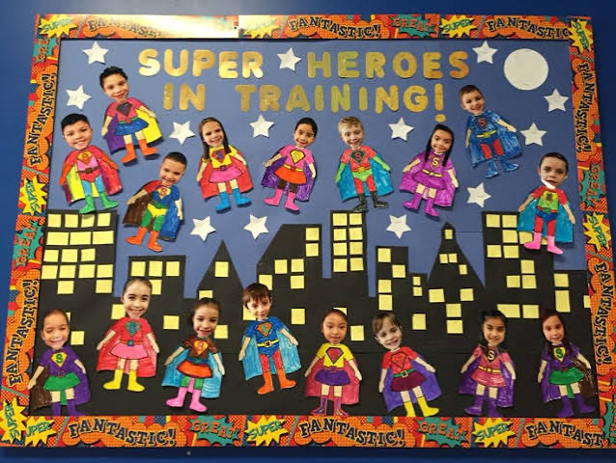 | Singing Head Shoulders Knees and Toes. Linking to key text. Have an activity board on the IWB (and print out) so pupils can fill in the gap when singing the song. Video performance if appropriate for class DOJO. | Finish the class display. Have a photo of each child ready to put on their superhero body. They choose the colour and how they want to decorate their superhero. | Using Chrome Music Lab - Rhythm  https://musiclab.chromeexperiments.com/Rhythm/  Allow children to experiment with the different sounds and rhythms. Spot if there are preferences or dislikes to particular sounds. | Using Chrome Music Lab - Rhythm  https://musiclab.chromeexperiments.com/Rhythm/  Allow children to experiment with the different sounds and rhythms. This week encourage them to use the slider at the bottom to change the speed of their rhythm. | Using Chrome Music Lab – Kandinsky  https://musiclab.chromeexperiments.com/Kandinsky/  Encourage children to make marks on the board, each mark will create a different sound. | Using Chrome Music Lab – Kandinsky  https://musiclab.chromeexperiments.com/Kandinsky/  Encourage children to make marks on the board, each mark will create a different sound.  Encourage the children to experiment with changing the colour as this changes the instruments. | Continue using Chrome music lab – revisit previous learning
Outdoor Provision | Maths - Large tactile numbers  Posting boxes labelled “1” and “lots”  Construction – Make houses with range of building blocks  Mud Kitchen – kitchen resources to explore and develop play skills  Explore signs of Autumn  PD – Ride on toys | Maths - Count-and-drop activities (marbles, pom-poms). Number lines with removable pieces  Construction – Make houses with range of building blocks  Mud Kitchen – kitchen resources to explore and develop play skills  Explore signs of Autumn  PD – Ride on toys | Maths - Peg-the-number washing line. Number mats for jumping onto the correct numeral.  Construction – Make houses with range of building blocks  Mud Kitchen – kitchen resources to explore and develop play skills  Explore signs of Autumn  PD – Ride on toys | Maths - Balance scales with large objects.  Sorting trays with “more/fewer” labels.  Construction – Make houses with range of building blocks  Mud Kitchen – kitchen resources to explore and develop play skills  Explore signs of Autumn  PD – Ride on toys | Maths -Ten-frame trays with counters. Magnetic part-whole boards.  Construction – Make houses with range of building blocks  Mud Kitchen – kitchen resources to explore and develop play skills  Explore signs of Autumn  PD – Ride on toys | Maths - Number-rich small world play.  Outdoor number trails.  Construction – Make houses with range of building blocks  Mud Kitchen – kitchen resources to explore and develop play skills  Explore signs of Autumn  PD – Ride on toys | Maths – Ball ramp  Construction – Make houses with range of building blocks  Mud Kitchen – kitchen resources to explore and develop play skills  Explore signs of Autumn  PD – Ride on toys | Maths – Target game using circle or sqaure as the target (on the floor)  Construction – Make houses with range of building blocks  Mud Kitchen – kitchen resources to explore and develop play skills  Explore signs of Autumn  PD – Ride on toys
SMSC & BV | SMSC is covered in our early years setting by developing activities and sessions that foster a sense of self-worth, respect for others and an understanding of the world around them.  Examples in our early years classes are: Engaging in stories, songs, and activities that have cultural or moral themes, such as celebrating different festivals, Creating a classroom that is inclusive, where different perspectives are welcomed, and children feel safe to express themselves, providing resources that support social and emotional learning, such as books about feelings and using everyday situations, like sharing toys or resolving a playground conflict, as a natural opportunity to discuss and practice social and moral skills.  In EYFS we teach children to be resilient, determined, confident, manage risks, make safe choices, knowing when where and how to get help. This teaching underpins the Fundamental British Values.
Evaluation/Comments
(Teacher use)

