
2025/2026 Medium Term Plans Year Group: EYFS Class: Cotton Term: Summer 1
At the heart of our school’s ethos is our theme, “Living Things”—a theme that encourages curiosity, connection, and a sense of care for the world around us. We aim to support our children as they explore all the wonderful things that grow and change. Our approach is built around the needs, interests, and strengths of every child. We create opportunities for hands‑on, sensory experiences so that all learners can take part in ways that feel meaningful to them. Our short‑term planning and continuous provision enhancements are shaped by the children, their fascinations, and the moments of joy they show us each day.
Area of Learning | Week 1 | Week 2 | Week 3 | Week 4  Internation Nurses Day 12th May | Week 5  World Bee Day 20th May | Week 6
Key Words: | Eat, taste, smell, touch, feel, help, facial and body parts, on top/under, in front/behind, next to, in/out, forwards/backwards,  I can, you can, family, pets, friends, favourite, choose, share, healthy, shadow, feelings
Key Themes and learning | Eyes, nose and chin – Busy bag | I like myself | Only one you | The Rainbow Fish | The Rainbow Fish | Nursery rhyme week
Key Texts | 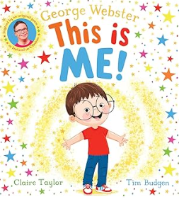 | 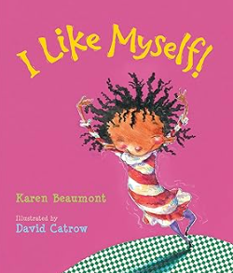 | 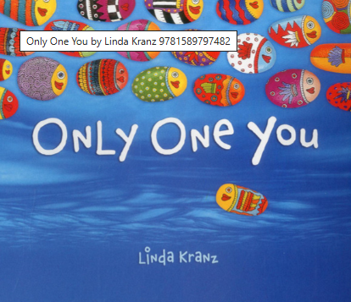 | 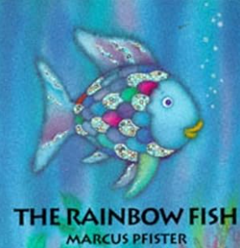
PSED (Personal, social, emotional development) | Circle time – Promoting discussions  Can you name different parts of your body? | Circle time – Promoting discussions - What do you like about yourself? Question can be broken down into smaller manageable questions for the children.  Provide opportunities for self-expression through music, art, dance etc | Circle time – Promoting discussions  What makes you special? | Circle time – Promoting discussions  What do you think the story will be about?  How are the characters in the story feeling? | Circle time – Promoting discussion  What makes a good friend? | Circle time – Listen to well known nursery rhymes. Can children answer questions based on the nursery rhyme? For example – Twinkle twinkle, what was twinkling in the sky?
CL (Communication and language) | Explore the nursery rhyme heads, shoulders knees and toes – remember key body parts  Feely bag, include small world objects or pictures of things that may make the children feel happy, sad, angry or worried. Children communicate how the objects make them feel. | All about me sensory basket – link to story, model language of objects (mirror, brush etc) Offer choices.  Role play – Silly self-stations (Wacky Hair Station: wigs, ribbons, hats. Silly Specs Station: glasses, masks. Dress-Up Station: scarves, capes, colourful clothing) | Feelings and faces matching games  Identify how children are feeling. | Sensory story  Identify under the sea sounds (Shells, water, beads etc) | Character exploration – what characters can be seen (Fish, octopus etc)  -Challenge ssl to include some simple descriptive language  Choice making/expressing preferences  -Share a range of fish with different textures | Rhyme bag - Children pull an object from a bag (e.g., star, sheep, spider) and guess which rhyme it belongs to.
PD (Physical Development) including PE sessions | Weekly fine motor activities including squiggle whilst you wiggle & dough disco.  Develop gross motor skills using the outdoors for large scale construction and painting/chalking.  Parachute – Early writing skills  PE: Athletics Focus | Weekly fine motor activities including squiggle whilst you wiggle & dough disco.  Develop gross motor skills using the outdoors for large scale construction and paint/chalk.  Parachute – Early writing skills  PE: Athletics Focus | Weekly fine motor activities including squiggle whilst you wiggle & dough disco.  To develop gross motor skills using the outdoors for large scale construction and paint/chalk.  Parachute – Early writing skills  PE: Athletics Focus | Weekly fine motor activities including squiggle whilst you wiggle & dough disco.  To develop gross motor skills using the outdoors for large scale construction and paint/chalk.  Parachute – Early writing skills  PE: Athletics Focus | Weekly fine motor activities including squiggle whilst you wiggle & dough disco.  To develop gross motor skills using the outdoors for large scale construction and paint/chalk.  Parachute – Early writing skills  PE: Athletics Focus | Weekly fine motor activities including squiggle whilst you wiggle & dough disco.  To develop gross motor skills using the outdoors for large scale construction and paint/chalk.  Parachute – Early writing skills  PE: Athletics Focus
Literacy | Core word of the week  Twinkl Phonics Level 1 & 2 (Dependent upon children and classes)  To explore story-related vocabulary through sensory experiences | Core word of the week  Twinkl Phonics Level 1 & 2 (Dependent upon children and classes)  To engage with story time through looking, touching, listening, or using objects of reference | Core word of the week  Twinkl Phonics Level 1 & 2 (Dependent upon children and classes)  To use signs, symbols, or spoken words to label familiar objects from the story, | Core word of the week  Twinkl Phonics Level 1 & 2 (Dependent upon children and classes)  To match pictures, symbols, or objects to simple words from a story. | Core word of the week  Twinkl Phonics Level 1 & 2 (Dependent upon children and classes)  To sequence two or three parts of a familiar story using objects, photos, or symbols | Core word of the week  Twinkl Phonics Level 1 & 2 (Dependent upon children and classes)  Name the Rhyme: Match pictures to rhyme titles
Maths | Respond to simple language of position. Sing rhymes such as Hokey Cokey with children but change the language of left and right to “Put one arm/leg in/out”. Encourage children to join in and follow the simple instruction of “in, out, shake it all about”. Length, weight, capacity  Know the different times of the day e.g. dinner time, home time, playtime and what order they come in (Time on symbols)  Talk about shapes and use in pictures and models. | Select shapes for a space. Place a large cardboard box in the middle of the carpet. Ask children what might fit inside the box. Would they fit inside the box? Then show children a smaller cardboard box and a range of items, ensuring that some items will fit and some will not. Encourage children to select the items they think will fit inside the box and prompt them to check. | Recognise when 2 objects are the same shape. Provide children with a range of box modelling and building blocks that include identical pieces. Model comparing 2 objects to see if they are the same shape and encourage children to continue this themselves. | Explore and describe shapes and objects. Show children a range of objects such as a party hat, a ball, a tissue box and a tube. As children explore the objects, model the language of ‘sharp’, ‘pointy’, ‘curvy’, ‘round’ and ‘flat’.  Underwater counting game on topmarks | Sort shapes and objects into simple categories. Provide children with a range of objects similar to those explored in the previous step. Support them to use the vocabulary of ‘sharp’, ‘pointy’, ‘curvy’, ‘round’ and ‘flat’ to categories the objects.  Underwater counting game on topmarks | Counting Songs: Use props for “Five Little Ducks”, “Ten in the Bed”, or “1, 2, Buckle My Shoe”  Size Sorting: Big and small stars for “Twinkle Twinkle”.  Positional Language: Use Incy Wincy to explore up, down, under, over.
UW (Understanding the World) | Explore faces using mirrors.  What’s in the box session – Use of technology, | Create vegetable faces. | Explore sensory trays with hands and feet – sand, water, shaving foam, jelly, cotton wool, mud etc | Explore touch and feel buckets linking to the story  Practice blowing bubbles like the Rainbow Fish | Water play – range of nets, utensils to catch fish in the water | Weather play: Explore rain, sun, water flow for ‘incy wincy spider’.  Animals in Rhymes: Look at real pictures of sheep, ducks, cows and talk about where they live.  Night and Day: Link “Twinkle Twinkle” to exploring light and dark with torches.
EAD (Expressive Art and Design) | Explore hand and feet printing – one fingerprint on each finger of hand  Clay/salt dough hand and feet imprints. | To create a self-portrait (Use of mirrors to identify facial features/think about how their face may look when feeling certain emotions) | Explore hand and feet printing – one finger print on each finger of hand | Decorate a Rainbow Fish template using jewels, glitter, shiny paper | Celery stick paining (Use celery to create scales) | Make a Star Wand for “Twinkle Twinkle”.  Create a Waterfall for Incy Wincy using foil, tubes, and blue cellophane.  Role Play: Set up a “Nursery Rhyme Theatre” with simple costumes and puppets.
Outdoor Provision | Chalk around children  Construction – build homes from around the world  Add stones/pebbles to sandpit with family members – children search the sand for them, create families | Shadow play, drawing round shadows (Weather permitting)  Taking care of flowers in the garden | Draw numbered footprints with chalk  Draw chalk faces for the pupils to add facial features too | Bubble play  Foil fish in the sunlight | Bubble play  Foil fish in the sunlight  "Under the Sea" Movement: Encourage children to move around the outdoor space like different sea creatures | Star hunt  Water wall  Wall building
SMSC & BV | SMSC is covered in our early years setting by developing activities and sessions that foster a sense of self-worth, respect for others and an understanding of the world around them.  Examples in our early years classes are: Engaging in stories, songs, and activities that have cultural or moral themes, such as celebrating different festivals, Creating a classroom that is inclusive, where different perspectives are welcomed, and children feel safe to express themselves, providing resources that support social and emotional learning, such as books about feelings and using everyday situations, like sharing toys or resolving a playground conflict, as a natural opportunity to discuss and practice social and moral skills.  In EYFS we teach children to be resilient, determined, confident, manage risks, make safe choices, knowing when where and how to get help. This teaching underpins the Fundamental British Values.
Evaluation/Comments
(Teacher use)

