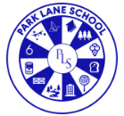
2025/2026 Medium Term Plans Year Group: EYFS Class: Silk Term: Spring 2

At the heart of our school’s ethos lies the empowering theme of "Global Warriors"—a concept that celebrates courage, resilience, and global citizenship. Through this plan, we aim to empower our pupils not just as learners, but as Global Warriors—ready to face the future with confidence, compassion, and a commitment to making a difference. Our short-term planning and enhancements in our continuous provision incorporates ideas and interests from the children.
Area of Learning | Week 1  Chinese New Year (Year of the Horse) | Week 2  Holi (Hindu Festival) | Week 3  Mother’s Day | Week 4  Global Recycling Day (18^{th)} | Week 5
Key Words: | Chinese New Year, Horse, celebrate, Holi, colour/colour names, Mothering Sunday, straw, brick, sticks, build
Key Themes and learning | Lunar New Year Story (CBeebies) | Holi – Hindu Festival of Colour | Guess how much I love you. | Three Little pigs | Three Little Pigs
Key Texts | 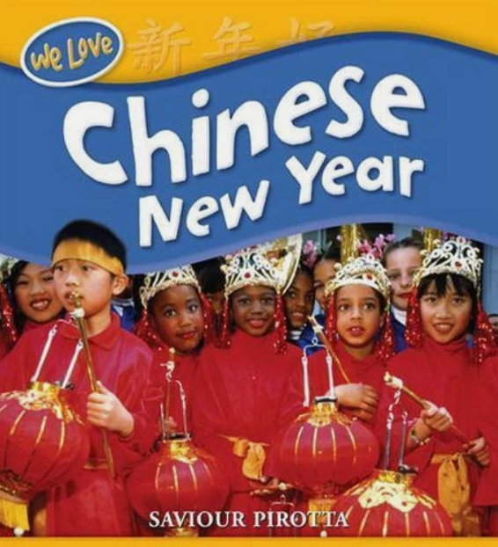 | 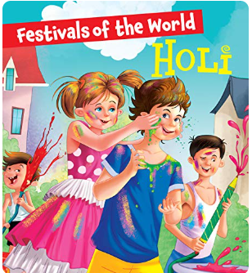 | 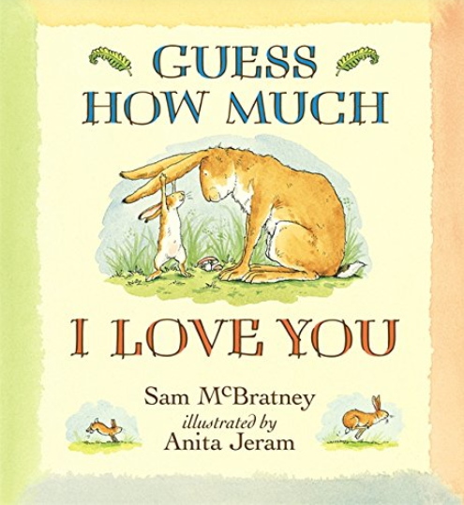 | 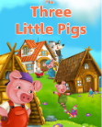
PSED (Personal, social, emotional development) | Circle time – Promoting discussions  Chinese New Year is a time when families come together and celebrate. What special things do you do with your family to celebrate something important? | Circle time – Promoting discussions  Holi is a festival where people throw colours and celebrate with friends and family. How do you feel when you play and have fun with your friends? | Circle time – Promoting discussion  Can you show me with your arms how big your love is? Is it as big as a tree, a house, or the sky? | Circle time – Promoting discussion  How do you think the pigs felt when the wolf blew down their houses? How would you feel if that happened to you? | Circle time – Promoting discussion  Why do you think the pigs decided to live together in the brick house at the end? How can we help our friends when they are in trouble?
CL (Communication and language) | Role play the story, encouraging use of vocabulary from the story. | Role play the story, encouraging use of vocabulary from the story. | Role play and small world provision providing opportunities to re-enact the story and use story language/ enhance vocabulary. | Role play and small world provision providing opportunities to re-enact the story and use story language/ enhance vocabulary. | Role play and small world provision providing opportunities to re-enact the story and use story language/ enhance vocabulary.
PD (Physical Development) including PE sessions | Encourage children to use to ride on toys to practice their balance and riding skills (ongoing throughout the term.)  Develop gross motor skills using the outdoors for large scale construction and painting/chalking.  PE: Basic ball skills – Kicking and dribbling | Weekly fine motor activities including squiggle whilst you wiggle & dough disco.  To develop gross motor skills using the outdoors for large scale construction and paint/chalk.  PE: Basic ball skills – Kicking and dribbling | Weekly fine motor activities including squiggle whilst you wiggle & dough disco.  To develop gross motor skills using the outdoors for large scale construction and paint/chalk.  PE: Basic ball skills – Kicking and dribbling | Weekly fine motor activities including squiggle whilst you wiggle & dough disco.  To develop gross motor skills using the outdoors for large scale construction and paint/chalk.  PE: Basic ball skills – Kicking and dribbling | Weekly fine motor activities including squiggle whilst you wiggle & dough disco.  To develop gross motor skills using the outdoors for large scale construction and paint/chalk.  PE: Basic ball skills – Kicking and dribbling
Literacy | Core word of the week  Twinkl Phonics Level 1 & 2 (Dependent upon children and classes)  Children will begin to recognize and explore basic features of non-fiction texts (e.g., photographs, labels, headings) through sensory and visual engagement. | Core word of the week  Twinkl Phonics Level 1 & 2 (Dependent upon children and classes)  Children will use a non-fiction book with adult support to find simple information related to a topic of interest. | Core word of the week  Twinkl Phonics Level 1 & 2 (Dependent upon children and classes)  To engage with a sensory story, exploring the story using their senses. | Core word of the week  Twinkl Phonics Level 1 & 2 (Dependent upon children and classes)  To listen to the story and identify key characters, settings, and materials used by the pigs | Core word of the week  Twinkl Phonics Level 1 & 2 (Dependent upon children and classes)  To retell the story in order and create simple sentences
Maths | White Rose Maths  Counting 2  Model saying 1, 2 and 3 in play. When playing alongside children in provision, model using the number names 1, 2 and 3 in order, for example, when counting characters in the small world area or counting blocks as you build towers in the construction area. | White Rose Maths  Counting 2  Children copy the sequence of 1, 2 and 3 in play. Introduce children to phrases such as “1, 2, 3, off we go!” or “1, 2, 3, run down the hill”. As children become more familiar with these phrases, encourage them to copy and repeat them in similar contexts. | White Rose Maths  Counting 2  Children will copy fingers to represent 1, 2 and 3 As you sing rhymes such as Baa Baa Black Sheep, count up on your fingers, showing one finger to represent one for the master, one for the dame and one for the little boy. Encourage children to copy you and represent this on their fingers too. | White Rose Maths  Counting 2  Children will begin to count actions. Sing rhymes such as Wind the Bobbin Up with children. Prompt them to join in with the actions such as pull and clap. Encourage children to count the actions as they join in, emphasising the 2 pulls and 3 claps as you sing along. | White Rose Maths  Counting 2  Children will say number names in order. Sing rhymes such as When Goldilocks Went to the House of the Bears with children. Prompt them to say the number names 1, 2 and 3 in order accurately. Encourage children to say these number names in order in other contexts during play.
UW (Understanding the World) | Learn about Chinese New Year | Learn about Holi  Make Holi snacks, mango lassi/sugar cookies | Learn about mothering Sunday  Create mothering Sunday cards/gifts | To explore and compare different materials used for building, and talk about their properties | To talk about different types of homes and how people live in different places around the world.
EAD (Expressive Art and Design) | Use junk to create a Chinese dragon  Create Chinese lanterns | Explore colour through powder paints. | Explore nursery rhyme  ‘Mary Mary quite contrary’ encouraging movement, joining in with song or instruments. | Nature collages with sticks, straw and bricks recreating the 3 pigs houses  Paint with mud, grass, and flower petals | To use a range of materials to create models of the pigs’ houses, exploring texture, shape, and construction techniques
Outdoor Provision | Chinese mud writing  Obstacle course – moving like the animals | Holi colour treasure hunt | Watercolours or chalks on fences, stones, or easels.  Set up flower shop or farmyard with props | Watercolours or chalks on fences, stones, or easels.  Set up flower shop or farmyard with props  Number/letter hunts | Watercolours or chalks on fences, stones, or easels.  Set up flower shop or farmyard with props  Number/letter hunts
SMSC & BV | SMSC is covered in our early years setting by developing activities and sessions that foster a sense of self-worth, respect for others and an understanding of the world around them.  Examples in our early years classes are: Engaging in stories, songs, and activities that have cultural or moral themes, such as celebrating different festivals, Creating a classroom that is inclusive, where different perspectives are welcomed, and children feel safe to express themselves, providing resources that support social and emotional learning, such as books about feelings and using everyday situations, like sharing toys or resolving a playground conflict, as a natural opportunity to discuss and practice social and moral skills.  In EYFS we teach children to be resilient, determined, confident, manage risks, make safe choices, knowing when where and how to get help. This teaching underpins the Fundamental British Values.
Evaluation/comments (Teacher use)

