
Glanhowy Primary School
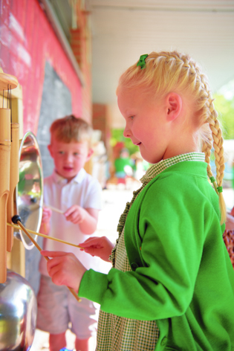


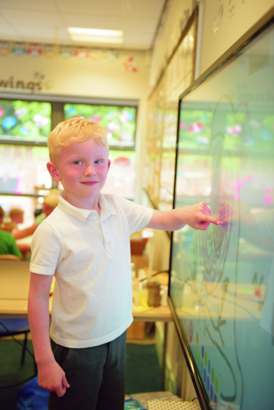

Annual Report to Parents 2026
Dear Parents

The format of this report will use the headings of the inspection areas from the Estyn Common Inspection Framework. This will ensure that all documents from our School Development Plan, Self-Evaluation Report and Annual Report to Parents are uniform in its appearance and clear in its aims. We will always aim to give up to date contextual information for the school and will then report under the following headings;

AI1 Teaching and Learning

AI2 Wellbeing, Care, Support and Guidance

AI3 Leading and Improving

This report will inform you of the progress made during the academic year 2025-2026. We have tried to move away from a descriptive document, to one which is informative and child focused and we welcome you to contact the school with comments or queries you may have.

Kindest Regards,

Mrs R. Phillips
Headteacher

Contextual Information

Glanhowy Primary School caters for pupils aged 3-11 years old. The Nursery provision caters for 62 pupils (31 Full Time Equivalent), this is an morning provision only. Our primary provision caters for pupils age 4-11 and they are organised into 10 classes. We currently have 252 pupils on roll. In September 2016, we opened a LA ASD Base which hosts 14 pupils from across Blaenau Gwent, entry into this provision is done via LA ALN panel. Most pupils transfer from Glanhowy Primary to the local secondary school which is Tredegar Comprehensive School.

Members of Staff
Headteacher:  Mrs R Phillips |  | Deputy Headteacher:  Miss H Jones
Teachers:  Miss R Burrows  Mrs C Williams  Miss L Davies  Mrs L Holmes  Miss S Hodges  Mrs C Davies (AHT)  Miss N Steele (AHT)  Miss H Jones  Miss G Bond  Mrs G Lane  Mrs C Zerk | Learning Support Assistants:  Mrs R Pippen  Mrs L Matthews  Mrs S Griffiths  Mrs R Westicott  Mrs G Prosser  Miss C Fletcher  Miss C Meak  Miss N Vaughan  Mrs C White  Miss D Ridings  Mrs K Harries  Miss C Mills  Mrs T Daley  Mrs M Edwards  Miss L Cullun  Mr E Fowler |  | School Support Officers:  Mrs R MacQuade  Mrs M Jones  Caretaker:  Mr T Statham  Midday Supervisors:  Mrs D Harris

Our Governing Body
The internal organisation of the school is the responsibility of the Headteacher in consultation with the School Governing Body.
Our Governors are a group of individuals who have been elected, nominated or co-opted and are representatives of parents, teachers, ancillary staff, the LA and the local community.
School Governors work with the Headteacher and are responsible for setting the strategic direction of the school. They meet each half term at school. Sub committees meet in addition to the full Governor meetings. The Governors are responsible for producing the Annual Report to parents.

Our Governing Body Members

Chairperson: Cllr T Smith
Vice Chairperson: Mr D Jones

Other Governors:
Mrs R Phillips - Headteacher
Mrs L Holmes – Teacher representative
Miss D Ridings – non-teaching representative
Mrs L Barnsley
Mrs N Street
Mrs G Davies
Mrs K Evans
Miss J Davies
Mrs C Williams
Mrs E Brain
Mrs L Jones
Mrs S Lewis

Clerk to Governors: Director of Lifelong Learning,
Education Department,
Anvil Court
Church Street
Abertillery NP13 1DB
Telephone: 01495 311556

Our Chair of Governors can be contacted at the school address.

Breakfast Club

Breakfast Club is free to all children in line with Welsh Assembly guidelines. It opens at 8.20am each morning with an excellent attendance.

After School Club

The school hosts a range of after school activities each term which run from 3-4pm.

Term Dates

Date | Start | Half Term Starts | Half Term Ends | Term Ends
Autumn | 1/9/26 | 26/10/26 | 30/10/26 | 18/12/26
Spring | 4/1/27 | 8/2/27 | 12/2/27 | 19/3/27
Summer | 5/4/27 | 31/5/27 | 4/6/27 | 20/7/27

There are 6 INSET days in 2026-27 which are yet to be confirmed.

- Academic Standards

Reading:
Pupils generally make strong progress in reading across the school. Most year groups achieve progress scores above the expected national range, and progress has improved over time in nearly all cohorts. Older pupils apply their reading skills successfully and demonstrate increasing competence in understanding and interpreting texts. However, a minority of pupils require further support to develop more sophisticated comprehension skills, particularly in retrieving, analysing and synthesising information from a range of texts. These areas provide a suitable focus for further curriculum and teaching development.

Maths:
Procedural
Pupils make secure progress in procedural numeracy across the school. Nearly all year groups achieve progress scores within or above the expected national range, and younger pupils demonstrate particularly strong progress. Teachers support pupils effectively to develop mathematical fluency and apply calculation strategies with increasing confidence. Over time, pupils build secure mathematical knowledge and understanding.
Reasoning
Pupils develop secure procedural mathematical skills as they move through the school. Across most cohorts, the proportion of pupils attaining below average standardised scores reduces over time, whilst increasing numbers attain highly. Older cohorts demonstrate particularly strong outcomes, including for disadvantaged pupils. Although the Year 4 profile is less secure than elsewhere in the school, this is strongly influenced by cohort mobility and pupils joining with lower starting points. Overall, the procedural mathematics data indicates that pupils build mathematical fluency successfully and are generally well prepared for the next stage of learning.

- Wellbeing and Attitudes to Learning

We look at a wide range of evidence relating to attendance, including benchmarked data, and evaluate strengths and weaknesses in relation to the school’s attendance relative to other similar schools. We currently use a cluster approach called Callio, which provides parents and carers with half termly information on their child’s attendance, alongside The Education Welfare Service’s Attendance Pathway for pupils whose attendance falls below 90% at any point in the academic year. Our school attendance officer is Miss H Jones. We work closely with the Education Welfare Officer and all members of the school community to continue to improve attendance rates. Our data for last year are included below.

Attendance 2025-2026
Month | % Attendance | % Authorised Absences | % Unauthorised  Absences
Autumn Term | 91.7 | 4.0 | 4.4
Spring Term | 92.8 | 3.6 | 3.5
Summer Term | 91.3 | 2.6 | 6.1
Total | 91.9 | 3.4 | 3.7

In addition, we use the Pupils Attitudes to Self and School (PASS survey to gather responses from pupils and identify areas of strengths and areas for development. In the June 2026 survey, all PASS factors for both the 3-7 and 7-11 phase remained within the 31st and 100th percentiles indicating a high satisfaction with school experiences.

In October 2022, we received verification for the Wellbeing Award for schools, which recognised our provision and support dedicated to the mental health and wellbeing of all stakeholders within the school.

Pupil Voice
Mrs C Zerk leads the Pupil Leadership Team and PLT elections are held in September. A newly elected PLT is in place and meet every other Friday to discuss items outlined in their development plan.

Our other pupil voice groups such as the ECO Committee, Digital Leaders and Criw Cymraeg will also be established by October half term.

Exclusion & Discriminary Incidents

There was 14.5 sessions of exclusions and 0 discriminary incidents reported last year including incidents of bullying.
Teaching and Learning Experiences
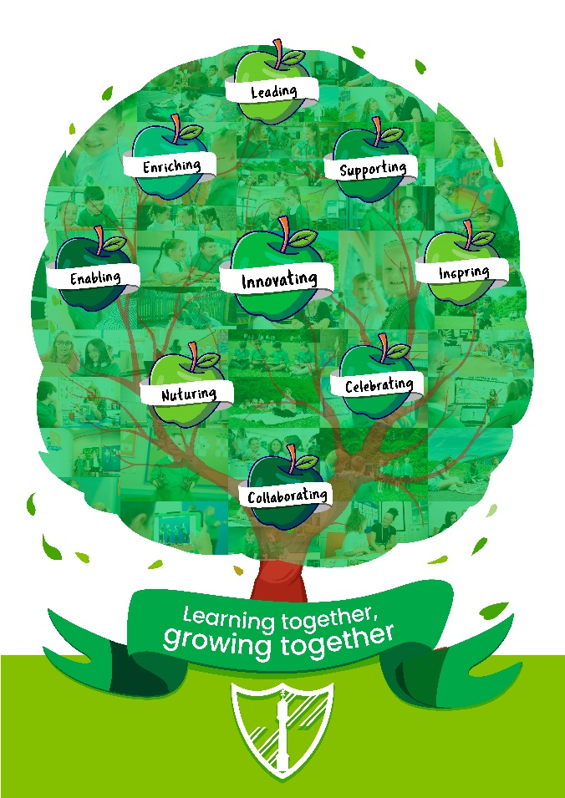

Vision

‘Learning together, growing together’

Values
Our core values of, ‘Leading, supporting, enriching, innovating, enabling, inspiring, nurturing, celebrating and collaborating’ were identified in collaboration with pupils, parents, staff and the wider community. We review our vision with all stakeholders annually.

School Aims

We will:-
- develop skills for lifelong learning
- provide active learning opportunities for all
- encourage children to value themselves and others
- foster a sense of belonging to a community
- promote a healthy lifestyle
- ensure we have a caring and happy environment where everyone feels safe.
We seek your support and co-operation in achieving these aims since we see education as a partnership between home and school. So that this partnership will give all children in the school the best possible chance of success, the partners must be clear as to what each can reasonably expect of the others. The following would seem to be the responsibilities of each member of the partnership.
These responsibilities are set out in the school’s Home School Agreement which parents are invited to sign, as each child enters reception class.

Curriculum Organisation

All pupils in Glanhowy Primary School are taught through the 6 areas of learning and experience (AoLE). In addition literacy and numeracy across the curriculum (LNF) and the digital competency framework (DCF) are taught across the curriculum.

The six areas of learning and experience (AOLEs) are as follows:
- Languages, Literacy and Communication
- Mathematics and Numeracy
- Science and Technology
- Humanities
- Health and Wellbeing
- Expressive Arts

Our school aims to ensure that all pupils receive a broad, balanced curriculum to ensure continuity and progression, as well as pace and challenge. A comprehensive summary of our curriculum provision is available on our school website. All school policy documents are monitored and approved by the Governing Body. You, as a parent, are also welcome to access them.

Welsh Language Development

Welsh is taught as a second language. Children progressively develop their skills in oracy, reading and writing. Pupils in our 3-7 Phase are introduced to the language through simple phrases and sentences, songs, poems, Welsh stories and folk tales. In the 7-11 Phase, Welsh builds upon and expands the language previously experienced by introducing more complex language patterns. Throughout the school Welsh is used to deliver simple classroom instructions, exchange greetings and make requests.

National Literacy and Numeracy Framework

It is a statutory requirement for teachers to use the National Literacy and Numeracy Framework (LNF) as a curriculum planning tool to embed literacy and numeracy into the teaching of the curriculum.
In addition to the LNF, national reading, numeracy procedural and mathematical reasoning personalised assessments will take place in summer term to provide a summative assessment of your child’s skill development and progress.

Digital Competency Framework

We also use the new Digital Competency Framework (DCF) as a planning tool to embed the teaching of digital skills into all areas of our curriculum. Digital competency skills are taught to all pupils throughout the curriculum, in line with the new Curriculum for Wales. These skills are central to a young person’s success in life and are integral to learning. The competence strands we deliver are information, communication, content creation, safety and problem solving.

Curriculum Enhancement

Our school is at the centre of our community. Many local businesses and people give us their support and are always very generous when we fundraise for school equipment. People in the community, including local fire crew, police officers and authors often visit us and tell us about what they do. We also visit people outside and take part in community activities such as singing carols at our local hospital and the local Nursing Home, enjoying the Harvest and Christingle Service at our local church.

Educational Visits

We take great pride in the number of opportunities we provide for our pupils to experience learning outside of the school environment. These include trips to;

- St Fagan’s
- The Big Pit Blaenavon Heritage Museum
- Brecon Mountain Railway
- Bedwellty Park
- Llancaiach Fawr
- Gilwern/Hilston/Talybont Outdoor Education Centres
- Cardiff Castle
- Cardiff Castle & Colorfoto Studios
- Brynbach Park
- Drayton Manor Park
- West Midlands Safari Park
- Eden Centre
- Heatherton
- Folly Farm
- Jump
- Cantref Farm

- Care, Support and Guidance

Our staff undertake regular professional development and attend regular training courses in line with whole school and personal targets. These have included;

- Taith 360
- My Concern
- Real P.E.
- Team Teach Training
- Basic Food Hygiene
- First Aid Training

Safeguarding

Safeguarding of staff and pupils is of paramount importance to us, it overrides other considerations. All schools are legally required to follow the procedures of the All Wales Child Protection Procedures.

The LA requires Headteachers to report any obvious or suspected cases of child-abuse, which includes non-accidental injury, severe physical neglect, emotional abuse and/or sexual abuse. This procedure is intended to protect children at risk.

The Child Protection Policy is available upon request. The designated Child Protection person in school is the Headteacher, Mrs R Phillips and the deputy designated Child Protection person is the Deputy Headteacher, Miss H Jones. Our Safeguarding Governor is Cllr T Smith.

- Leadership and Management

Headteacher, Mrs R Phillips took up post on 1st September 2014 and is well supported by the Senior Leadership Team and all staff members as well as Governors. All have worked together to prioritise targets to develop the school’s 3 year improvement plan, a copy of which is available upon request.

Budget Update
An outline of our school budget and spend can be found below.
Glanhowy Primary School
Out-turn Statement 2025/2026
Funding | £
Funding | 1852668
Balance Brought Forward 2021/22 (Surplus / - Deficit) | 210574
Total | 2063242
Employees | £
Teachers | 877665
Support & Premises Staff | 573235
Total | 1450900
Other Employee Costs | £
Supply | 166442
Travel/Expenses | 69
Other incl DBS/Medical | 661
Total | 167172
Energy | £
Gas | 12802
Electricity | 21069
Total | 33870
Capitation | £
Capitation | 80126
Total | £80126
Premises | £
Rates & Rent | 29536
Building Maintenance | 49845
Building Cleaning | 44305
Grounds Maintenance | 5585
Water | 8100
Miscellaneous | 3630
Refuse Collection | 6194
Total | £147195
Communications | £
Postage
Broadband | 2187
Telephones | 1850
Total | £4037
Transport | £
Insurance | 2437
Vehicle Hire | 0
Total | 2437
Central Services/SLA's | £
Finance Support | 7555
OD (including H&S and Payroll) | 13021
SMISS | 3147
Comms | 132
Courier | 236
Creditors | 265
Building Maint Client inc management fee | 14415
Legal Services | 680
Management charge | 0
GDPR | 1202
Catering | 54512
Music Support
Governor Support | 2936
Schools ICT | 15546
SMIFFS/Sickness insurance | 25804
PRC | 2761
Biodiversity | 0
Total | 142212
Total Expenditure
Total | £2027949
Income | £
Miscellaneous | 25127
Interest | 13501
Sickness Compensation | 6361
Maternity Compensation | 39411
Total | £84401
Total Income
Total | £84401
Net Expenditure
Total | £1,943549
Outturn | £1,464,004
Surplus | £119693

