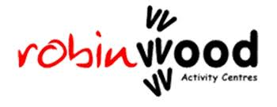
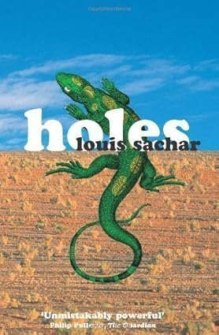
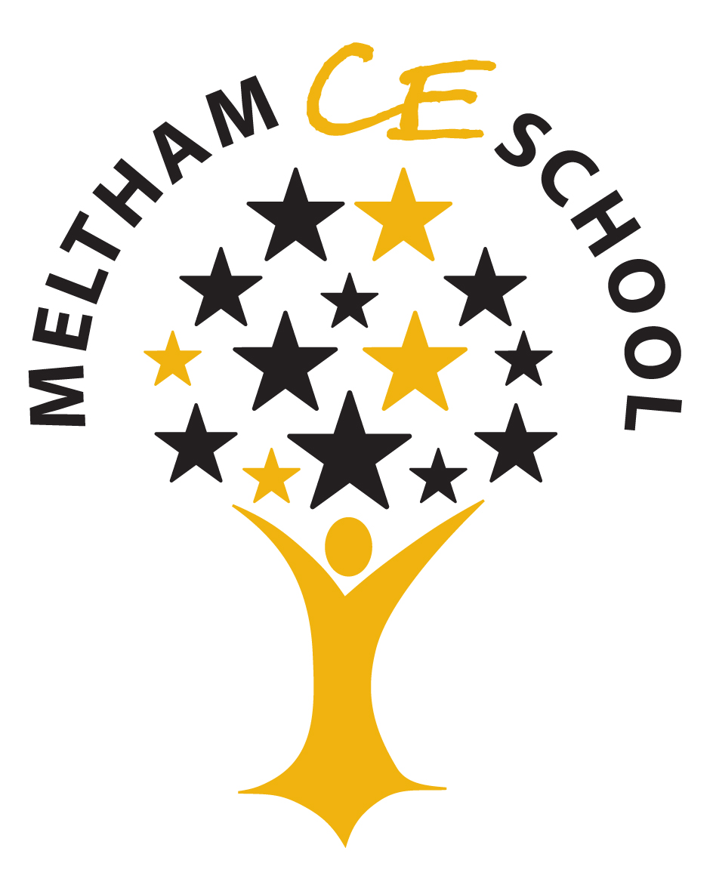

Welcome to Spring Term!

With a strong Humanities focus, year six will continue exploring the North American continent, through Geography, History, English and more. We will delve into the American culture and history. We will be using our North America homework from last term as a starting point, to begin to look at different geographical features of the main cities in North America. We will then compare Meltham with the Death Valley.
Spring Term is always a very busy time in Year 6. We have a jam-packed ten weeks, including our much-anticipated trip to Robinwood, SATs preparations and some fantastic learning.
Reminders
- Reading is essential and underpins comprehension, writing and all areas of learning. Please try to read as much as possible at home.
- Children’s tables need constant practice up to 12 x 12. Please use Timestable Rockstars (TTRS), timestables.co.uk and top marks at home to assist with this. We will be having a school wide focus on times tables this term so any extra done at home would be very beneficial.
- Weekly homework, based on learning from the week, comes home for independent practice. If children need further help on any concepts, please let us know.
- This term’s homework project is based around our SATs preparation. The children will each receive a revision pack for Maths and English. They will bring one test home a week to have a go at and then bring it back into school the following week.

Year 6
We are super excited for our upcoming residential trip to Robinwood. We leave on the 21st and return on the 23rd January. A letter will be with you shortly, containing the finer details.

Robinwood Residential Trip
9th and 11th March 2026
Appointment times will be available soon – watch out on communication platforms.

‘North America’

Parents’/Carers’ evening

Our next Sing Up Assembly is on the 19th of March

Meltham Newsletter

Save the Date!

Sing Up

JANUARY 2026
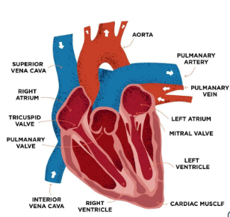
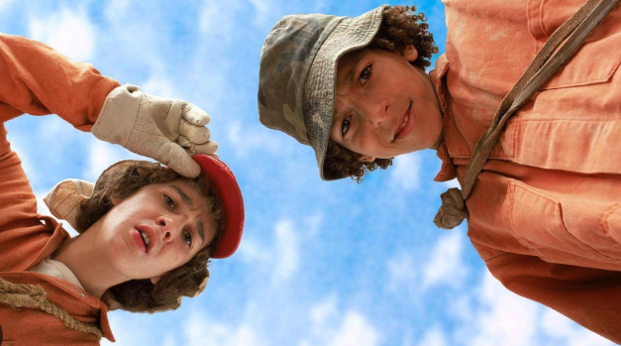

Science – Continuing with the topic Living Things and their Habitats then moving on to Animals including Humans.

They will be learning about the circulatory system, parts of the blood and how substances are transported around the body.

Holes

Holes is a captivating novel that follows the story of Stanley Yelnats who is sent to a juvenile camp where he and other boys dig holes under mysterious circumstances. Themes of friendship, fate and family are all explored in this novel.
Mrs Walker Mrs Osborne Miss Henderson Mrs Stier Mrs Widdop

P.E – Our PE day is Thursday
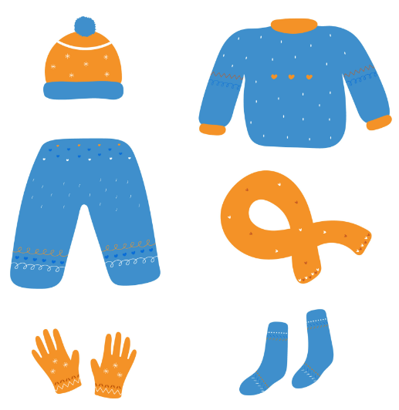
As we intend conducting some curriculum lessons outside, in order for the children to experience learning outdoors in our excellent school grounds, please can you ensure your child has warm clothes and sensible shoes in line with the school PE uniform. Tracksuits for PE and hat and gloves for outdoors are essential at this time of year, even if we do avoid a snowfall. Thank you.

