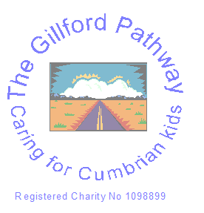
GILLFORD PATHWAYS CHARITY
Charity no. 1098899
The Gillford Centre, Upperby Road, Carlisle, CA2 4JE
Request Form

Name:
Date:
Amount:
Description:

Date needed:

How does it link to our objectives? (please highlight)
1. TO ADVANCE THE EDUCATION OF THE PUPILS ATTENDING GILFORD CENTRE PUPIL REFERRAL UNIT, BY THE PROVISION OF FACILITIES FOR THE DAILY CARE AND RECREATION OF CHILDREN DURING OUT OF SCHOOL HOURS AND SCHOOL HOLIDAYS AND SUCH FINANCIAL SUPPORT AND OTHERWISE NOT ALREADY PROVIDED FROM STATUTORY FUNDS.
2. TO PROVIDE OR ASSIST IN THE PROVISION OF FACILITIES FOR RECREATION AND OTHER LEISURE TIME OCCUPATION IN THE INTERESTS OF SOCIAL WELFARE WITH THE OBJECT OF IMPROVING THE CONDITIONS OF LIFE OF THE SAID BENEFICIARIES.

Signed:

