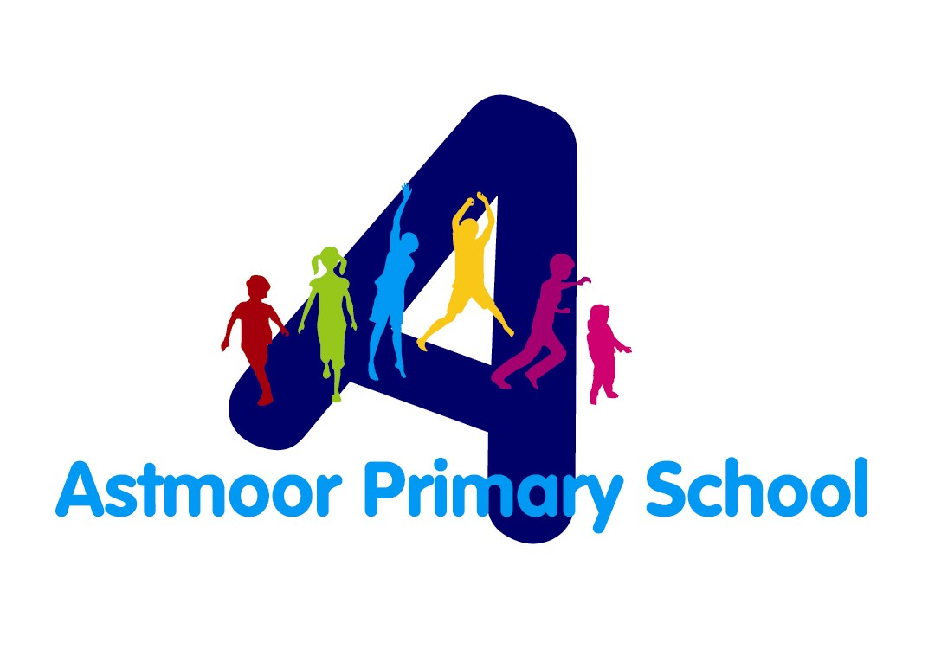

Astmoor Primary School
Uniform Policy

Recommended by: | Mrs Aldridge
Approved by: | Curriculum Committee
Approval Date: | March 2026
Review Date: | March 2028

Introduction
At Astmoor Primary School, our school uniform plays an important role in creating a sense of community, pride, and equality among pupils. This policy outlines expectations for school uniform, how it should be worn, and how the school will support families in meeting these standards.

Aims of the Uniform Policy
Our uniform policy aims to:
- Promote a positive and inclusive school identity
- Ensure pupils feel part of a cohesive school community.
- Encourage high standards of presentation and readiness for learning.
- Provide a practical and affordable uniform suitable for school activities.
- Ensure equality and avoid discrimination in line with the Equality Act 2010.

Required Uniform
Everyday Uniform:
- Sky blue cotton shirt (long or short-sleeved).
- School tie (elasticated or standard).
- Navy blue sweatshirt or cardigan: with or without logo.
- Grey trousers, shorts, skirt, or pinafore.
- Dress: Blue gingham (optional, spring/summer term).
- Socks/tights: White, grey, or black.
- Footwear: Black school shoes (flat, practical, no open-toed sandals).
PE Kit
- T-shirt: Plain white or school PE shirt.
- Shorts: Black or navy.
- Trainers/pumps: Suitable for physical activity.
Optional Items
- School-branded fleece or coat.
- School book bag or backpack.
- Hair accessories in school colours (blue/white).
Jewellery, Hair, and Appearance
- Jewellery must not be worn, except a wristwatch or small stud earrings (removed or taped for PE).
- Hair should be tidy and kept away from the face.
- Extreme hairstyles (e.g., shaved patterns, brightly dyed hair) are not permitted.
- Make-up and nail varnish should not be worn.
Religious and Cultural Considerations
We respect pupils’ rights to wear items of clothing for religious or cultural reasons. Items such as hijabs or turbans should be in school colours where possible. Adjustments will be considered on request.
Reasonable Adjustments and SEND Considerations
Where a pupil has a medical, sensory, or additional need that affects their ability to wear certain uniform items, the school will work with families to agree appropriate adjustments.
Support for Families
We ensure our uniform is accessible and affordable. Families may:
- Purchase generic items from any retailer.
- Access second-hand uniform through the school’s pre-loved uniform shop.
- Request support confidentially in cases of financial difficulty.
Expectations for Pupils and Parents
- Pupils are expected to wear the correct uniform each day.
- Parents/carers must ensure children leave home dressed appropriately.
- Staff will communicate politely with families if uniform issues arise.
Monitoring and Review
The uniform policy will be reviewed regularly with input from pupils, parents, staff, and governors to ensure it remains inclusive, affordable, and supportive of learning.

