 |  | Astmoor Primary School  Kingshead Close, Castlefields, Runcorn WA7 2JE  Telephone: (01928) 565053 Fax (01928) 574627  Headteacher: Mrs L Aldridge head.astmoor@halton.gov.uk  sec.astmoor@halton.gov.uk  www.astmoorprimaryschool.co.uk
 | 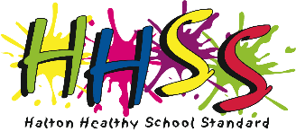


8th March 2022

Dear Parents,

On Friday 17th March it is Comic Relief. This Red Nose Day is all about coming together, spreading joy and having the best day ever in school. Therefore we are asking that the children come to school dressed in bright clothing and bring £1 donation that will be passed onto the comic relief charity.

We will also be having a cake sale at break time. Therefore we would be grateful of any donations of cakes or biscuits, which may be brought into school on the morning of the 17th March. Cakes and biscuits will be on sale for no more than 30p.



Throughout the day, children will be learning about the Comic Relief charity, the contributions you make, will help comic relief to continue to support many amazing projects and organisations who are making a difference for people across the UK and around the world.

Please note that this year Red Noses are available to purchase at Amazon.

Thank you,

The School Council

