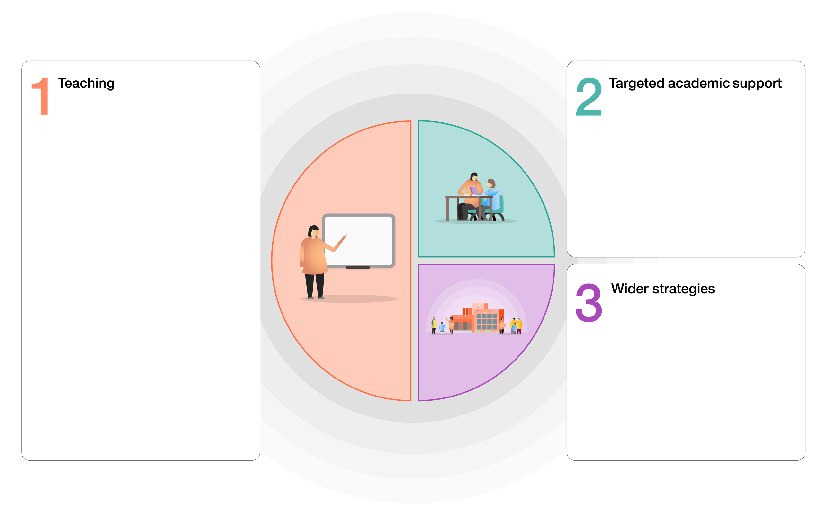
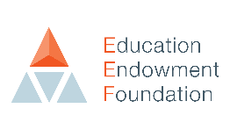
How we intend to use the COVID-19 Catch up Premium

High quality teaching for all children. Focus on:
- Explicit instruction
- Scaffolding learning
- Flexible groupings
- Cognitive and metacognitive strategies
Use coaching / mentoring to support staff development (SLT)

Assessment:
Effective high quality assessment which includes analysis of progress and attainment enabling teachers to focus teaching to plug gaps (Insighttracking.com): Each half term

Remote learning: (See learning offer plan)
- Effective and reliable home learning offer via google classroom / Tapestry
- Peer interactions – google stream
- Promoting independence
- Different approaches – use of Oak Academy / Bite size / RWI / Literacy Company
- Daily check to support engagement with learning and identify any difficulties / change in wellbeing
Professional Development:
- Deep subject knowledge (CPD)
- Flexible understanding of content – support with planning + use of text books & schemes
- Coaching (RWI development days) + in-house
Social, emotional and behavioural needs:
- Establishing routines
- MyHappyMind
- ELSA
- Mental Health Practitioner in school
- DHT and AHT non class based
- Our ways of working: Trauma informed practice
Parents – communication and support:
- Email links
- Zoom parent teacher meetings
- Tapestry / Earwig academic
Attendance – monitor daily (Studybugs)
How the impact of this expenditure on educational attainment will be assessed:

- Teacher assessment: gains in progress, skills and knowledge
- Formal summative assessment (RWInc / Phonics screen / SATs / benchmarking / EYFS profile)
- Parents and children know what the child can do and their next steps (Earwig Academic / tapestry / Google classroom)
- Pupil wellbeing questionnaires
- Happy children, attending school regularly.
- Behaviour in school continues to be outstanding: 0 exclusions
How we intend to use the COVID-19 Catch up Premium

0.4FTE teacher in UKS2 – boost reading and maths/ DHT – interventions for LKS2 / AHT: Step up to Year 6
Read, Write Inc.: EYFS / KS1 / LKS2
Read, Write, Inc.: Fresh Start – identified children in UKS2 / Beanstalk reading
Wellcomm (S&L) – EYFS
Nuffield Early Language Intervention (NELI): Reception
Narrative immersion & Helicopter stories: EYFS
Number blocks – EYFS / KS1
Maths interventions: Plus 1, Power of 2 / NRich
White Rose Maths
In house Speech and Language teacher
ELSA
Mental health practitioner in school
EEF GUIDE TO SUPPORTING SCHOOL PLANNING (2020-21) – TIERED MODEL
Rivacre Valley Primary School: COVID-19 Recovery Curriculum and Catch up premium

