Dear Parents,
Last week, on the evening of Monday 4th January 2021, the Government announced that schools would close to all children except those who are vulnerable or children of critical workers.
We then received guidance from the DfE on “Restricting attendance during the National lockdown: Schools” on Thursday 7th January 2021.
Within this guidance document they have stated that schools with nurseries should continue to operate as normal for their nursery aged children.
This is baffling and goes against the rational for closing schools on 4th January 2021!
We were told that: Limiting attendance is about supporting the reduction of the overall number of social contacts in our communities.
The Government have resisted restrictions on attendance at schools since the first lockdown but, in the face of the rapidly rising numbers of cases across the country and intense pressure on the NHS, they now need to use every lever at their disposal to reduce all social contacts wherever possible.
The DfE have asked schools to put in place a number of measures to minimise risks of viral transmission. These are:
Prevention | Rivacre Valley systems of controls
1) Minimise contact with individuals who are unwell by ensuring that those who are required to stay at home do not attend school. |   This is in place across the school.  Signage on all entry points.  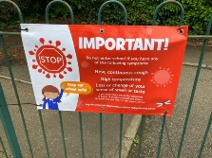  Expectation to comply with this included in communications with parents and carers.
2) Where recommended, the use of face coverings in schools |   This does not appply to younger children in primary schools and early years settings. Staff told to wear face coverings when outside by CWC PH.
3) Clean hands thoroughly more often than usual.   | 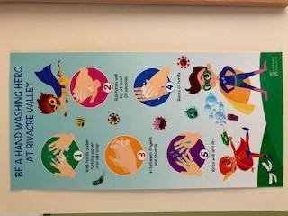  Staff remind children to wash hands and use sanitizer regularly but the effectiveness of this can’t be guaranteed with our youngest children.
4) Ensure good respiratory hygiene by promoting the ‘catch it, bin it, kill it’ approach.  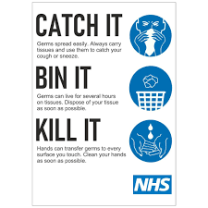 | All classes have acess to tissues and a lidded bin.  Staff support our younger children to follow this routine and have shared the e-Bug coronavirus resources.  However, like with hand washing, our youngest children and those with complex needs do not always get this right.
5) Introduce enhanced cleaning, including cleaning frequently touched surfaces often, using standard products such as detergents | Cleaning of equipment and the classroom – this is completed regularly throughout day and at end of each day.  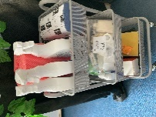
6) Minimise contact between individuals and maintain social distancing wherever possible | Consistent groups – Nursery operates as one bubble / group. This is due to the organization of the classroom and the access to resources to support the EYFS curriculum  - Measures within the classroom  social distance: 2m away from other children and staff, avoid face to face contact within 1m of anyone – this is not possible within EYs. The children do not understand this and are unable to comply. To enforce this could cause some children distress.  - Measures elsewhere  - Groups kept apart – no assemblies or gatherings  - One way systems  - Other: classroom resources – own items / limit sharing + use of quarantine of resources
7) Where necessary, wear appropriate personal protective equipment (PPE) | This is only required in a limited number of circumstances.  However, due to the age of the children in Early Years and in particular nursery the frequency of intimate care procedures such as changing a child following a toileting accident are significantly raised.
8) Always keeping occupied spaces well ventilated | Windows and doors kept open to aid ventilation.  This does, on occasion, mean the classroom spaces become quite cold at this time of year.
Response to any infection
9) Engage with the NHS Test and Trace process   | School complies with all aspects of NHS Test and trace
10) Manage confirmed cases of coronavirus (COVID-19) amongst the school community. | School takes swift action as soon as we are aware of a confirmed case of COVID-19.  All close contacts told to self-isolate for 10 days
11) Contain any outbreak by following local health protection team advice. | School will engage with any advice provided by PH in the event of an outbreak.

As you can see from the above table all of the preventative measures at our disposal are in place and work well to keep the environment safe. However, there are some key measures that are almost impossible to secure in full with our youngest children and the DfE recognize this within their guidance documentation.
So, put simply, I can not guarantee the safety of the environment or the safety of the children and staff attending currently due to a number of factors addressed above.
It may be useful to remember that attendance for nursery age children is not statutory and there will be no penalties for non attendance during this lockdown.
The DfE has also advised that even parents who are critical workers should keep their children at home if they can.
We will continue to offer nursery provision but I would advise you to consider the above points very carefully.
At this point in time maintaining the integrity of household bubbles is the best way to ensure the safety of your family and children. Once they attend a setting the risks rise significantly.
If you would prefer to access online learning, via Tapestry, we will continue to support you and your family remotely until we are advised that the risk of the virus within our community has reduced to a safe level.
Please could you notify school if, in light of the above, you want to accept the offer of a place for your child in nursery.
Tel; 0151 8327602 email: admin@rivacrevalley.cheshire.sch.uk
Please note:
If your child attended Nursery last week (4th or 5th January 2021) the Nursery class bubble has now had to be closed following notification of a positive case of COVID-19. Your child is required to self-isolate.
Nursery provision will remain online for those children self-isolating until either Friday 15th or Monday 18th January 2021, dependent on which days your child attended (separate notification should have been sent from the school Office).
We will continue to update you as the situation evolves.
Your support and understanding during this time is truly appreciated.
Stay safe,
Kindest regards,
Mrs K Docherty
Headteacher

