
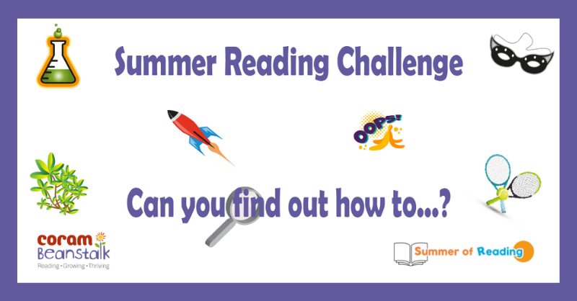

We’re sharing six great challenges from Coram Beanstalk that will keep your children entertained across the summer. Help them find out how to do something new and exciting and have fun sharing reading with you as they are doing it. Choose one or more challenges from: put on and share a performance, play a new game or sport, do an experiment or fix something safely, make something you’ve never made before, work out what something in the natural world is, make someone laugh. You can find six short films, from six fun authors, and ideas to help you get started on Coram Beanstalk’s website under Our Reading Tips – Our Summer Reading Challenges here.

