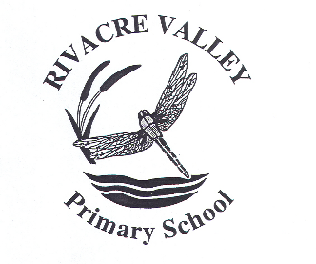
Dear Parents,
Key Information for September:
We are hoping that school life will look a lot more “normal” in September. The main COVID preventative measures we are required to maintain are: good hygiene, enhanced cleaning, ventilation and following public health advice on testing, self-isolation and managing confirmed cases of COVID-19.
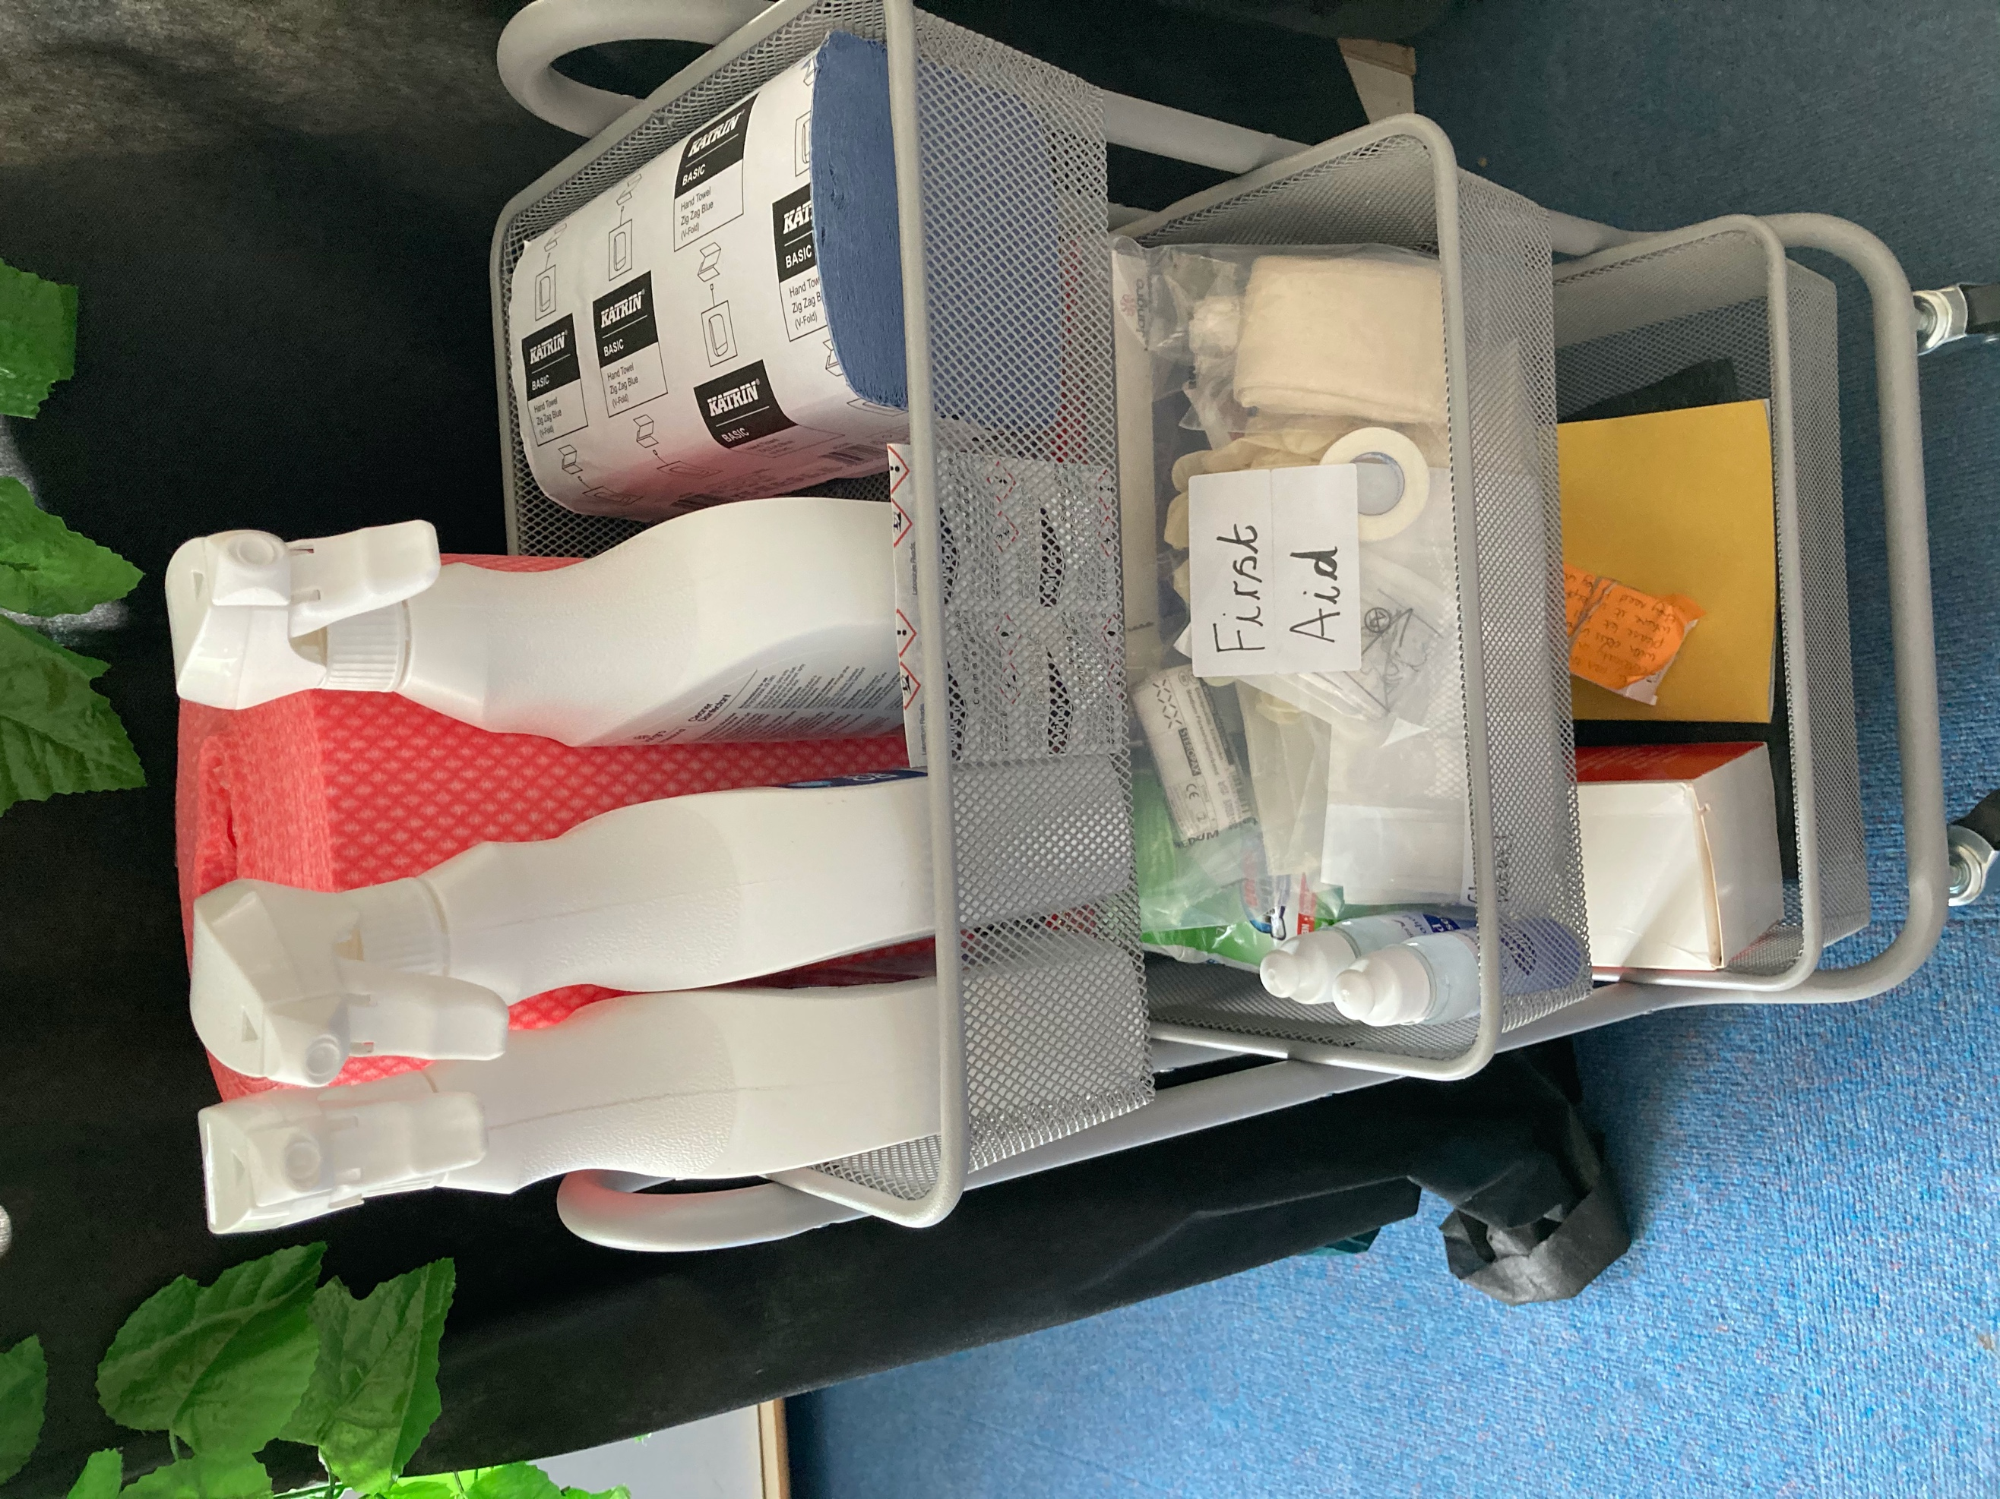
Cleaning stations will remain in every room and on the playground.

At Rivacre Valley Primary School:
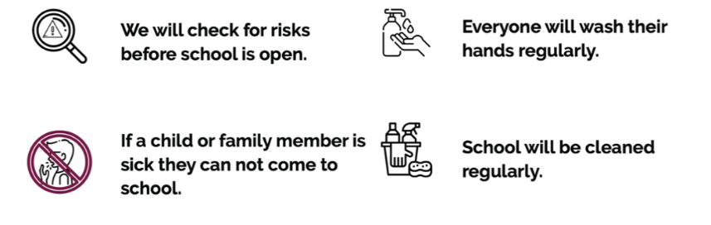
Start to the day:
Breakfast from 8:30am / Register 8:50am)
We will resume a class based breakfast offer from Thursday 2nd September.
Children will be able to arrive at school from 8:30am – please enter the school site from either Warren Drive or Rivacre Brow entrance. Staff will be on the playground to meet and greet your child and direct them to the correct doorway.
Nursery:  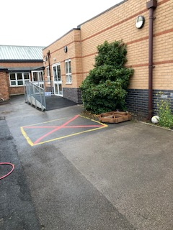  Miss Woods  Mr Davies | 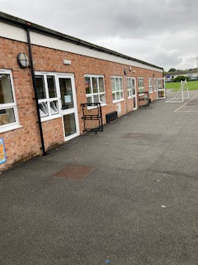  Mr Gough  Miss Walker  Miss Harper
Reception:  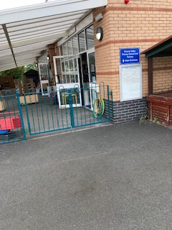  Mr Denham  Mrs Vaughan | Miss Causer  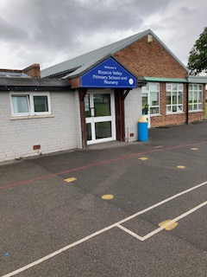  Miss Jones  Miss Gidlow
Miss Stokes  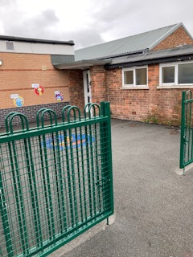  Miss Roberts  Mr Parsonage | We are hoping to continue our partnership with The National Schools Breakfast Programme, providing free breakfasts for every child.  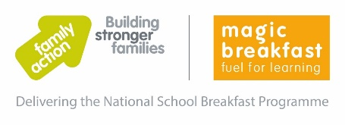

Classroom organisation:
Last week was our class swap week. This provided the opportunity for your child to meet their new teacher, new classmates and begin to learn the new class routine.
The DfE has removed the requirement to keep children in class bubbles but have asked that we produce an Outbreak Management Plan in the event of needing to revert back to this system. This is all included in our Risk Assessment.
We are hoping to be able to group children for their daily phonics sessions across classes, as is best practice. However, we will continue with class groups for the rest of the curriculum offer as this has worked well this year.
Playtimes and lunchtimes will allow children from different classes to mix again, so if your child’s best friend is in a different class they will be able to spend time together throughout their playtimes.

Lunch:
Lunchtime will return to being served in the school dining hall. Menus are available on the school website.
Children in Reception, Year 1 and Year 2 will receive a Universal Infant Free School Meal (UIFSM).
Children in Nursery and KS2 can purchase a school meal (2.34 per day), or receive them for free if you qualify for a free School Meal (FSM). Please enquire at the school office to see if you are entitled for a FSM for your child. This is an important check, as not only do you then receive a free lunch for your child but school also receives additional funding.
You can also provide your child with a healthy packed lunch – these will be stored in the fridges located in the corridors.

Snack:
Children in EYFS and KS1 will be provided with a piece of fruit free of charge.
Children in KS2 can purchase a snack – details to follow in September.
Milk can also be purchased in KS1 – 20p per day. This is provided free to children under the age of 5.

Home-time:
School finishes at 3:15pm - please collect your child from the area outside the door you dropped them off at in the morning. Please note that at present social distancing and wearing a face covering is not a requirement – if this changes we will notify you and reinstate such measures.

Wrap around care:
Vara Education will provide wrap around care for any parent who wishes to use this service.
7:30am – 8:30am: £3.50
3:15pm – 5:15pm: £6.50
3:15pm – 6:15pm: £9.00
Please contact Vara Education direct if you are interested in this service. info@varaeducation.co.uk / 0780 8833673

After school clubs:
We hope to re-start staff led after school clubs very soon – further information to follow in September.

Uniform: Sweatshirts, cardigans and polo shirts can be purchased from the school office.
- Royal blue sweatshirt / cardigan
- Pale blue polo shirt
- Grey trousers / shorts / skirts
- Pale blue gingham dress / play suits

PE kit: white t-shirt / black shorts / black pumps / jogging bottoms + sweat top (we hope to do lots of PE outside!)
Please remember to label every piece of clothing with your child’s name.

Thank you again for your support over the last year. Please have a lovely summer holiday and I look forward to seeing you all on Thursday 2nd September.
Mrs Docherty.

