
Curriculum Guidance and Long Term Plans
EYFS
2024 – 2025

Curriculum
Children develop quickly in the early years; staff aim to do all they can to help children have the best possible start in life. A child’s experiences in the Early Years have a major impact on their future life chances.
Our curriculum is aligned to a school wide set of principles which are underpinned by our mission to challenge educational and social disadvantage in East Manchester. We believe all students entitled to an ambitious knowledge rich curriculum which will open doors and maximise life changes. At Varna community Primary School, we challenge social inequality by providing a knowledge rich academic curriculum that is broad and balanced.
The way in which young children engage with other people and their environment is through playing and exploring, active learning and creating and thinking critically. Play is a very important part of all children’s development; play and learning cannot be divided during the earliest years.
Everything in the environment has been put there for a purpose, to help children acquire the skills they need.
Children have access to a variety of materials including sand, water, paint, collage materials, large and small construction sets, large and small role play areas, music resources, books, mark-making, jigsaws, dough, maths games and ICT equipment.
Outdoors children can run, climb, explore natural and reclaimed resources, use wheeled toys and take care of the garden. Children are encouraged to make their own choices. We know that research shows that children who are active are better at regulating their emotions.
Children’s spiritual and moral development is an important aspect of their whole development. We foster this through giving children opportunities to share the wonder of the world, e.g. looking at the beauty in the world around them, a new baby, animals, flowers; helping them develop responsibility towards friends, other people and the environment.
Underpinned by the Development Matters document (EYFS) and National Curriculum (Year 1), each subject specifies, in detail the knowledge children will learn. We ensure children are well taught, acquiring powerful knowledge that prepares them well for national assessments and the gives them ability to contribute positively to an ever changing and developing society. We have considered the knowledge and skills we want our children to have learnt and mastered in each curriculum area to enable them to achieve our mission to 'develop good moral principles and achieve exceptional outcomes that allow ambitious life choices'.
Staff are careful and meticulous about what is learnt and in what order, providing relevant and purposeful learning experiences for all of our children. Our curriculum is informed by the latest evidence research from cognitive science about memory, targeting and practice in order to help children remember and connect learning. We want knowledge to stick so that it can be applied in a variety of different contexts and situations.
Our sequential curriculum begins in EYFS to ensure that children successfully access a broad and balanced curriculum from the very beginning of their all-through education. Our EYFS is underpinned by structured phonics, writing and mathematics lessons to ensure core knowledge is secured and that transition into KS1 is successful. Through a careful balance of child led and adult initiated activities, children are exposed to a wealth of knowledge and experiences to develop their understanding of the world around them. During KS1, we remain focused on securing the foundations of effective communication, ensuring that all children have learnt to read fluently and can write and speak cohesively by the end of Year 2. Through the NCETM and Power Maths programme, we ensure core mathematical knowledge is mastered and practised. Connected by a high quality core text and overarching question, the teaching of humanities and the arts is continuous and further embedded through the use of enhanced provision.
Across the phase, PSHE themes have been carefully grouped around a moral focus. Alongside a focused weekly assembly, children explore themes deeper within their individual classes to support them to make educated and informed choices when keeping healthy, happy and safe.

Nursery Long Term Plan
NURSERY LONG TERM PLANNING 2024-2025

 | AUTUMN 1 | AUTUMN 2 | SPRING 1 | SPRING 2 | SUMMER 1 | SUMMER 2
Over Arching Question | Who looks after us? | When do we see stars? | What journeys do we go on? | How do we grow? | Are our homes all the same? | What’s your favourite animal?
Focus  Key Text + Rationale | Family, starting school, bedtime routines | Seasonal changes | Journeys | Growth and Change | Around the World | 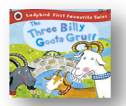  Animals
Focus  Key Text + Rationale | 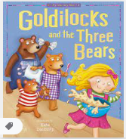  Traditional Tale. Simple story of a regular bedtime routine with one sentence per page. | 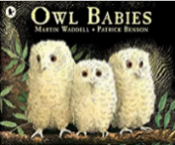  Our children come with little knowledge of nature and the natural world. Simple, repetitive book. | 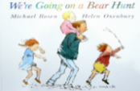  Repetitive refrains, longer sentences. | 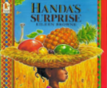  Simple story with repeated refrains. | 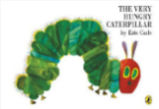  Introduces days of the week, simple book. Repetitive, simple phrases children enjoy memorising. | 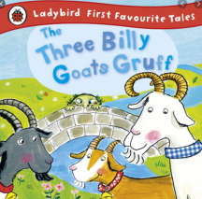  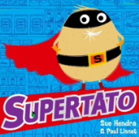  Our children come with little knowledge of animals. Simple, repeating phrases.
Oral Storytelling | Model telling stories using objects such as puppets. | Linked to autumn animals. Introduce the word ‘character’ and learn about it’s meaning. | Create stories using the polar small world – select characters and introduce the word ‘setting’ and explore the mearning. | Provide wooden blocks and small world figures for children to build castles for storytelling. Introduce the word ‘event’ and explore its meaning. | Use the story mountain including beginning, middle and end. Model how to use the story mountain to create a story. | Use the story mountain to develop own stories using small world items, pictures and props.
Key Vocabulary to learn and use in a variety of contexts  (wow words) | Hot  Cold  Hard  Soft | Brave  Swooped  Flapped  Bounced  Fuss | Wavy  Oozy  Stumble  Swirling  Narrow  Gloomy | Delicious  Surprised  Sweet  Ripe  Spiky  Tangy | Little  Warm  Tiny  Hungry | Large  Medium  Small  Horrid  Croaked  Meadow
Focus  Innovation | Focus: Character and Setting  Innovation: Substitution | Focus: Sequencing and repetition  Innovation: Substitution | Focus: Character and Setting  Innovation: Substitution | Focus: Character and Setting  Innovation: Substitution | Focus: Setting and Sequencing  Innovation: Substitution and Addition | Focus: Description  Innovation: Innovation: Substitution and Addition
Fiction
Linked Texts and Favourite 5
Fiction  Linked Texts and Favourite 5 | Dear Zoo  - Can’t you sleep little bear?  -So Much  --Brown Bear, Brown Bear, What do you See?  -Where’s Spot | - Elmer  -Peace at Last  -Tree - Seasons come, Seasons Go  - Dim Sum for Everyone | -There’s a Bear on my Chair  -Oi Dog  -The Train Ride  -The Snowy Day – Ezra Jack Reats  Bear snores on | Handa’s Hen  -Giraffes Can’t Dance  -Handa’s Noisy Night  - Odd Dog Out  -Baby Goes To Market | - The Bad Tempered Ladybird  -Aaaarrgghh Spider  -The Odd Egg  - Hairy Maclary from Donaldon’s Dairy  -Rainbow fish | -The Great  Goat Chase  - A Squash and a Squeeze  -Harry and the Dinosaurs  - Farmer Duck  - Duck in a Truck
Linked Non-Fiction texts  Teachers to create their own versions of nonfiction texts to mirror the key text | - All About Me  - My Family | - Animal Homes  - Homes Around the World  - Christmas Texts | - All About Bears  - Animals that live in Caves | - All About Elephants  - All About Monkeys  - Life in Handa’s Village | - The Life Cycle of a Butterfly  - All About Butterflies  - All About Caterpillars  - How to Grow Cress  - How to look after a Baby. | - All About Goats  - All About Ducks  - Life on the Farm
Rhyme and Poetry | -Wind the bobbin up  - Rain, rain go away  - Copy cat | - Twinkle Twinkle little star  -- If you’re happy and you know it  - Are you listening? | - Row, row, row your boat  - Pat a cake, pat a cake  - Hello, How are you? | - I’m a little teapot  -The wheels on the bus.  - Hello, Rabbit | - Round and round the garden  - Incey Wincey spider  - Snail, Snail, Snail | - Old Macdonald  - Old MacDonald had a farm.  - Magic box
Repeated Cultural Capital / Vocabulary acquisition enrichments | Manchester Baking:  Follow a recipe and make porridge together, eat your porridge whilst enjoying a story. | Dance!  Children have an overwhelming drive to be active, get moving and use their bodies in any ways that they are able. Dancing brings people together and encourages children to be active and healthy through movement. | Woodland Wandering:  Visit the local wood. Collect natural items. Stand still. Listen. Look. What can you see? What can you hear? What’s over there? Did something move? | Go shopping!  Make a list of fruit to buy just like Handa in the story. Try to stick to the list. Talk about how much things cost and discuss your journey to and from the shops. Enjoy eating the items you buy! | Mini Beasts and Bug Hunting  Let’s go on a minibeast hunt and find out about these facinating creatures which live all around us. This experience provides many opportunities for learning linked to developing language and new vocabulary, along with learning about the lives of the creatures, their habitat and habits. | Who’s that trip trapping over my bridge?  Visit a park with a bridge, play pooh-sticks, cross over the top of the water – what is going on below? Who might live there?
Enrichment | Pyjama Day/ Bed Time Story (Parents)  Make and eat porridge | Visit from owls | Local journeys / trip to the woods | Visit the market | Grow caterpillars/ cress  Minibeast workshop | Visit a Farm
Enrichment | 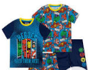 | 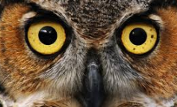 | 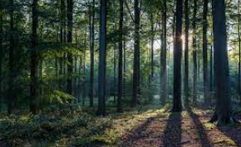 |  | 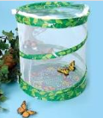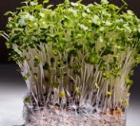 | 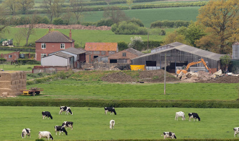
Role Play | Introduce the home corner - Making porridge resources | Home corner enhancements | Role Play We’re going on a Bear Hunt Journey | Role Play Market  (outdoor) | Pretend to be butterflies  (outdoor) | Bridge/troll  (outdoor)
Role Play | 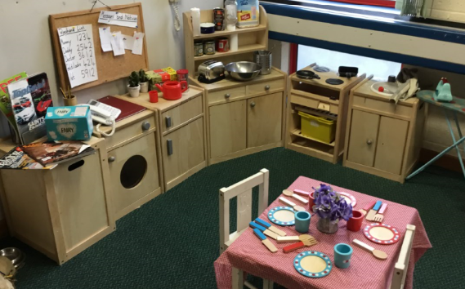 |  | 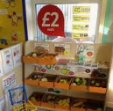 | 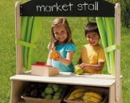 | 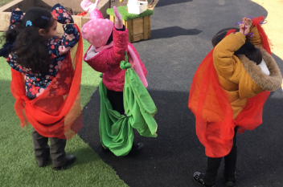 | 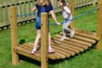
Mark Making/ Writing Opportunities | Playful mark making | Emergent Scribbles | Writing Lists | Writing Lists | Writing signs and labels | Writing signs and Messages (i.e. Watch out)
Mark Making/ Writing Opportunities | Investigate use of pencils, pens, paints, etc | Mark making on the inside of the owl house. Writing messages to Mummy Owl | Writing a list of ingredients to make a cake.  Writing bear messages. | Writing shopping lists | Writing labels for different parts of plants and the life cycle of a butterfly. | Writing signs and messages from the Troll to the goats and from the goats to the Trolls (i.e. Watch out. Troll!)
Maths Focus | Number / Numerical Patterns |  | Number / Numerical Patterns |  | Number / Numerical Patterns
Maths Focus | Numbers 1 - 3  (Numberblocks) 1-2-1 counting  Subitising numbers 1 to 3  Language relating to comparison e.g. more and less  Language relating to size e.g. small, tall Repeating patterns |  | Numbers 1 - 7 (Numberblocks)  1-2-1 counting  Subitising numbers 1 to 5  Number bonds to 3  Matching written numerals to quantities  2D and 3D shapes Identifying real world patterns |  | Numbers 1 - 10 (Numberblocks)  1-2-1 counting  Subitising numbers 1 to 5  Number bonds to 5  Matching written numerals to quantities  2D and 3D shapes  Comparing objects based on size, weight and capacity
Maths Meeting | Days of the week  What’s the weather?  Timetable – using sequential language  Colour in the bag | Days of the week  What’s the weather?  Timetable – using sequential language  Colour in the bag  Counting by 1s | Days of the week  What’s the weather?  Timetable – using sequential language  Hidden number with fingers  2D shape in the bag  Counting by 1s | Days of the week with counting down sleeps until Friday  What’s the weather?  Timetable – using sequential language  Hidden number with fingers  Pattern – colour and music  Counting by 1s | Days of the week with counting down sleeps until Friday  What’s the weather?  Timetable – using sequential language  Hidden number with fingers  Positional language  2D shape in the bag | Days of the week with counting down sleeps until Friday  What’s the weather?  Timetable – using sequential language  Real world maths problems up to 5  3D shape in the bag
Physical Development | Multi-skills | Multi-skills | Athletics | Games | Dance | Gymnastics
EAD - Artist | Jackson Pollock  (Abstract Expressionism)  Drawing  Small skills using a range of skills (pencils, hands, chalks, wax).  Draw with diferent materials. | Wassily Kandinsky  (Abstract)  Printing  Use a range of tools to make coloured marks.  Printing on different textures e.g dough. | Piet Mondrian  (De Stijl)  Natural Materials  Simple repeated patterns using concrete objects. E.g buttoned, stones, blocks and beads. | Paul Klee  (Cubism)  Collage  Simple collage. | Alma Woodsey Thomas  (expressionism and realism)  Painting  Explore mixing colours.  Experiment with primary colours. | Cy Twombly  (Expressionism)  Observational drawing  Observe and draw a variety of objects both living and non-living.
EAD - Music | Nursery Rhymes  Counting Songs | Christmas show songs.  Starting to sing new songs as a group, matching pitch and melody. E.g from the Christmas show.  Perform to an audience. | Sing a range of familiar songs  Begin to move in response to music. | Explore the sounds of instruments.  Action songs. | Begin to move in time to music. | End of year show.  Sing a range of well-known Nursery Rhymes and songs.  Perform to an audience.
Let’s Celebrate | Harvest Festival | Black History Month  Christmas – Christmas story  Hannukah  Diwali  Bonfire Night | Chinese NY  Shrove Tuesday | Eid  Easter | Easter  Mother’s Day | Eid – visit from an Imam  Father’s Day
UTW  (not limited to these and subject to change dependent on children’s interests)  Important scientific experiences to help children interact with science in the world around them. | Past and Present  Compare this story with our bedtime routines.  People, Culture and Communities  What is school?  Who are your teachers?  The Natural World  Exploring mixing materials.  Autumn changes – What is happening to the trees?  Going for an autmn walk and feeling leaves crunching under our feet.  What am I made of? | Past and Present  Begin to talk about their life story, their families and homes.  People, Culture and Communities  Talk about their immediate family and community.  The Natural World  Animals that are awake during the night.  Identifying the moon and the sun – when do we see them?  Visit from the owls. | Past and Present  Different modes of transport.  People, Culture and Communities  Different modes of transport  Visit to the woods  Nature walks  The Natural World  Observing winter changes  Natural terrain – woods, forests, frosty/icy ground etc.  Jumping in muddy puddles, handling ice and snow.  What makes it move? | Past and Present  Who are my parents?  People, Culture and Communities  Our homes – how are they different  The Natural World  Bug hunts – observational drawings.  Exploring flowers and their seeds – observational drawings.  Going for a walk and smelling flowers. | Past and Present  Begin to talk about the homes they have lived in.  People, Culture and Communities  What foods do we enjoy at home?  The Natural World  Gardening and planting to observe transformation of plants.  Caterpillar transformation – What does a caterpillar do?  Grown plants and eat them. | Past and Present  Bringing in baby photos  People, Culture and Communities  Bringing in baby photos  The Natural World  Looking at baby animals and grown up animals.  Compare with humans and babies  Visit a farm and stroke / wfeed a farm animal.
PSED  Think Equal  Level 1 | Marvellous Me  -understand the concepts same and different  -demonstrate self confidence | Me, myself and I  - demonstrate a positive sense of identity  - develop self-confidence and self esteem  - recognise similarities and difference between themselves and others  Is there anyone like me?  - celebrate individuality and uniqueness  - discuss similarities and differences | Amazing Daisy  - demonstrate self knowledge and self-esteem  - understand the importance of persistence  - set a goal and work towards achieving it  Healthy minds A  - name kind ways to grow friendship  - learn mindfulness of the body | How we feel  - name 2-3 emotions  - recognise that everyone has feelings  Wally the wave  - Name ‘big’ feelings (anger, frustration)  - Begin to demonstrate self regulation and impulse control  - Demonstrate understanding that feelings change | I have a plan  - show ability to listen to other’s words  - demonstrate compassion for all creatures  The wall  - Further understand similarities and differences  - Further celebrate diversity and understand and accept others | The tale of baby beetroot  - Recognise kind behaviour  - Celebrate diversity  Lara the yellow ladybird  - Demonstrate a strong sense of identity  - Demonstrate an appreciation of diversity  - Express self confidence and self esteem

Reception Long Term Plan
RECEPTION LONG TERM PLANNING 2024-2025

 | AUTUMN 1 | AUTUMN 2 | SPRING 1 | SPRING 2 | SUMMER 1 | SUMMER 2
Over Arching Question | Should you always help your friends? | Can you tame a dragon? | Could a penguin survive in Openshaw? | Are vegetables good or evil? | Can you eat the Gingerbread Man? | Can you really hug a tiger?
Focus  Key Text and Rationale | Harvest (UW The Natural World) | Past and Present (UW) | A Winter Wonderland (UW People and Communities) | Healthy eating | Once Upon a Time (Geography – journeys, maps) | Wild Animals – The Zoo  (UW – The Natural World)
Focus  Key Text and Rationale | 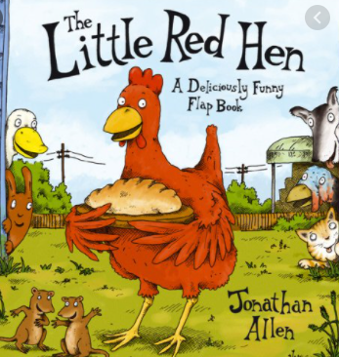  Children in Reception need to learn about making the right choices. The book introduces simple inference and comprehension skills. | 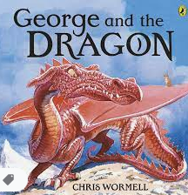  Children learn about past and present including how buildings have changed (castles). | 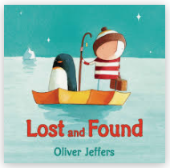  Children learn about arctic animals and discussion around our own feelings. The story contains more text and building in complexity and vocabulary. | 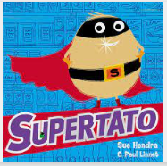  Diet and nutrition is a focus for our communities. A story with a simple plot for children to follow. | 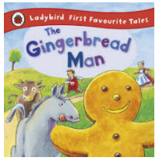  Children explore classic literature and understand the morals behind the stories. | 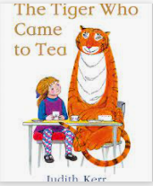  A more complex story containing more text and subject specific vocabulary.
Oral Storytelling | Adult model how to use the small world to create class stories. (character/setting/events) | Children use the small world to create class stories. (character/setting/events). Adults to scribe stories. | Children use the small world to create class stories. (character/setting/events) | Introduce the parts of the story mountain and use to create a story with fairy-tale characters/settings. Link story mountain structure. | Use story mountain model to create own stories. Introduce giant story maps. | Use story mountain model to create own stories. Childrem make own giant story maps. Focus on different openings.
Key Vocabulary to learn and use in a variety of contexts  (wow words) | Little  Cut  Carry  Grind  Knead  Bake | Fiery  Smash  Flick  Sweep  Montrous  Terrible  Terrified | Floated  Discovered  Tested  Strength  Delighted  Lonely  Searched | Escaped  Trouble  Gasped  Strength  Evil  Vanished  Shrieked | Baked  Yelled  Catch  Lean  Mean | Suddenly  Furry  Stripey  Swallowed  Lovely
Focus  Innovation | Focus: Action  Innovation: Substitution | Focus: Characterisation and dialogue  Innovation: Substitution | Focus: Setting  Innovation: Substitution | Focus: plot/bad characters description  Innovation: Substitution | Focus: Ending  Innovation: addition (extend the text/ending) | Focus: characterisation and dialogue  Innovation: Substitution
Fiction
Linked Texts & Favourite 5
Fiction  Linked Texts & Favourite 5 | The Gruffalo  Baby Goes to Market  There was an Old Lady who Swallowed a Fly  Rosie’s walk  The Three Little Pigs | How to catch a star  Stick Man  Lila and the secret of rain  There is no dragon in this story.  Billy and the Dragon | All Are Welcome  The Emperor’s Egg  Up and Down  Two Bears  Astro Girl | Oliver’s Fruit Salad  Oi! Frog  That’s not a daffodil  My Nana’s Garden  Burgler Bill | Not Now Bernard  Oi! Cat!  I want my Hat Back  The Gingerbread Cowboy  The Giant Jam Sandwich | Julian is a Mermaid  Lubna and the Pebble  Mog and Baby  Avocado Baby  Six Dinner Sid
Non-Fiction Linked Texts  Teachers to create their own versions of nonfiction texts to mirror the key text | - My New Classroom  - All About My Teacher  - How to make Bread.  - Different Kinds of Bread  - Bread from Around the World. | -All about castles  -What were castles for?- | All About Penguins  - All About Polar Bears | - How to get to market  - Country fact files  -World Kitchen – Food from around the World | - How to make a Ginger Bread Man. | - All About Tigers  - All About …
Rhyme and Poetry | Copy Cat  Can you slap the beat?  The dingle, dangle scarecrow.  My Many Coloured Days – Dr Seuss | Are you listening?  Juba up, Juba down.  Five little speckeld frogs.  Chubby Snowman | Hello, How are you?  Cobbler, cobbler.  Hickory, Dickory Dock  Sharing a shell | Snail  Hot cross bun, hot cross bun.  Five little ducks.  One potatoe, two potatoes | Hello, Rabbit  Engine, Engine  One, two, three, four five.  A treasury of songs – Julia Donaldson | Magic box.  Here I come.  I’m a little teapot.  This Little Puffin
Repeated Cultural Capital / Vocabulary acquisition enrichments | Manchester Baking  Baking different kinds of bread each week.  Children love to help with cooking and baking, and they can chop and mix ingredients whilst we chat about what we are doing. Cooking is fun and provides quality time together making an end result you can eat. | Yours Sincerely  Writing a letter to someone is a great way to keep in touch or find something out. Write a letter and walk to the postbox to post it. It is always exciting to receive letters through the post. | Brrr: Explore the cold!  Snow, ice and cold weather are experiences that children can find really exciting; they need to discover our world using all their senses to properly understand it. | Market Visits  Visit the local shop to buy vegetables from the story – can we plant them? Can we eat them? | Lend a hand  Help with the shopping list (making gingerbread men and other kinds of biscuits each week)  Be in charge of writing the shopping list and making sure you stay within the weekly budget. | Yummy Picnic  Having a picnic is a great opportunity to build relationships, acquire vocabulary and learn from one another together. We will even do it on a rainy day on our carpet in our classroom.
Enrichment | Visit a local shop to buy ingredients  Make Bread | Visit Castlefield/other nearest castle | Visit a local park to float boat like in the story. | Visit an allotment / gardening workshop | Visit a Bakery to buy a GingerBread Man | Visit Dunham Massey to have a picnic
Enrichment | 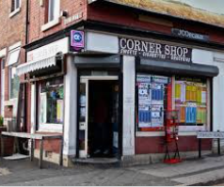 | 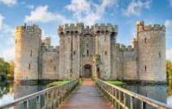 | 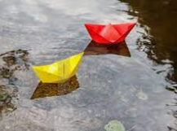 | 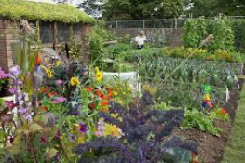 | 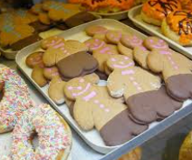 | 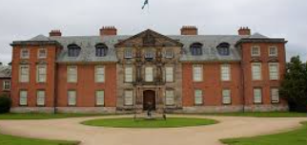
Role Play | Introduce the home corner (props for bread baking roleplay) | Castle | Arctic Small World | Supermarket / shop | Baker’s Shop | The Zoo Keeper/ Afternoon tea café
Role Play |  | 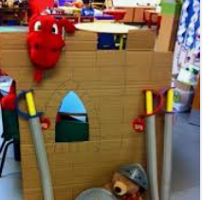 | 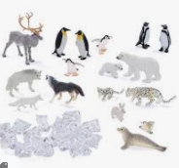 | 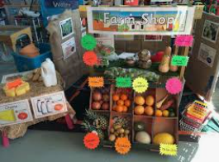 | 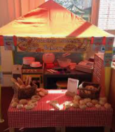 | 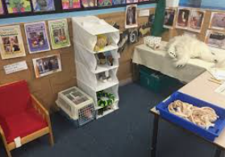
Writing progression
Writing progression | Develop listening and speaking skills in a range of contexts. Aware that writing communicates meaning. Give meaning to marks they make. Understand thoughts can be written down.  Write their name copying it from a name card or try to write it from memory. | Copies adult writing behaviour e.g writing on a whiteboard, writing messages. Makes marks and draeings using increasing control, Know there is a sound/symbol relationship. Use some recognisable letters and own symbols. Write letters and strings, sometimes in clusters like words. | Use appropriate letters for initial sounds | Build words using letter sounds in writing. | Continue to build on knowledge of letter sounds to build words in writing. Use writing in play. Use familiar words in their writing. | Show awareness of the different audience for writing. Write short sentences with words with known letter-sound correspondences using a capital letter and full stop.
Maths Progression | Number / Numerical Patterns |  | Number / Numerical Patterns |  | Number / Numerical Patterns
Maths Progression | • identify when a set can be subitised and when counting is needed  • subitise different arrangements, both unstructured and structured, including using the Hungarian number frame  • make different arrangements of numbers within 5 and talk about what they can see, to develop their conceptual subitising skills  • spot smaller numbers ‘hiding’ inside larger numbers  • connect quantities and numbers to finger patterns and explore different ways of representing numbers on their fingers  • hear and join in with the counting sequence, and connect this to the ‘staircase’ pattern of the counting numbers, seeing that each number is made of one more than the previous number  • develop counting skills and knowledge, including: that the last number in the count tells us ‘how many’ (cardinality); to be accurate in counting, each thing must be counted once and once only and in any order; the need for 1:1 correspondence; understanding that anything can be counted, including actions and sounds  • compare sets of objects by matching  • begin to develop the language of ‘whole’ when talking about objects which have parts  Automatically recall number bonds for numbers 0–5  Select, rotate and manipulate shapes to develop spatial reasoning skills.  Compose and decompose shapes so that children recognise a shape can have other shapes within it, just as numbers can. |  | • continue to develop their subitising skills for numbers within and beyond 5, and increasingly connect quantities to numerals  • begin to identify missing parts for numbers within 5  • explore the structure of the numbers 6 and 7 as ‘5 and a bit’ and connect this to finger patterns and the Hungarian number frame  • focus on equal and unequal groups when comparing numbers  • understand that two equal groups can be called a ‘double’ and connect this to finger patterns  • sort odd and even numbers according to their ‘shape’  • continue to develop their understanding of the counting sequence and link cardinality and ordinality through the ‘staircase’ pattern  • order numbers and play track games  • join in with verbal counts beyond 20, hearing the repeated pattern within the counting numbers  Automatically recall number bonds for numbers 0–5 and some to 10  Continue, copy and create repeating patterns.  Compare length |  | • continue to develop their counting skills, counting larger sets as well as counting actions and sounds  • explore a range of representations of numbers, including the 10-frame, and see how doubles can be arranged in a 10-frame  • compare quantities and numbers, including sets of objects which have different attributes  • continue to develop a sense of magnitude, e.g. knowing that 8 is quite a lot more than 2, but 4 is only a little bit more than 2  • begin to generalise about ‘one more than’ and ‘one less than’ numbers within 10  • continue to identify when sets can be subitised and when counting is necessary  • develop conceptual subitising skills including when using a rekenrek  Automatically recall number bonds for numbers 0–5 and some to 10.  Continue, copy and create repeating patterns.  Compare weight and capacity.
Physical Development | Multi-skills | Multi-skills | Dance | Games | Athletics | Gymnastics
EAD - Artist | Artist: Mark Rothko  Colour Mixing  To independently make one colour of paint successfully.  To explore different types of glue for a range of purposes.  Begin to use observation skills to draw things with increasing details. | Artist: Yves Klein  Colour Mixing  To experiment with and use primary colours.  To learn the names of different tools and techniques that can be used to create art. | Artist: Monet  Natural Materials  To use black and white to change the shade of paint.  To experiment with creating different things and to be able to talk about their uses. | Artist: Hilma Al Klint  Collage  To use paints, pastels and other resources to create observational drawings.  To mix a range of colours using a colour mixing chart. | Artist: Vincent Van Gogh  Water Colour  To use their knowledge of colour mixing to mix a range of colours.  To use what they have learnt about media and materials in an original way and be able to explain their choices. | Artist: Wangetchi Mutu  Colour Mixing  Selects appropriate resources and adapts work where necessary.  Share their creations, explaining the process they have used.
EAD - Music | Sing a range of familiar songs.  Begin to move in response to music. | Christmas show songs.  Starting to sing new songs as a group, matching pitch and melody. E.g from the Christmas show.  Perform to an audience.  Begin to have an understanding of syllables. | Penguin and Polar bear action songs.  Move to music in time, thinking of space.  Explore and engage in msuci making and have a simple understanding of beat. | Explore the sounds of instruments.  Rhythm  Rhyme  Move in appropriate ways to accompany instruments. E.g creep to the sound of a maraca. | Rhythm / beat instruments.  Music around the word. | End of year show.  Performs songs, rhymes, poems and other stories with others and, when appropriate, try to move in time with music.  Perform to an audience.
Let’s  Celebrate | Harvest Festival | Black History Month  Christmas – Christmas story  Hannukah  Diwali  Bonfire Night | Chinese NY  Shrove Tuesday | Easter  Mother’s Day | Eid | Eid – visit from an Imam  Father’s Day
UTW experiences  (please note these can change with children’s interests)  Important scientific experiences to help children interact with science in the world around them. | Past and Present  Ourselves and our families  Farming in the past  People, Culture and Communities  Farming around the world  Harvest in the community  From the farm to the supermarket  The Natural World  What happens when you mix it?  Making and eating bread.  What’s inside an egg? | Past and Present  Use vocabulary such as: in the past, a long time ago  Castles and dungeons,  Royal family  People, Culture and Communities  Talk about members of their immediate family and community.  Talk about the features of different celebrations for different faiths.  The Natural World  What is in the sky?  How do you make a good bubble?  Blowing bubbles. | Past and Present  The first man to discover the south pole  People, Culture and Communities  Find out about how Chinese New Year is celebrated around the world including the UK.  The Natural World  What melts?  Eating an ice lolly / melting chocolate to bake with.  What is the weather like today?  Recognise similarities and differences between the arctic and Manchester/Openshaw.  Habitats – the south pole  Polar bears and their habitats  Winter weather changes  Studying frost, snow, ice | Past and Present  Talk confidently about their personal experiences of weddings using language of past and present.  People, Culture and Communities  Easter  Find out how people with different beliefs get married.  Real heroes – visit from a Nurse, fire station visit  Talk about the lives of the people around them and their roles in society.  The Natural World  What can I grow for my dinner?  Growing and eating plants.  Growing plants / flowers  Being healthy. | Past and Present  Ourselves and our families  People, Culture and Communities  Map of the gingerbread man’s journey  Map to our local bakery  Countries around the world  Where do we live?  The Natural World  What am I made of?  What hat is the best to wear today?  Being outside and feeling the sun on our skin. | Past and Present  Our families – who would meet the tiger if he came to our house for tea?  People, Culture and Communities  What food would we have at our home to give to the tiger?  The Natural World  Who has stripes?  Who lives here?  Visit the zoo to see a real tiger.  Habitats across the world  Summer changes.  Animal life cycles - ladybird
PSED
Think Equal
The Think Equal Early Years Programme is based on narrative (story), as we believe that narrative is a valuable process that can be used to bring about positive change in the lives of children. This begins on an individual level, and as a result of individual change, moves to a collective (community) level, building social cohesion.

Stories reflect children’s own culture, experiences and lives and introduce them ot the culture, experiences and lives of others. Stories offer a safe world aim which children can begin to learn about emotions, relationships and the perspectives of others. This understanding prepares children to navigate the complexities of the real world.

A narrative process provides an ideal way to combine personal, social and emotional experiential learning. The Think Equal Programme places narrative at its centre and develops activities around the narrative to create favourable envrinoments where learning through modelling role-play, compassion, creativity, perspective consideration, emphathetic skills, critical thinking and conflict resolution can flourish.
PSED  Think Equal | Thabo and the Trees  -show a sense of responsibility for the environment  -understand the interconnectedness of all living things  Week 13 Learning C  -Practice paying attention to sensations  -learn strategies for regulating the body | These Feelings.  -Understand feelings come and go  -demonstrate strategies for managing feelings  The weather inside me  -Give examples of how emotions in our bodies can feel like different types of weather  - Understand feelings come and go | The secret adventures of annonymouse.  -perform acts of kindness  -demonstrate an understanding that small acts of kindness can inspire other act of kindness  Ted the Tiger Tamer.  -name different emotions  -use ‘take a break’ as a tool to calm their bodies and make positive choices. | Curly the Chameleon  -name at least 5 different emotions  Learning A  -explore our need for kindess in how we act with each other | Learning B  -apply their understanding of kindeness to concrete individual and collective kind actions  Faisal’s not himself.  -recognise that we should express our feelings  -take the persperpective of someone else. | Biyu the brave pea.  -experience empathy and the persperctive of others  Passing clouds x 3  -Recognise an name different feelings  -Recall strategies to help them have control over their own feelings

