2nd Sepetember 2026

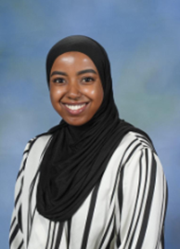

Dear Parents/Carers,

I would like to take this opportunity to welcome you and your family to 1H. I hope you all had a fantastic break over the summer. I am so excited to get to know the children in 1H. Over the summer I have been very busy spending time with my family and friends and baking lots of delicious cakes! I am very much looking forward to teaching Year 1 again this year, at Varna. We have lots of fun and exciting activities planned!

PE
Both indoor and outdoor will be on Thursday but children can bring in PE kits on a Monday and take them home on Thursday. P.E kits should include:
- Pumps or trainers
- Black shorts or leggings, tracksuit bottoms for cold weather
- White t-shirt
Please ensure that all PE kit and school uniform is clearly named.

Homework
You will receive a RWI reading book, a reading for pleasure book and a reading record to record when you read at home with your child. Please listen to your children read at home at least 3 times a week and sign their reading journals. Please encourage your child to look after their reading book as they are costly to replace. There is a charge of £5.00 for lost books and £1.00 for lost journals.

Homework will be given out on a Thursday and everything needs to be returned on a Tuesday.

Can I take this opportunity to thank you for your continued support and co-operation and remind you that if you want to talk to me you can always catch me in the playground at the beginning or the end of the day.

Yours sincerely,
Miss Hussein

