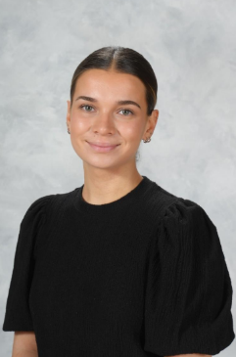
2nd Sepetember 2026



Dear Parents/Carers,

I’d like to warmly welcome you and your family to 1G! I hope you all had a wonderful and relaxing summer break. I’m really looking forward to getting to know all of the children and sharing a fantastic year together. Over the holidays, I enjoyed spending quality time with my family and friends and had the chance to visit some new places. I’m so happy to be teaching Year 1 at Varna again this year, and we have plenty of exciting activities and learning experiences planned!

PE
Both indoor and outdoor will be on Thursday but children can bring in PE kits on a Monday and take them home on Thursday. P.E kits should include:
- Pumps or trainers
- Black shorts or leggings, tracksuit bottoms for cold weather
- White t-shirt
Please ensure that all PE kit and school uniform is clearly named.

Homework
You will receive a RWI reading book, a reading for pleasure book and a reading record to record when you read at home with your child. Please listen to your children read at home at least 3 times a week and sign their reading journals. Please encourage your child to look after their reading book as they are costly to replace. There is a charge of £5.00 for lost books and £1.00 for lost journals.

Homework will be given out on a Thursday and everything needs to be returned on a Tuesday.

Can I take this opportunity to thank you for your continued support and co-operation and remind you that if you want to talk to me you can always catch me in the playground at the beginning or the end of the day.

Yours sincerely,
Miss Govey

